Shifts in Bacterial Family Composition in Goat Rumen Fluid Supplemented with Terminalia catappa L. Leaf Extract
ABSTRACT
Phytogenic feed additives have the potential to influence the structure of the community and composition of microbes in the rumen when supplementes into feed through interaction with bacteria. However, study on the effect of feed additives on rumen bacterial shifts at the family level are still limited. This study aimed to evaluate shifts in the composition of rumen bacteria in goats at the family level when supplemented with Terminalia catappa L. leaf extract. The study used three treatments: T0: control ration; T1: Ration with 1% Terminalia Catappa L leaf extract supplementation; and T2: Ration with 2% Terminalia Catappa L leaf extract supplementation. The composition of the microbiota was analyzed using 16S rRNA Amplicon Sequencing targeting the V3-V4 hypervariable regio using Illumina MiSeq platform. The results of alpha diversity analysis showed that supplementation with Terminalia Catappa L. leaf extract at a level 2% (T2) had a significant effect on rumen microbiota because it had the highest diversity and species richness values compared to T0 and T1. The results of beta diversity analysis showed that differences and separation of cluster between treatments. Relative abundance analysis showed a decrase in the Prevotellaceae family, and found Incertae Sedis at T0. Overall, this study shiws that supplementation with Terminalia catappa L. leaf extract at a level 2% has a significant effect on shifting the composition of goat rumen bacterial community, and supporting functional bacteria so that digestion of fiber can be carried out efficiently.
Keywords: 16S rRNA Amplicon Sequencing, Alpha Diversity, Beta Diversity, Bacterial Family Composition, Rumen Microbiota.
- INTRODUCTION
The rumen is an ecosystem for complex anaerobic microbes that functions as a fermentation center in the digestive system of ruminant livestock. The most dominant microorganisms in the rumen that are involved in feed fermentation in ruminant livestick are bacteria. Bacteria can decompose organic matter such as plant fiber so that it can be used as an energy source. The interaction between rumen bacteria enables the conversion of feed substrates into volatile fatty acids (VFA) as an energy source for ruminants (Xie et al., 2025). The composition and activity of the rumen bacterial community directly affect nutrient metabolism, digestive efficiency, and livestock productivity, resulting in an impact on ruminant production. The advancement of technology in the form of high-throughtput sequencing based on the 16S rRNA gene allows for the analysis of bacterial diversity without having to go through conventional microbial culture. The 16S rRNA gene approaches provide detailed information about changes in the composition and shifts in the bacterial community due to nutritional interventions. The Illumina MiSeq plastform and focus on the V3-V4 hypervariable region were selected because of the balance between amplicon length and taxonomic resolution (Wang et al., 2025).
An approach that is currently being developed to modulate rumen microbes involves supplementation with plant-based bioactive compounds as phytogenic feed additives. Terminalia catappa L. leaf extract contains bioactive compounds in the form of flavonoids and tannins, which are antimicrobials and antioxidants. These compounds are involved in inhibiting the growth of proteolytic bacteria and bacteria that produce excessive methane gas, as it supports the population of cellulolytic bacteria that are involved in fiber degradation (Ku Vera et al., 2020). Although there have been some findings that have evaluated the effect of plant extracts on microbial populations in the rumen, data regrading the supplementation of Terminalia catappa L. leaf on the composition and shift of rumen bacteria in goats are still limited, especially using the 16S rRNA Amplicon Sequencing.
The 16S rRNA-based approaches will be comprehensive when combined with controlled and effective in vitro approaches. This approach uses goat rumen fluid as a fermentation model and is conducted in a laboratory so that it is more controlled to evaluaste the effect of feed supplementation on the rumen bacterial community. The aim of this study is to evaluate shifts in the composition of goat rumen bateria at the family level through in vitro incubation of feed supplemented with Terminalia catappa L. leaf extract using the 16S rRNA. The findings of this study are hopefully able to contibute to scintific understanding and the utilization of the potential of Terminalia catappa L. leaf extract in modulatig rumen microbes.

- MATERIAL AND METHODS
  - Source of Rumen Sample and Terminalia catappa L. Leaves
The rumen fluid used in this study was goat rumen sourced from the Bustaman Slaughterhouse in Semarang City, Central Java, Indonesia. The rumen fluid collected after slaughter was placed in a vacuum flask dan immediately taken to the laboratory for in vitro fermentation. Meanwhile, Terminalia catappa L. leaves were collected from the surrounding area of Diponegoro University, Semarang City, Central Java, Indonesia. The leaves used were dark green in color, with the spesification that the fifth leaf from the base was used. This was carried put so that the leaves used were uniform.
  - Preparation of Terminalia catappa L. Leaf Extract
Terminalia catappa L. leaves used in the study were fresh, dark green leaves that had been cleaned and separated from the leaf veins, and cut to a size of approximately 1-2 cm using sciccors to increase the extraction surface area. A total of 20 g of leaves were mixed with 300 mL of distilled water or aquadest. The extraction methog used was on an electric stove until it boiled. The distillation time began when the first extract droplets appeared. After getting the desired extract volume, it was then collected in a sterile container and stored at room temprature and dark condition.

  - Ration Formulation
The feed used in this study were in the ration from consisting of forage and concentrate with a ratio of 40% and 60%. The forage used was dried Pennisetum purpureum cv. Mott (odot grass) and concentrate was composed of pollard, rice bran, cassava by-product (onggok), copra meal, corn gluten feed (CGF), palm kernel meal, coffee husk, molasses, and mineral mix. The feed formulation used is presented in Table 1.

Table 1. Ration Formulation and Nutrient Composition
Feed Ingredients | Composition | Nutrient Composition
Feed Ingredients | Composition | MC | Ash | CP | EE | CF | TDN
Feed Ingredients | Composition | ---------- (%) ----------
Dried Odot Grass | 40 | 11,98 | 13,78 | 14,63 | 1,94 | 21,76 | 63,08
Pollard | 15 | 3,67 | 4,90 | 13,27 | 2,74 | 7,87 | 80,14
Rice Bran | 5 | 8,50 | 16,30 | 4,81 | 1,25 | 11,18 | 69,94
Onggok | 5 | 11,44 | 4,14 | 5,92 | 0,26 | 42,85 | 71,14
Copra Meal | 10 | 14,58 | 3,69 | 20,50 | 2,21 | 18,80 | 74,81
CGF | 12 | 14,65 | 12,74 | 22,27 | 14,69 | 13,33 | 77,41
Palm Kernel Meal | 7 | 8,87 | 3,36 | 20,48 | 4,21 | 48,77 | 65,27
Coffee Husk | 3 | 7,65 | 3,36 | 11,18 | 3,19 | 50,89 | 63,99
Molasses | 2 | 23,00 | 0,20 | 5,40 | 0,20 | 7,70 | 66,62
Mineral Mix | 1 | 0,00 | 39,10 | 0,00 | 0,00 | 0,00 | 0,00
Source: Result of laboratory analysis conducated at the Laboratory of Nutrition and Feed Sciences, Faculty of Animal and Agricultural Sciences, Diponegoro University (2025). Abbreviations: Moisture Content (MC), Ash, Crude Protein (CP), Ether Extract (EE), Crude Fiber (CF), and Total Digestible Nutrients (TDN).

The formulation ration was then analyzed proximately to determine the nutrient content. The ration was formulated with 15% CP and 68% TDN. The results of the proximate analysis of the dried odot grass, concentrate, and ration are presented in Table 2.

Table 2. Proximate Analysis of Dried Odot Grass, Concentrate, and Experimental Diet (Rations)
 | Nutrient Composition
Ingredients | MC | Ash | CP | EE | CF | TDN
 |  |  | (%)
Dried Odot Grass | 11,98 | 13,78 | 14,63 | 1,94 | 21,76 | 63,08
Concentrate | 12,35 | 8,32 | 16,33 | 3,27 | 11,77 | 72,78
Rations | 12,60 | 10,16 | 15,65 | 2,74 | 14,74 | 68,90
Source: Result of laboratory analysis conducated at the Laboratory of Nutrition and Feed Sciences, Faculty of Animal and Agricultural Sciences, Diponegoro University (2025). Abbreviations: Moisture Content (MC), Ash, Crude Protein (CP), Ether Extract (EE), Crude Fiber (CF), and Total Digestible Nutrients (TDN).

The nutrient content of the ration was determined, and then Terminalia catappa L. extract supplementation was added at a predetermined level/dose. Phytochemical testing was then conducted to determine the flavonoida and tannin content are presented in Table 3.

Table 3. Phytochemical Analysis of Supplemented Rations
Parameters | Treatments
Parameters | T0 | T1 | T2
Flavonoid | 355,91 | 377,16 | 380,93
Tannin | 3,79 | 3,39 | 2,99
Source: Result of laboratory analysis conducated at the Laboratory of Nutrition and Feed Sciences, Faculty of Animal and Agricultural Sciences, Diponegoro University (2025).
  - Experimental Design
This study was designed using three treatments with different levels of Terminalia catappa L. leaves extract supplementation, including:

T0 = Control ration without Terminalia Catappa L leaf extract supplementation.
T1 = Ration with 1% Terminalia Catappa L leaf extract supplementation.
T2 = Ration with 2% Terminalia Catappa L leaf extract supplementation.

  - In Vitro Fermentation Procedure
The method of feed fermentability was carried using the in vitro method according to Tilley and Terry (1963). The measurement began with weighing approximately 0,55-0,56 g of each sample, followed by puttig the samples into fermentation tubes what had been labeled based on the treatments and replicated used. The sampel was then added to 40 ml of McDougall’s solution, which had been previously flushed with CO₂ to change the pH value to around 6,5 - 6,8. The fermenter tube was then sealed and placed in a waterbath to allow the McDougall’s solution to reach a temprature of 39 ºC. After that, 10 ml of rumen fluid were also added to the tube. The incubation process was caried out for 3 hour at a temprature of 39ºC. The sample was then centrifuges at a speed of 3000 rpm for 15 minutes. After centrifugation, there was a residue and a supernatant liquid. The supernatant that resulted was then used as a sample for bacterial community analysis.

  - 16S rRNA Amplicon Sequencing Analysis
The procedures for analyzing the 16S rRNA region involve bacterial DNA extraction, amplification of the 16S rRNA gene, electrophoresis, DNA sequencing, and comparison of the sequencing results with a database. Noer (2021), states that the extraction method selected will depend on the source of the DNA sampel and the required level of purity. The most common method used for bacteria is with the enzyme lysozyme. Thais enzym acts to cut peptidoglycan, and sodium deodycal sulfate (SDS) is added to destroy the fatty layer found in the cell membrane. Next, the DNA that has been extracted will be used as a template to apply segments of approximately 500 or 1,500 bp from the 16S rRNA gene sequencing using PCR. The amplification of the gene will be separated using gel electrophoresis. The sequencing process was carried out at PT. Genetika Science Indonesia using the Illumina MiSeq platform with the V3-V4 regian and the 16S gene target. The data was then analyzed to determine diversity, community differences, and relative abundance. The sequencing results were compared with the database using the Basic Local Alignment Search Tool (BLAST) technique.

- RESULT
  - Sequencing Quality Control
Table 4. Sequencing Quality Control menggunakan DADA2 Statistic
SampleID | Trimmed | Filtered | denoisedF | denoisedR | merged | nonchim
T0 | 99811 | 80733 | 77974 | 78149 | 61379 | 57838
T1 | 99813 | 80742 | 78321 | 78159 | 62312 | 59056
T2 | 99847 | 80831 | 78215 | 78328 | 63700 | 60451

In the sequencing quality control process using 16S rRNA Amplicon sequencing resulted in high-quality data with the number of reads at T0, T1, and T2. Based on Table 4. it shows that after the trimming stage, the average number of reads for each sample reached more than 99.000 reads. This indicates that 80-81% of reads passed the quality filtering process. However, during the denoising stage using DADA2, the reads per sample were around 78.000 reads, and became 61.379 – 63.700 reads after the merging stage. Meanwhile, the number of non-chimerical reads ranged from 57.838 – 60.451 reads, which means that the chimera rate produced by DADA2 was very low. This shows that the DADA2 pipeline is capable of maintaining a large number of high-quality reads that are suitable for further use in bacterial diversity analysis.

  - Amplicon Sequence Variants (ASVs) and Taxonomic Composition
The moleculer analysis resulted in a total of 1.202 ASVs after the denoising process. These ASVs were divided in several major bacterial families, such as Prevotellaceae, Lachnospiraceae, Rikenellaceae, and Oscillospiraceae. ASV1 classified in the Bacteroidota phylum, Bacteriodia class, and Prevotellaceae familiy showed a decrase in the number of reads from T0 3.614; T1 2.298; and T2 1.858. This was also shown in the Bacillota phylum, Clostridia class, and Lachnospiraceae family, swhich showed a decrase in the number of reads from T0 897; T1 658; and T2 555. Based on this, the decrase in dominant ASVs, especially in T1 and T2, indicated a response from the microbial community due to the supplementation of Terminalia Catappa L. leaf extract.

  - Alpha Diversity
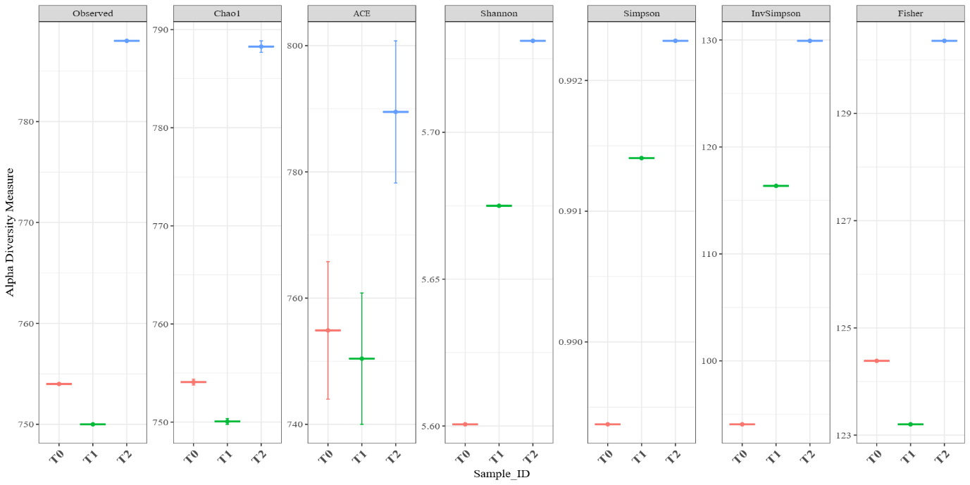
Fig 1. Alpha Diversity Measure

According to Fig 1. alpha diversity analysis is divided in two approaches, which are species richness and species diversity. The species richness parameters are Observed, Chao1, and ACE, which show an increase in T2 with values of 788; 788,27; and 789,50 respectively. In contrast, T0 as the control shows values that have a tendency to be higher than T1. Meanwhile, species diversity is comparised of Shannon, InvSimpson, and Fisher which show a more stable pattern with the highest values in T2. These values include Shannon 5.731, InvSimpson 129,92, and Fisher 130,35. In contrast to species richness, T1 shows higher values for species diversity compared to T0. This indicates that the pattern of increased diversity is consistent with the level of supplementation with Terminalia Catappa L. leaf extract.

  - Beta Diversity
Beta diversity analysis on Bray-Curtis based PCoA shows that T0 is separated from T1 and T2. This indicates that the microbial composition differs based on relative abundance. These results are also consistent with NMDS which revelas a distance between treatments, resulting from differences in microbial communities. Meanwhile, unifrac and wunifrac analysis show differences affected by the availability or un-availability of taxa and relative abundance of taxa.

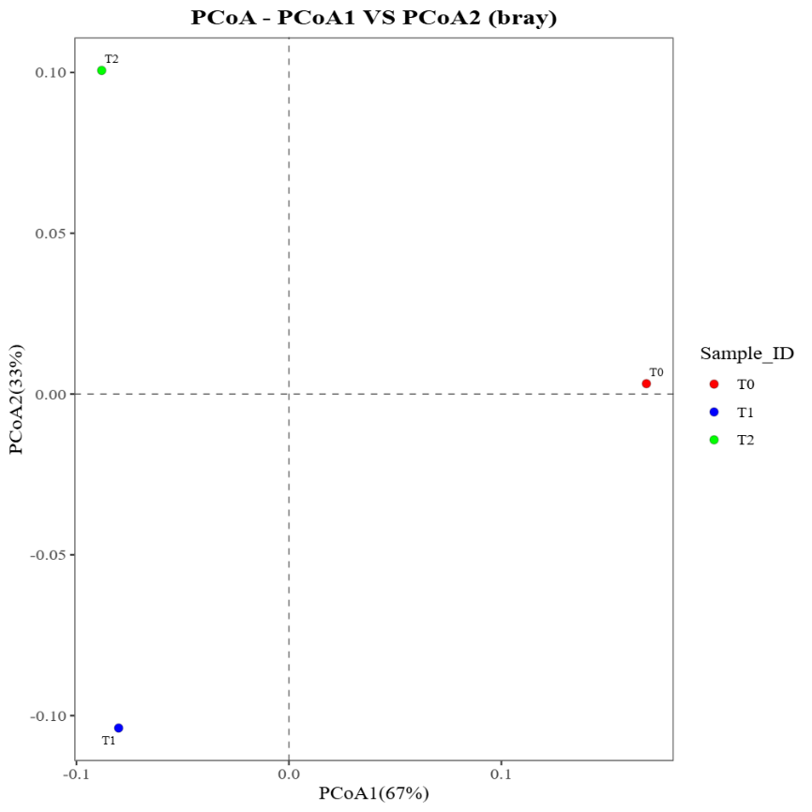
Fig 2. PCoA – PCoA1 vs PCoA2 (bray)

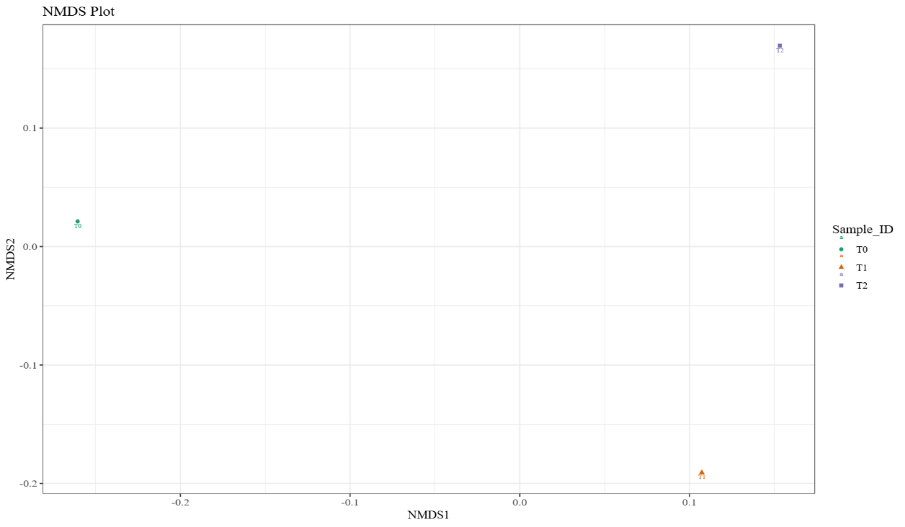
Fig 3. Non-metric Multidimensional Scaling (NMDS)

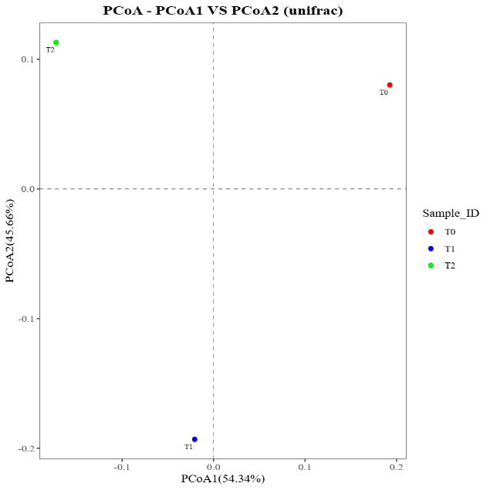  Fig 4. PCoA – PCoA1 vs PCoA2 (unifrac) | 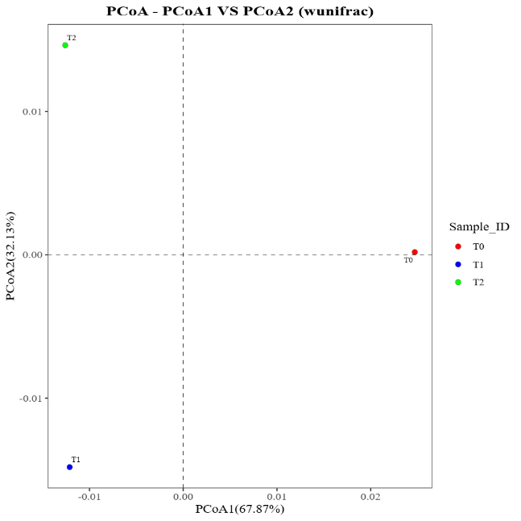  Fig 5. PCoA – PCoA1 vs PCoA2 (wunifrac)
  - Relative Abundance at the Family Level
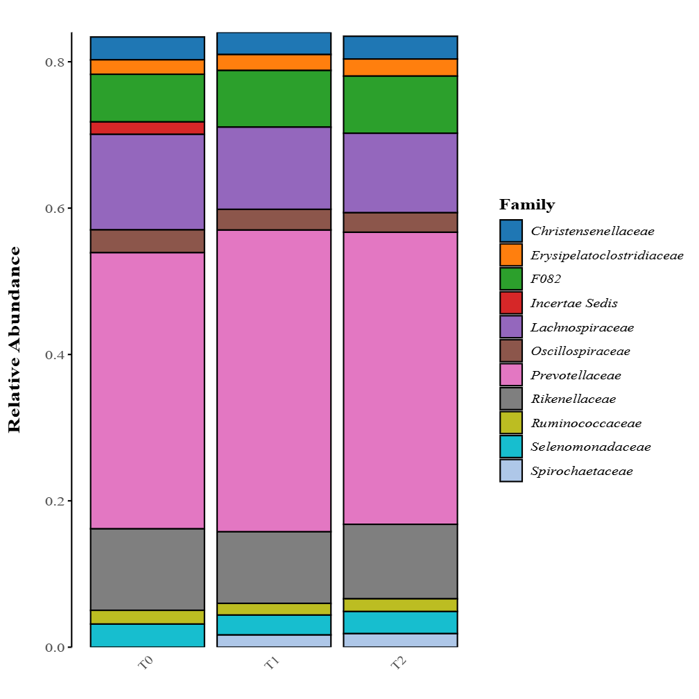
Fig 6. Relative Abundance
According to the Bar Plot in Fig 6. The family-level bacterial community is dominated by three main families, including Prevotellaceae, Lachnospiraceae, dan Rikenellaceae. This is also in line with Fig. 7 which shows that the Prevotellaceae family had the highest value at T0 an d experienced a decrase in colour at T1 and T2. Meanwhile, there is a relatively high increase in cellulolytic bacterial families such as Ruminococcaceae and Oscillospiraceae at T1 and T2. However, a very obvious finding at T0 is the appearance Incertae Sedis, which doesn’t appear at T1 and T2. This difference indicates that supplementation with Terminalia Catappa L. leaf extract can modulate the rumen bacterial community.
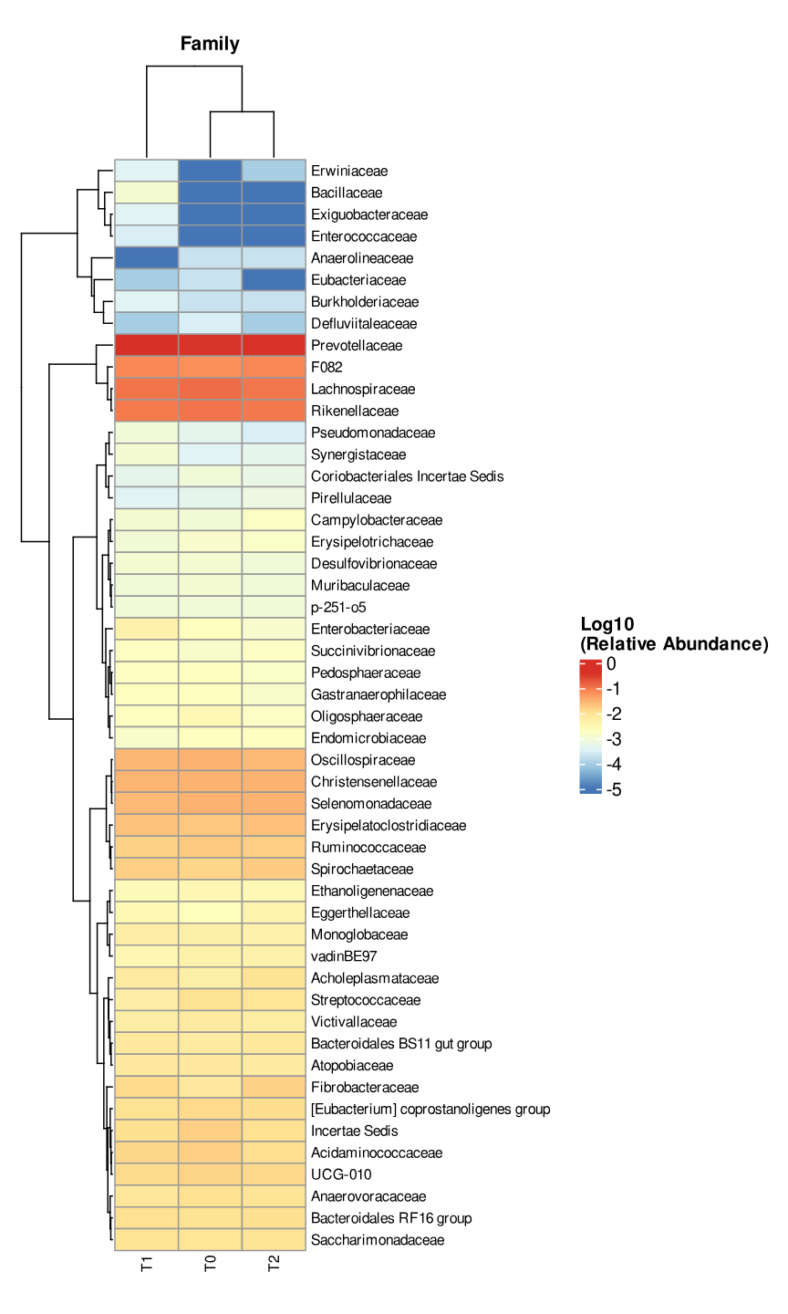
Fig 7. Heatmap

- DISCUSSION
The result of the study shows that the DADA2 pipeline used in the sequencing quality control stage produced data with a sufficient number of high-quality reads up to the non-chimera stage in three treatments. This consistency in the number of reads is a requirement for valid microbial diversity estimates. This requirement is because if the number of reads is too low, it can potentially produce unstable or biased diversity estimates. Alpha diversity analysisi shiwed that supplementation with Terminalia catappa L. leaf extract was able to modulate the rumen ecosystem. T2 treatment with leveel 2% was consistently able to produce the highest species richness and diversity between T0 and T1. High species richness was indicated by Observed, Chao1, and ACE, while high diversity was indicated by Shannon and InvSimpson in T2, which a more diverse community. This incrased diversity is related to better ecosystem stability and sustainability, which has the potentially to improve goat’s adaptation to feed changes or when experiencing stress (Guo et al., 2022). This was thought to be due to the phytochemical compounds tannins and flavonoids contained in Terminalia catappa L. extract, resulting in less efficient bacterial supperssion. This is in agreement with the findings of Taganna et al. (2011) and Allyn et al. (2018) that Terminalia catappa L. leaf extract containing phytochemical compounds such as tannins and flavonoids selectively inhibits certain bacteria that are less efficient, and creating an environment that allows other bacterial species to repoduce and potentially produce a more balanced and diverse microbial community.
Beta diversity analysis shows that supplementation with Terminalia catappa L. leaf extract resulted in a significant in the composition of the bacterial community. This ini in line with the results of Ault-Seay et al. (2022) that beta diversity can be used to measure differences in the composition of bacterial communities between samples affected by feed supplementation. Both PCoA plots show that the cluster separations are clearly visible between T0, T1, and T2. This clear separation indicates that the extract is the main factor that chages the structure of the rumen bacterial community. This ini agreement with the findings of Zhang et al. (2025) that the use of extracts or additives can bee a major factor in changing structure of the rumen bacterial community. The resulting distance shows a different communitis, conforming that rumen microbial modulation is dosis-dependent. This finding is in line to Rabee et al. (2024) that the phytochemical compound has a role in modulating the rumen by changing the rumen microbial composition, increasing the abundance of beneficial bacteria, and reducing the pathogenic bacteria with the given level.
The shift in community composition in Beta Diversity is consistent with the relative abundance changes in the bacterial families that dominate. The family or communities are dominated by the Prevotellaceae family in all treatments. According to Dao et al. (2021), the Prevotellaceae family has an important role in the digestion of hemicellulose, starch, cellulose, hemicellulose, and pectin, as well as the metabolism of protein in the goat rumen. Prevotellaceae has many genes that code for amylytic enzymes such as α-amylase and other enzymes that are active towards carbohydrates, facilitating the breakdown of complexes starch molecules into simple sugars (Chen et al., 2022). However, Prevotellaceae tends to decline in T1 and T2, especially when viewed on the heatmap. This decrease was caused by the antimicrobial properties of tannins, which are able to bind proteins and inhibit the growth of Prevotellaceae, but don’t interfere with rumen function. Meanwhilee, there was an increase in the relative abundance of Ruminococcaceae and Oscillospiraceae, especially in T1 and T2. These two groups of bacteria contribute to the degradation and production of VFA, particularly butyrat production, which imporves fermentation function and energy efficiency. The Ruminococcaceae ferment carbohydrates to produces butyrate, which is important for maintaining gut health and as an energy source, and has anti-inflammatory properties (Ploger et al., 2012). This shifft in the community indicates that supplementation with Teminalia catappaa L. leaf extract can be used to balance the rumen community towards greater stability.
The other finding was the existence of the Incertae sedis group, that was only detected in the control (T0) and not found in T1 or T2. Incertae sedis indicate a group of bacteria that have not been clearly defined. The disappearence of this result in T1 and T2 is due to the effect of supplementation, indicating that the pressure from Teminalia catappaa L. leaf extract directs the microbial community to become more functional. The decrease in Incertae sedis and the increased presence of fibrolitic bacteria indicate that supplementatio with tihis extract can stimulate the formation of a more efficient, stable, and fiber degradation friendly microbial community. This agreement with the opinion of Xie et al. (2018) that when fibrolytic bacteria expandd their ability to degradation fibers, the ecological space for non-specialist or unclassified taxa narrows, resulting in a decrease in the frequency of Incertae sedis.

- CONCLUSIONS
Supplementation of Terminalia catappa L. leaf extract at a level of 2% increased bacterial diversity and separation of community structure, with a decrease in relative abundance in the Prevotellaceae family and Incertae Sedis found at T0. Findings show that inTerminalia catappa L. leaf extract has the potential to modulate the rumen bacterial community, especially that involved in fiber fermentation and rumen metabolism.

