Stakeholders’ preferences and constraints along the taro (Colocasia esculenta L.) value chain in southern Benin

Yélognissè Gilles CHODATON ¹, Lucie zinzi NDLALA ², Réel Gael HOUNGBELAGNON¹, Janine DONHOUEDE³, Lucrece ATINDEHOU³, Kabirou KEOUNGUE ¹, Rodrigue IDOHOU¹
¹Ecole de Gestion et de Production Végétale et Semencière, Université Nationale d’Agriculture, BP 43 Kétou, Bénin
²Agricultural Research Council, Grain Crops Institute, Private Bag X1251, Potchefstroom, South Africa.
³ Laboratoire d’Ecologie Appliquée (LEA), Faculté des Sciences Agronomiques, Université d’Abomey-Calavi, 01BP 526, Bénin.
*Corresponding author: rodrigidohou@gmail.com
Abstract
Taro (Colocasia esculenta) is a root crop of considerable economic, nutritional, and industrial importance among tuber crops. Despite its multiple uses, taro remains a neglected and underutilized species. This study aimed to identify stakeholders’ preference criteria and constraints along the taro value chain in order to enhance its valorization in Benin. A total of 102 taro producers, 76 traders, and 43 taro processors were surveyed through face-to-face interviews and focus group discussions across 31 villages located in several districts of southern Benin. The collected data were analyzed using descriptive statistics, log-linear models (loglm), and Multiple Correspondence Analysis (MCA). Producers identified the lack of high-yielding varieties (62.74%), labor shortages (62.74%), and skin irritation during handling (51.96%) as the major constraints to taro production. In contrast, product attributes such as color (24%), edibility of all plant parts (9%), and taste (27%) were among the least prioritized preference criteria by producers. A significant relationship was found between producers’ preference criteria and their sociocultural groups (p < 0.05). These findings suggest that extending the study to other taro-producing regions across the main production zones could help uncover additional constraints or challenges not identified by the stakeholders involved in this research. Overall, the results provide valuable insights to guide policymakers in designing effective extension services, breeding programs, and value-addition strategies to promote taro development in Benin.

Keywords: Colocasia esculenta, Constraints, Preferences Criteria, Wémé, Processor
Introduction
By 2050, the global population is expected to exceed 10 billion people, leading to an increase in food demand by up to 56% (WRI 2024). This rapid population growth, combined with challenges caused by climate change worldwide, particularly in sub-Saharan Africa, necessitates the development of additional strategies aimed at ensuring food security and sovereignty. One such strategy involves the utilization of plants beneficial for human well-being and consumption, including cereals, pulses, oilseeds, vegetable crops, condiments, and aromatic plants etc. (Knez et al. 2024).
In addition, roots and tubers (RTs) crops represent another major group of significant importance. RTs crops contribute meaningfully to sustainable development, income generation and food security, especially in tropical regions (Sharma and Kaushal 2016). They are also recognized for their resilience to changing climatic conditions (Chokkappan Mohan et al. 2016). Rich in carbohydrates, RTs crops serve multiple uses such as staple food crops, cash crops and raw materials for industries (Saranraj et al. 2019). RTs are considered as the third most important crops group after cereals, pulses (Daryanto et al. 2017). Key crops of this group include Cassava (Manihot esculenta Crantz), Sweet potato [Ipomoea batatas (L) Lam.], Yam (Dioscorea spp Linné) and taro (Colocasia esculenta (L) Schott, Xanthosoma sagittifolium Schott). In terms of cultivation and consumption in Africa, taro ranks third after cassava and yam (Onyeka 2014), but fourth in Benin, following cassava, yam and sweet potato (Tamadaho et al. 2024b). Taro is an economically important crop (Chokkappan Mohan et al. 2016), and its nutritional composition, includes 60 to 90% of carbohydrates, 0.4 to 0.7% of lipids, and 1 to 4.5% of protein (Chabi et al. 2019).
Taro tubers are rich in carbohydrates (Bammite et al. 2018; Rashmi et al. 2018), while the leaves, stems, and petioles are also consumed as vegetables (Shange, 2004). These parts provide
important minerals and vitamins such as calcium, phosphorus, iron, vitamin C, thiamine, riboflavin, and niacin (Otekunrin et al. 2021; Muthoni and Shimelis 2023). In Benin, taro tubers are consumed in several forms such as porridge, stew, grilled, fried, chips, as well as dried slices and flour (Houngbo et al. 2015). Based on the consumer preferences criteria particularly tastes, taro ranks as the second most preferred root and tuber crop after yam in Southern Benin (Houngbo et al. 2015). Taro tubers are also valued for good paste quality when pounded into foutou (Quenum et al. 2023).
Beyond its food uses, taro leaves and tubers are traditionally used in Benin to care and to treat various diseases such as asthma, sexual weakness, acne, frigidity, measles (Tamadaho et al. 2024b). Taro starch is particularly beneficial for individuals suffering from ulcers and chronic pancreatic disorders, liver problems, inflammatory bowel diseases, and gallbladder diseases (Lebot et al. 2011). Thus, taro holds significant potential across economic, nutritional, medicinal domains.
However, despite its importance, taro cultivation in Benin, remain neglected, and considered as a minor or orphan crop (Houngbo et al. 2015). Scientific studies on taro remain sparse and insufficient to support its full potential (Dansi et al. 2012). Furthermore, apart from a few studies conducted on yam, cassava, and sweet potato, research on RTs remains scarce or geographical restricted (Tamadaho et al. 2024a). According to Houngbo et al. (2015), taro is a relatively expensive product for consumers, making it accessible primarily to those with higher purchasing power. This economic barrier limits access for many potential consumers who may wish to acquire it but lack the financial means.
Although taro offers economic advantages (Houngbo et al. 2015), structured information regarding its commercialization is lacking (Grimaldi and Van Andel 2018). Tamadaho et al. (2024b) identified the absence of a formal market outlet as one of the key economic constraints faced by stakeholders in the taro value chain. Despite its economic potential, taro commercialization is confined to local markets (Muthoni and Shimelis 2023). Its economic valorization should be expanded to regional and international markets.
The lack of effective research and policy intervention focusing on taro production and marketing particularly international trade has impeded its lower popularity compared to other RTs such as yam, cassava, and sweet potato (Otekunrin et al. 2021). Given taro’s multiple potentials, strengthening the RTs sector in general, and the taro value chain specifically, could generate increased income and foster greater enthusiasm for its cultivation in Benin.
Therefore, this study aimed to identify preferences criteria and constraints across the taro value chain and to examine the relationship between these criteria and the sociocultural groups of the various actors involved. This information will help to identify the gaps and inefficiencies at each level of the chain. Moreover, it will open new avenues for research within the scientific community, contributing significantly to the improvement and valuation of taro in Benin.

Materials and methods
This study was conducted across 31 villages located in several districts and belonging to different agricultural development zones: Dangbo, Adjohoun, Bonou and Missrété, Zè, Toffo and Dantokpa (Poles 7); Sakété, Kétou, Adja-oueèrè and Pobè (Poles 6); Ouinhi districts (Poles 4) (MAEP 2017). These areas were selected due to the high concentrations of taro value chain actors surveyed. According to MAEP (2024), these districts represent key taro production zones in Southern Benin.
Taro producers were identified using “non-probabilistic snowball sampling technique” as done by Vissoh et al. (2023). Initial contact was obtained from Departmental Directorates of Agricultural, livestock and fisheries (DDAEP), and these key producers subsequently referred to the research team and other taro producers within their village.
Constraints and preferences criteria along the taro value chain identified through face-to-face interviews and focus group discussions with producers, processors, and traders/retailers of taro tubers in various districts (Fig 1). Four focus group, each composed of 8 to 10 producers, were organized to triangulate data collected. Additionally, a small randomly selected group of 4 to 7 women, were interviewed to gather gender-specific insights into constraints and preference criteria. Socio-demographic data collected included variables such as sex, age, household size, education level, processing and sales activities, as well as the challenges and constraints encountered in selling, buying, or processing taro. Additionally, information was gathered on participants’ membership in a farmers' association or taro sellers' association, among other relevant factors.
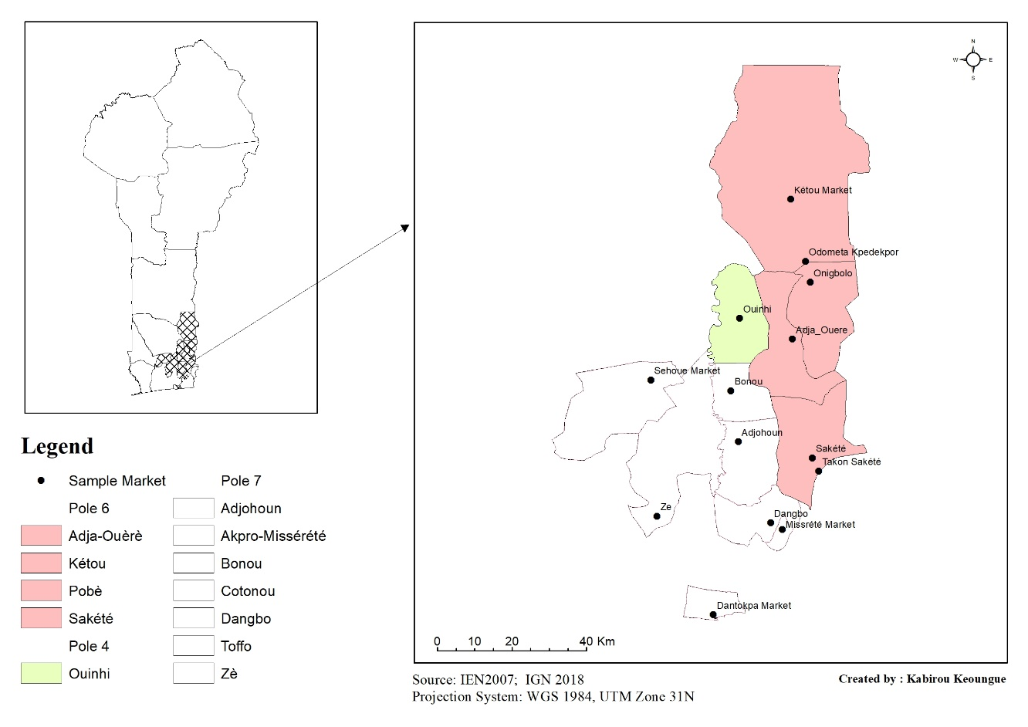
Fig 1: Map of study area
Statistical Analysis
In order to identify major constraint, preference criteria and to describe socio-demographic characteristics of taro producers, traders, and processors, the data collected were subjected to descriptive analysis including frequency, mean etc... and results were presented in tables and histograms. Radar chart visualization were used to selected the principal constraint, preference criteria of the actor along taro chain value. To examine the relationship between preferences’ criteria and the sociocultural groups of actors involved in the value chain, a logistic linear model and Multiple Correspondence Analysis (MCA) were performed. These analyses were conducted using the loglm function and the FactoMineR and factoextra packages, respectively, in R software version 4.4.0 (R Core Team 2019).

Results
Socio-demographic characteristics of taro producers, traders, and processors
Among the 102 taro producers interviewed, 79 were men (77.45%) and 23 were women (22.55%), belonging to Fon, Nago, Holi, Wémé, and Mahi sociocultural groups. Holi, Wémé, and Nago sociocultural groups were most represented, with 33.33%, 27.45% and 21.57%, respectively. The majority of respondents were adults, aged from 30 to 60 years old. Regarding education level, 23.53% had no formal education, while 43.13%, 19.61% and 13.72% had completed primary, secondary and university education, respectively.
In terms of occupation, 69.60% of these producers were fully engaged in agriculture, while 19.60% were Craftsman, and 10.80% combined farming with other activities such as driving, trading, or housewives. Most producers (89.21%) practiced monoculture, and vast majority (97.06%) cultivated the pink taro variety (Table 1).
Regarding taro traders, all respondents (100%) were women from the Aïzo, Fon, Goun, Holi, Mahi, Nago, and Wémé sociocultural groups. Wémé sociocultural group was the most dominant (26.31%), followed by Holi (19.73%) and Fon (19.73%). Most traders (75%) were adults aged between 30 and 60 years, while 22.37% were young and 2.63% were over 60 years. In terms of educational level, 47.37% had completed primary education, and 34.21% had no formal education. A majority (89.48%) were married, while 10.52% were single.
Although primarily engaged in selling taro tubers, 13.16% of traders reported full-time involvement in agriculture. Additionally, 65.79% sold other food items (maize, millet, sorghum, yam, etc.) and 21.05% were involved in crafts such as hairdressing or tailoring, alongside taro sale, respectively. Most traders (85.52%) indicated that the pink taro variety was the most preferred (Table 2).
All taro processors surveyed were also women, belonging to Aïzo, Fon, Goun and Nago sociocultural groups, with Aïzo group being the most represented (37.2%). The majority processors (62.8%) were youth, while 37.2% were adults. Most (86.04%) were married. In addition to processing taro into other derived products such as chips and boiled taro, 41.86% were also food traders (cowpeas, maize, sorghum, rice, etc.), 37.2% were artisans (hairdressers, tailors) and 20.93% were housewives (Table 3). Taro processing appears to be an activity almost exclusively reserved to women.

Table 1. Socio-demographic data of taro producers.
Variables |  | Number (N=102) |  | Frequency (%)
Ethnic group
Nago |  | 22 |  | 21.57
Fon |  | 12 |  | 11.76
Holi |  | 34 |  | 33.33
Wémé |  | 28 |  | 27.45
Mahi |  | 6 |  | 5.88
Sex
Male |  | 79 |  | 77.45
Female |  | 23 |  | 22.55
Education level
None |  | 24 |  | 23.53
Primary |  | 44 |  | 43.13
Secondary |  | 20 |  | 19.61
University |  | 14 |  | 13.72
Age
Youth (age≤30 years) |  | 20 |  | 19.61
Adult (30< age ≤60years) |  | 81 |  | 79.41
Elderly ((≥60 years) |  | 1 |  | 0.98
Marital Status
Married |  | 94 |  | 92.15
Single |  | 8 |  | 7.84
Occupation
Agriculture |  | 71 |  | 69.6
Craftsman |  | 20 |  | 19.6
Other |  | 11 |  | 10.8
Land Access Mode
Purchase |  | 27 |  | 26.47
Lease |  | 35 |  | 34.31
Inheritance |  | 40 |  | 39.21
Farming System
Intercropping |  | 11 |  | 10.78
Monoculture |  | 91 |  | 89.21
Varieties Cultivated
White |  | 3 |  | 2.94
Pink |  | 99 |  | 97.06

Table 2. Socio-demographic data of taro traders.
Variables |  | Number (N=76) |  | Percentages (%)
Ethnic group
Aïzo |  | 5 |  | 6.59
Fon |  | 15 |  | 19.73
Goun |  | 4 |  | 5.27
Holi |  | 15 |  | 19.73
Mahi |  | 5 |  | 6.57
Nago |  | 12 |  | 15.8
Wémé |  | 20 |  | 26.31
Sex
Female |  | 76 |  | 100
Education level
None |  | 26 |  | 34.21
Primary |  | 36 |  | 47.37
Secondary |  | 10 |  | 13.15
University |  | 4 |  | 5.27
Ages
Youth (age≤30years) |  | 17 |  | 22.37
Adult (30<age≤60year) |  | 57 |  | 75
Elderly (age≥60years) |  | 2 |  | 2.63
Marital Status
Single |  | 8 |  | 10.52
Married |  | 68 |  | 89.48
Occupation
Sales |  | 50 |  | 65.79
Crafts |  | 16 |  | 21.05
Agriculture |  | 10 |  | 13.16
Varieties Cultivated
Pink |  | 65 |  | 85.52
White |  | 11 |  | 14.48
Variables |  | Number (N=43) |  | Percentage (%)
Ethnic group
Aïzo |  | 16 |  | 37.2
Fon |  | 13 |  | 30.23
Goun |  | 10 |  | 23.27
Nago |  | 4 |  | 9.3
Sex
Female |  | 43 |  | 100
Level of Education
None |  | 9 |  | 20.93
Primary |  | 24 |  | 55.81
Secondary |  | 10 |  | 23.26
Ages
Youth (age≤30years) |  | 27 |  | 62.8
Adult (30<age≤60years) |  | 16 |  | 37.2
Marital Status
Single |  | 6 |  | 13.95
Married |  | 37 |  | 86.04
Occupation
Artisans |  | 16 |  | 37.2
Housewives |  | 9 |  | 20.93
Retailers of foodstuffs |  | 18 |  | 41.86
Table 3. Socio-demographic data of taro processors.

Constraints of actors in the taro value chain
Among the constraints identified during the survey, taro producers highlighted labor shortages (62.74%), the lack of high-yielding planting material (62.74%), skin irritation and itching during handling (51.96%), recurrent drought spells (50%), limited market access (47.05%), and increasing weed pressure (33.33%) as the major challenges affecting production (Fig 2). In contrast, taro traders reported insufficient financial support (77.63%), high costs of raw materials (71.05%), lack of reliable market outlets (51.31%), and rodent infestations (46.05%) as the primary constraints encountered during taro commercialization (Fig 2). Regarding taro processors, the unavailability of raw materials (100%) and their high cost (93.02%) were identified as the most critical challenges. Additional constraints included labor-intensive processing activities (88.37%), financial difficulties (88.37%), absence of stable market outlets (79.06%), and post-harvest storage difficulties (67.44%) (Fig 2).

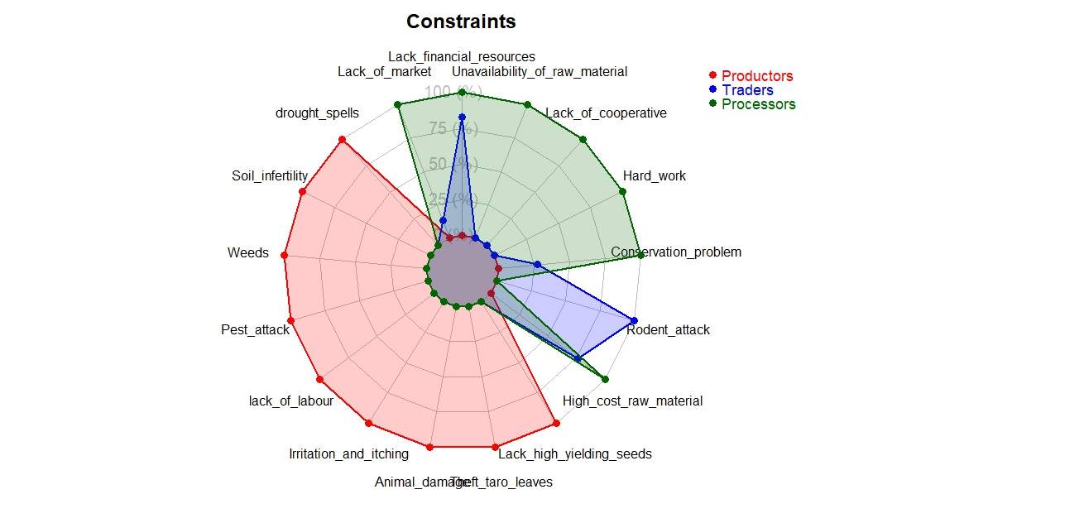
Fig 2. Radar chart of stakeholders constraints
Preference criteria of actors in the taro value chain
Across the different actors in the taro value chain, several preference criteria were identified. Among taro producers, yield (100%), disease resistance (75.49%), market demand (71.57%), drought tolerance (68.62%), and storage ability (36.27%) were the most frequently cited criteria. Taro traders primarily emphasized profitability (86.84%), storage capacity (67.10%), and market demand (64.47%) as key determinants of their preferences. For taro processors, profitability (88.37%), taste (81.39%), and storage ability (81.39%) emerged as the most important criteria, along with the suitability of taro varieties for processing (88.37%) (Fig 3).

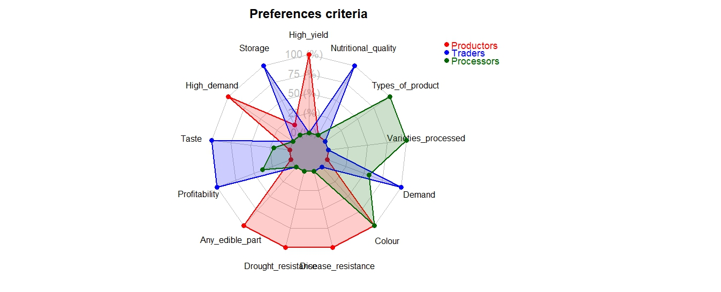
Fig 3. Radar chart of stakeholders preference criteria

Relationship between preference criteria and sociocultural groups of the different actors in the taro value chain
A statistically significant association was observed between producers’ preference criteria and their socio-cultural groups (p < 0.05; Table 4). This finding indicates that ethnicity plays a meaningful role in shaping producers’ preferences, suggesting that sociocultural factors influence decisions related to taro cultivation and utilization.

Table 4. Interaction between preference criteria and sociocultural groups of taro producers.
 | X² | df | P (> X²)
Likelihood Ratio | 59.620 | 32 | 0.002
Pearson | 52.699 | 32 | 0.012

A Multiple Correspondence Analysis was performed on the preference criteria and sociocultural groups of taro producers, traders and processors. This revealed that the first two axes of these three groups explained 75.3%, 85.4% and 100% of the total variation, respectively.
For taro producers, the first principal component (PC1) showed that the Mahi sociocultural group was positively correlated with high yield and disease resistance. The second principal component (PC2) revealed that the taste, profitability and colour preference criteria were positively associated with the Holi and Wémé sociocultural groups, while the storage criteria were negatively associated with the same axis (Fig 4).
For taro traders, nutritional quality and demand are positively correlated with the Wémé ethnic group, whereas the Mahi and Goun sociocultural groups are negatively correlated with taste, storage and profitability on the first axis. However, on the second axis, demand criteria are negatively correlated with the Fon sociocultural group (Fig 5).
Finally, for taro processors (Fig 6), the Aïzo ethnic group is positively associated with storage criteria. However, the Goun and Nago sociocultural groups are negatively correlated with colour, processed varieties, and type of product on the first axis.

Taro value chain
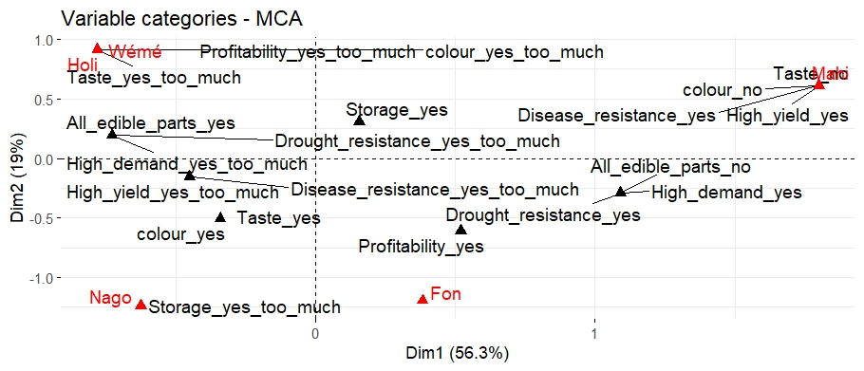
Several stakeholders, including producers, traders, processors, consumers and conveyors, are involved in the taro value chain (Fig 7). Within this value chain, taro processors appear to obtain their raw materials either directly from producers or indirectly via conveyors. Traders, on the other hand, source fresh taro only from producers. Consumers can obtain taro either from traders or processors, depending on the type or form they require.

Fig 4. Multiple Correspondence Analysis (MCA) of ethnic and preferences criteria of taro producers.

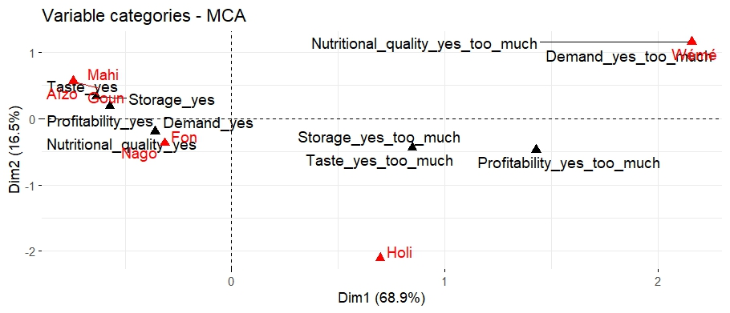
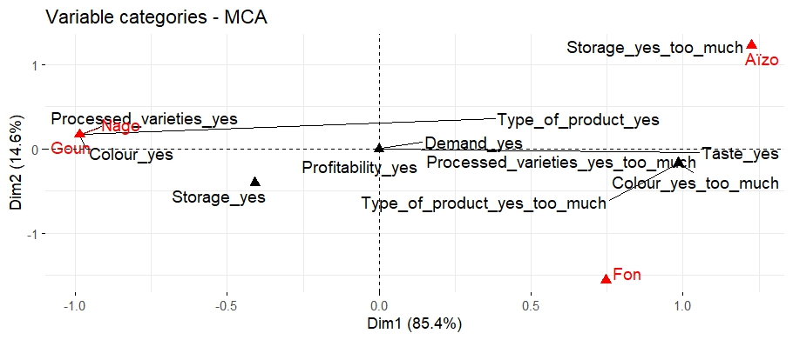
Fig 5: Multiple Correspondence Analysis (MCA) of ethnic and preferences criteria of taro traders

Fig 6. Multiple Correspondence Analysis (MCA) of ethnic and preferences criteria of taro processors.

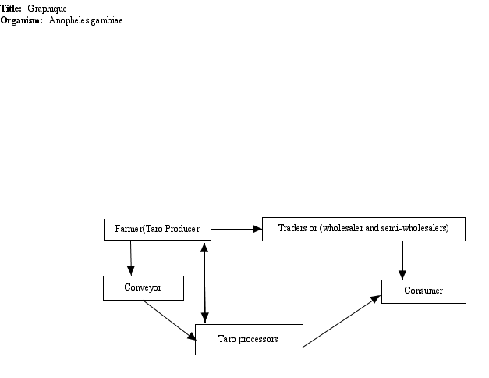

Fig 7. Taro value chain based on our study area.

Discussion
The results of this study revealed that the majority of taro producers surveyed were male, which is consistent with the findings of Tumuhimbise et al. (2016). This trend could be explained by the availability of arable land for farming, as well as the fact that agricultural practices in Africa still require a lot of energy and physical effort, tasks which are predominantly assigned to men. Furthermore, the commercial value of taro production may encourage male dominance in its cultivation (Ajijola et al. 2003). Men and women are responsible for farming and marketing, respectively (Martin et al. 2008). This aligns with the findings of Ezin et al. (2018), who observed that men were more involved in sweet potato production than women, which they attributed to the physically demanding nature of the work, particularly on vertisol soils.
In terms of the varieties adopted and used, the pink variety of taro is much more widely produced and used by both producers and traders. The preference for this variety may be due to factors such as high demand, high yield and cultural significance, as reported by Akplogan et al. (2018). In fact, cultivar selection is often based on seed availability, productivity, and organoleptic qualities. The majority (79.41%) of taro producers are aged between 30 and 60. This may be because young people are not interested in taro production in the areas covered by this study. According to Tumuhimbise et al. (2016), older taro producers tend to resist new technologies.
Monoculture was practiced by the majority (89.21%) of taro producers, likely because it reduces competition for resources such as water, light, and soil nutrients between taro and associated crops. This preference may also be linked to the poor performance of other crops when intercropped with taro (Tumuhimbise et al. 2016), as well as the potential for higher yields and reduced pest and disease pressure. Producers reported a range of constraints, including labor shortages, lack of high-yielding planting material, skin irritation and itching, drought, limited market access, increasing weed pressure, declining soil fertility, pest attacks, and theft. These challenges are consistent with previous findings (Tamadaho et al. 2024b; Dossou Adanlienklounon et al. 2021; Tumuhimbise et al. 2016; Houngbo et al. 2015).
The reported skin irritation and itching are likely caused by acrid compounds present in taro organs. According to Kai and Silla (1983), the leaves, petioles, and corms of taro contain irritant agents, and consumption of raw taro can induce a burning and itching sensation in the mouth, throat, and on the skin (Kai and Silla 1983; Akpan and Umoh, 2004).

To address the shortage of planting material, the multiplication of taro suckers using the stem fragment technique has been suggested as a viable alternative (Dossou Adanlienklounon et al. 2021; Tumuhimbise et al. 2016). Drought spells, increasingly associated with climate change, were also identified by respondents as a major constraint. Developing targeted taro breeding programs could help produce varieties that are both drought- and pest-resistant. However, such efforts are currently limited by the absence of structured crop improvement programs and the lack of economically valuable traits in available resistant genotypes (Oladimeji et al. 2022).
Financial constraints were reported across all actor groups in the taro value chain, corroborating Haladou et al. (2024), who identified limited funding as a major challenge for root and tuber crop producers. Singbo et al. (2004) emphasized that the intensity of these constraints reflects the financial capacity of producers.
The preference criteria reported by producers including high yield, disease resistance, market demand, drought tolerance, and storage ability align with previous findings (Tumuhimbise et al. 2016). Yield remains the primary objective, highlighting the importance of developing high-yielding varieties. These preferences reflect the traits that producers prioritize when selecting cultivars: robust, healthy, and high-yielding genotypes are favored due to their superior market value (Fufa et al. 2021). Consequently, taro breeding programs should focus on traits of relevance to both producers and consumers, such as yield and disease resistance (Mgbedike et al. 2017).
The positive association observed between the Aïzo sociocultural group and the preference criterion “storage” among taro processors, as revealed by Multiple Correspondence Analysis (MCA), may be attributed to socio-economic and organizational factors. This is consistent with Kiki (2007), who reported that the N’Tcha sociocultural group employs specific yam storage mechanisms. Root and tuber crop thus exhibit a sociocultural dimension (Kiki 2007).
Taro processing into derived products such as chips, dried slices, and flours requires effective long-term preservation and storage to facilitate commercialization. According to Darkwa and Darkwa (2013), taro can be stored longer than most other root crops without significant changes in quality or taste.
Furthermore, storage could be seen as a strategic factor for taro processors, enabling them to respond to market demand during periods of low taro availability when prices are higher. This suggests that storage criteria could be linked to traditional post-harvest management practices that are well established within Aïzo communities and which utilise proven storage methods. According to Cele and Mudhara (2025), limited storage is one of the challenges faced by the taro and sweet potato value chain. Compared to other root and tuber crops such as cassava and sweet potatoes, yams have the advantage of being storable for several months before being used as fresh produce, seed material or for processing (Kleih et al. 2012). Taro undergoes limited processing globally, except in Asia where its taste and texture are highly valued (Cirad 2023). Processing taro with modern storage technology can generate more income for actors in the value chain.

The significant relationship (P < 0.05) between sociocultural group and preference criteria suggests that ethnicity influences producers' preferences. This may be rooted in cultural traditions and historical perceptions. The role of actors in the taro value chain in promoting sustainable practices and improving incomes is particularly important for achieving Sustainable Development Goal 2 (SDG 2) (Liverpool-Tasie et al. 2020). Based on this study, which assessed the preference criteria and constraints of different actors in the taro value chain, taro can be considered a resilient crop for adapting to climate change. Increasing its production in Central, Northern and Sub-Saharan regions could enhance food security and bolster the resilience of local farming systems.

Conclusion

This study highlighted the key constraints and preference criteria of the stakeholders involved in the taro value chain in Benin, emphasising its economic importance and underexploited potential. By considering producers, traders and processors simultaneously, this study addresses the lack of existing literature on the taro value chain in Benin.
The findings reveal that taro producers face significant challenges, including a lack of high-yielding seeds, labour shortages and the impact of drought on productivity. In contrast, processors prioritise profitability, conservation and market demand when making decisions. A significant relationship was found between producers' preferences and their sociocultural groups, suggesting that cultural factors play a crucial role in shaping agricultural practices and varietal choices. From a scientific perspective, this study advances existing knowledge by combining stakeholders’ perceptions with multivariate analytical approaches to improve our understanding of the interactions within the taro value chain. These results highlight the need for targeted interventions to address the identified constraints and optimise the valuation of taro in the region. Expanding this study to other taro-producing regions in Benin could provide a more comprehensive understanding of the sector's challenges and inform more effective development strategies. Addressing these challenges and capitalising on the crop's diverse potential could make taro a more profitable and sustainable part of Benin's agricultural landscape, contributing to economic growth and food security.
Conflict of Interest Statement
The authors declared that the research was conducted in the absence of any commercial or financial relationships that could be construed as a potential conflict of interest.
Acknowledgments
The authors would like to sincerely thank all farmers and stakeholders who participated in the survey and shared their time, knowledge, and experience. The authors also acknowledge the support provided by colleagues and field assistants during data collection. No specific funding was received for this study.
Authors’ Contributions
Yélognissè Gilles CHODATON conducted the survey, performed data analysis, and drafted the initial version of the manuscript. Lucie Zinzi NDLALA contributed to data validation, manuscript review, and editing. Réel Gael HOUNGBELAGNON contributed to manuscript review, editing, and formatting. Janine DONHOUEDE and Lucrece ATINDEHOU contributed to manuscript review and editing. Kabirou KEOUNGUE perfomed the study area and value chain maps, supported data analysis, and contributed to manuscript review and editing. Rodrigue IDOHOU conceptualized the study, validated the research proposal, supervised survey design, data collection and management, and contributed to manuscript development. All authors read and approved the final version of the manuscript.

References
Ajijola S, Ajani O, Saka J, 2003. Efficiency of resource use among cocoyam farmers in Owo Local Government area of Ondo State, Nigeria. Moor Journal of Agricultural Research 4: 281-287.http://dx.doi.org/10.4314/mjar.v4i2.31789
Akpan EJ and Umoh I, 2004. Effect of heat and tetracycline treatments on the food quality and acridity factors in cocoyam [Xanthosoma sagittifolium (L) Schott]. Pakistan Journal of Nutrition 3: 240-243. http://dx.doi.org/10.3923/pjn.2004.240.243
Akplogan RM, Cacaï GHT, Ahanhanzo C, Houédjissin SS and Traoré ER, 2018. Endogenous perception of the diversity of taro (Colocasia esculenta) cultivars produced in Benin. Journal of Plant Science 6: 144-148. https://doi.org/10.11648/j.jps.20180604.14
Bammite D, Matthews PJ, Dagnon DY, Agbogan A, Komi O, Dansi A, Koffi T, 2018. Agro morphological characterization of taro (Colocasia esculenta) and yautia (Xanthosoma mafaffa) in Togo, West Africa. African Journal of Agricultural Research 13: 934-945. http://dx.doi.org/10.5897/ajar2018.13043
Cele T, Mudhara M, 2025. Factors Influencing Intensity of Participation in Value Chains of Underutilised Crops Among Smallholder Farmers: A Case Study of Taro Roots and Sweet Potatoes in KwaZulu‐Natal, South Africa. Food and Energy Security 14: e70123. http://dx.doi.org/10.1002/fes3.70123
Chabi N, Bahou G, Kouton ES, Agbangnan DP, Hounkpatin WA, Konfo TC, Dahouénon-Ahoussi E, Baba-Moussa L, 2019. Rheological and nutritional characteristics of infant flours prepared from mixed flours of taro (Colocasia esculenta (L.) Schott), soybean and baobab pulp. International Journal of Bioscience 14: 328-338. http://dx.doi.org/10.12692/ijb/14.1.328-338
Chokkappan Mohan CM, Vidya Prasannakumary VP, Nair A, 2016. Tropical roots and tubers: impact on environment, biochemical, molecular characterization of different varieties of tropical roots and tubers. Tropical Roots and Tubers: Production, Processing and Technology. http://dx.doi.org/10.1002/9781118992739.ch3
Cirad, 2023. Roots and tubers roadmap summary. The road to sustainable root and tuber growing [2023-2033]. Montpellier : CIRAD, pp : 8.
Dagnelie P, 1998. Statistique théorique et appliquée : Statistique descriptive et bases de l'inférence statistique (Vol. 1) : De Boeck Supérieur ; pp : 508-517
Dansi A, Vodouhè R, Azokpota P, Yedomonhan H, Assogba P, Adjatin A, Loko Y, Dossou-Aminon I, Akpagana K, 2012. Diversity of the neglected and underutilized crop species of importance in Benin. The scientific world journal 2012: 932947. http://dx.doi.org/10.1100/2012/932947
Darkwa S, Darkwa AA, 2013. TARO “Colocasia esculenta”: It’s Utilization in Food Products in Ghana. Food Processing & Technology 4: 225. Doi :10.4172/2157-7110.1000225
Daryanto S, Wang L, Jacinthe PA, 2017. Global synthesis of drought effects on cereal, legume, tuber and root crops production: A review. Agricultural Water Management 179 : 18-33. http://dx.doi.org/10.1016/j.agwat.2016.04.022
Dossou Adanlienklounon DG, Azocli D, Chougourou D, Adjahossou S, 2021. Utilisation des techniques des plants issus de fragments de tiges (PIF) pour l’amélioration de la production du taro (colocasia esculenta (l.) Schott dans le département du plateau au Sud du Bénin. EPAC/CAP/UAC, pp : 55.
Ezin V, Quenum F, Bodjrenou RH, Kpanougo CM, Kochoni EM, Chabi BI, Ahanchede A, 2018. Assessment of production and marketing constraints and value chain of sweet potato in the municipalities of Dangbo and Bonou. Agriculture & Food Security 7: 15. http://dx.doi.org/10.1186/s40066-018-0164-6
Fufa TW, Oselebe HO, Nnamani CV, Afiukwa CA, Uyoh EA, 2021. Revue systématique sur les perceptions, les préférences et les modes d’utilisation du taro [Colocasia esculenta (L.) Scott] par les agriculteurs pour la sécurité alimentaire et nutritionnelle au Nigeria. Journal of Plant Sciences 9(4): 224-233. https://doi.org/10.11648/j.jps.20210904.23
Grimaldi I, Van Andel, 2018. Food and medicine by what name? ethnobotanical and linguistic diversity of taro in Africa. Economic botany 72 :217-228. http://dx.doi.org/10.1007/s12231-018-9413-7

Haladou IO, De Falcis E, Tietiambou FRS, Grazioli F, Borelli T, Jika AKN, Otieno G, Lochetti G, Acasto F, Ghione A, 2024. Caractérisation des chaînes de valeur et des marchés des cultures négligées et sous-utilisées à l’Ouest du Niger : cas de patate douce, manioc, moringa, gombo, oseille et voandzou. International Journal of Biological Chemical Sciences 18: 614-632. http://dx.doi.org/10.4314/ijbcs.v18i2.23
Houngbo NE, Abiola A, Adandonon A, 2015. Contraintes liées au développement de la culture du taro (Colocasia esculenta) au sud-Bénin. International Journal of Neglected Underutilized Species 1: 1-9.
Kai WJ, Sally H, 1983. Taro, a review of Colocasia esculenta and its potentials. University of Hawaii Press, Honolulu, USA, 400 pp.
Kiki CK, 2007. Connaissances endogènes liées à la production et au stockage d’igname au centre du Bénin : Etude de cas des groupes socioculturels autochtones et migrants. Bulletin de la Recherche Agronomique du Bénin 56 : 6-17.
Kleih U, Phillips D, Mignouna D, Ogbonna M, Siwoku B, 2012. Nigeria – Scoping Yam Value Chain Analysis. Projet Yam Improvement for Income and Food Security in West Africa (YIIFSWA). Ibadan: International Institut of Tropical Agriculture (IITA), pp: 92.
Knez M, Ranić M, Gurinović M, 2023. Underutilized plants increase biodiversity, improve food and nutrition security, reduce malnutrition, and enhance human health and well-being: Let’s put them back on the plate! Nutrition Reviews 82: 1111–1124. https://doi.org/10.1093/nutrit/nuad103
Lebot V, Malapa R, Bourrieau M, 2011. Rapid estimation of taro (Colocasia esculenta) quality by near-infrared reflectance spectroscopy. Journal of agricultural food chemistry 59: 9327-9334. https://doi.org/10.1021/jf202310w
Lebot V, Tuia V, Ivancic A, Jackson G, Saborio F, Reyes G, Rodriguez S, Robin G, Traore R, Aboagye L, 2018. Adapting clonally propagated crops to climatic changes: a global approach for taro (Colocasia esculenta (L.) Schott). Genetic resources crop evolution 65: 591-606. https://doi.org/10.1007/s10722-017-0557-6
Liverpool-Tasie LSO, Wineman A, Young S, Tambo J, Vargas C, Reardon T, Adjognon GS, Porciello J, Gathoni N, Bizikova L, 2020. A scoping review of market links between value chain actors and small-scale producers in developing regions. Nature sustainability 3 : 799-808. https://doi.org/10.1038/s41893-020-00621-2
MAEP, 2024. Direction des Statistiques Agricoles, productions du taro. https://dsa.agriculture.gouv.bj/statistics/vegetale
MAEP, SNRA, 2017. Programme National de Recherche Agricole (PNRA) pour accompagner le Programme d’Actions du Gouvernement (PAG) « Le Bénin Révélé » 2018-2022. 62p.https://pspdb.dev.gouv.bj/server/storage/app/PolitiqueFichiers/60_PNRA Document-mre.pdf
Martin A, Forsythes L and Butterworth R, 2008. Gender implications of developing cassava postharvest systems. Expert Consultation on Cassava Processing, Utilization, and Marketing; pp: 11-12.
Mgbedike N, Ugwumba C, Obiekwe J, Akubilo C, 2017. Strategies for Improving Cocoyam Production among Farmers in Anambra State, Nigeria. Discourse Journal of Agriculture and Food Science 5(5), 60-65.
Muthoni J, Shimelis H, 2023. Minor root and tuber crops in Africa: Cocoyams ('Colocasia esculenta and Xanthosoma sagittifolium'). Australian Journal of Crop Science 17: 653-663. https://search.informit.org/doi/10.3316/informit.373113895691638
Oladimeji JJ, Kumar PL, Abe A, Vetukuri RR, Bhattacharjee R, 2022. Le taro en Afrique de l'Ouest : état des lieux, défis et opportunités. Agronomie 12: 2094. doi: https://doi.org/10.3390/agronomy12092094
Onyeka J, 2014. Status of cocoyam (Colocasia esculenta and Xanthosoma spp) in West and Central Africa: production, household importance and the threat from leaf Blight. CGIAR Research Program on Roots, Tubers, Bananas; pp: 1-39.
Otekunrin OA, Sawicka B, Adeyonu AG, Otekunrin OA, Rachoń L, 2021. Cocoyam [Colocasia esculenta (L.) Schott]: exploring the production, health and trade potentials in Sub-Saharan Africa. Sustainability 13: 4483. https://doi.org/10.3390/su13084483
Quenum ZNJ, Kumar PL, Akoroda MO, Dansi A, Vetukuri RR, Bhattacharjee R, 2023. Ethnobotany and Perceptions on the Value of Taro (Colocasia esculenta) among farmers in the Benin Republic. African Journal of Agricultural Research 19: 466-481. https://doi.org/10.5897/ajar2022.16240
Rashmi D, Raghu N, Gopenath T, Palanisamy P, Bakthavatchalam P, Karthikeyan M, Gnanasekaran A, Ranjith M, Chandrashekrappa G, Basalingappa K, 2018. Taro (Colocasia esculenta): an overview. Journal of Medicinal Plants Studies 6: 156-161.
R Core team, 2019. R: A language and environment for statistical computing. Vienna, Austria: R Foundation for Statistical Computing. https://www.R-project.org
Saranraj P, Behera SS, Ray RC, 2019. Traditional foods from tropical root and tuber crops: Innovations and challenges. In Innovations in traditional foods. Elsevier; pp: 159- 191.http://dx.doi.org/10.1016/b978-0-12-814887-7.00007-1
Shange LP, 2004. Taro [Colocasia esculenta (L.) Schott] production by small-scale farmers in KwaZulu-Natal: farmer practices and performance of propagule types under wetland and dryland conditions. Doctoral dissertation, University of KwaZulu-Natal, Pietermaritzburg
Sharma H, Kaushal P, 2016. Introduction to tropical roots and tubers. Tropical roots tubers: Production, processing technology ; pp : 1-33. https://doi.org/10.1002/9781118992739
Singbo G, Nouhoheflin T, Irissou L, 2004. Étude des perceptions sur les ravageurs des légumes dans les zones urbaines et périurbaines du sud Bénin. Projet Légumes de qualité. Rapport d'activités. IITA-INRABOBEPAB, pp : 21
.
Tamadaho A, Houenon G, Fagbedji R, Adomou A, Yedomonhan H, 2024b. Système de production et importance socio-économiques du taro (Colocasia esculenta) et du macabo (Xanthosoma sagittifolium) au Bénin. Revue Marocaine des Sciences Agronomiques et Vétérinaires 12 : 174-182. https://doi.org/10.5281/zenodo.13755854
Tamadaho A, Houénon G, Fagbédji R, Ahamidé D, Yédomonhan H, 2024a. Parataxonomy and diversity of local varieties of taro (Colocasia esculenta (L.) Schott) and macabo (Xanthosoma sagittifolium (L.) Schott) grown in Benin (West Africa). Heliyon 10. https://doi.org/10.1016/j.heliyon.2024.e33292
Tumuhimbise R, Gwokyalya R, Kazigaba D, Basoga M, Namuyanja V, Kamusiime E, 2016. Assessment of production systems, constraints and farmers' preferences for Taro (Colocasia esculenta (L.) Schott) in Uganda. American-Eurasian Journal of Agriculture Environemental Sciences 16 : 126-132.
Vissoh PV, Agoyi EE, DOHOU ERJ, MIASSI YES, 2023. Déterminants socio-économiques de la production de lentille de terre [Macrotyloma geocarpum (HARMS) MARÉCHAL & BAUDET] au Bénin. African Crop Science Journal 31 :15-29. https://doi.org/10.4314/acsj.v31i1.2
Word Resources Institute, World Bank & United Nations, 2024. Global food demand and population growth projections: Challenges to feeding nearly 10 billion people by 2025. https://www.globalcitizen.org (Consulted in 2025).

