COMPARATIVE STUDY OF CHANGES IN SOIL FERTILITY OF VINEYARD PLANTATIONS IN AZERBAIJAN UNDER THE INFLUENCE OF NATURAL AND ANTHROPOGENIC FACTORS

Mammad Mammadov¹, Zaman Mammadov¹, Afaq Rzayeva¹, Araz Gasimov², Roza Mammadova³, Vafa Mammadzade¹
- Institute of Geography PLE, Ministry of Science and Education, Baku, Azerbaijan,
- Azerbaijan State Agrarian University, Ganja, Azerbaijan
- Baku State University, Ministry of Science and Education, Baku, Azerbaijan,

Abstract. In order to study changes occurring in the morphogenetic soil profile and fertility indicators, the influence of grapevine cultivation on the physicochemical and agronomic properties of soil under irrigated conditions in the arid subtropical regions of Azerbaijan was investigated. The combined and separate application of mineral and organic fertilizers to grape plants contributed to an increase in the content of nutrients in the soil. It was found that the amount of nutrients in the soil was relatively higher in the N150, P150, K150 variant, when comparing the variant in which mineral fertilizers were applied at a high rate (N150, P150, K150) with the equivalent amount of N100, P125, K90+10 t/ha manure in researches conducted with “Tabrizi” and “Cardinal” grape varieties on irrigated grey-brown and light grey-brown soils.
It was established that soil fertility improved as a result of the mineralization of pruning residues and fallen leaves. A laboratory experiment was conducted by mixing the ground pruning materials and fallen leaves in the soil. After complete mineralization over a period of 18 months, absorbed ammonia increased from 21.68 mg/kg to 22.82 mg/kg, nitrate nitrogen from 7.38 mg/kg to 8.05 mg/kg, mobile phosphorus from 19.41 mg/kg to 21.11 mg/kg, and exchangeable potassium from 286 mg/kg to 294.0 mg/kg.
Nutrients contained in atmospheric precipitation and irrigation water also had a positive effect on soil fertility. With atmospheric precipitation, 5.85 kg/ha of mineral nitrogen, 1.41 kg/ha of water-soluble phosphorus, 2.95 kg/ha of potassium, and with irrigation water, 3.21; 1.32; 19.51 kg/ha of nutrients were introduced into the soil, respectively.

Keywords: soil fertility, mineral and organic fertilizers, pruning residues and fallen leaves, mineralization, atmospheric precipitation, irrigation water.

Introduction
Soil fertility is a fundamental factor determining the productivity and sustainability of agricultural systems, particularly in arid and semi-arid regions where nutrient availability is often limited (Arinushkina E.V. 1970, Dospekhov B.A. 1985). In Azerbaijan, vineyards occupy a significant portion of agricultural land, and the long-term cultivation of grapevines affects both the physicochemical properties and morphogenetic characteristics of soils. Over time, natural processes and anthropogenic activities - including irrigation, the application of mineral and organic fertilizers, and the removal of plant biomass - alter nutrient dynamics, soil structure, and overall fertility (Akhundov F.G 1989, Zamanov P.V et al. 2007,Mammadov M.I 2014).
In the studied areas, common soil types were determined by landscape types, their use in agriculture, the state of erosion, and signs that shape the fertility indicators of soil types were analyzed. It is also shown that different land use affects the change of the ecological environment to different degrees on both landscape and soil types. This has a serious negative impact on the efficient use of land in the environment and the creation of a sustainable agricultural system ( Zaman Mammadov et al. 2024).
Previous studies have demonstrated that the proper management of nutrient inputs is crucial for maintaining soil productivity (Shafran S.A. 2006, Movsumov Z.R. 2006, Zamanov P.V. 2011). The balance of nitrogen (N), phosphorus (P), and potassium (K) in soils is influenced not only by fertilization practices but also by the recycling of nutrients through pruning residues, fallen leaves, and organic matter. In addition, atmospheric precipitation and irrigation water contribute to nutrient input, while percolation and leaching can result in significant losses. Consequently, understanding the interplay of natural and anthropogenic factors is essential for developing sustainable viticulture practices (Mammadov M.I 2014).
Berry composition also differed between HV and LV zones but seemed unconnected to vigour and mainly depended on soil-climate-plant interactions over the years. The heterogeneity of plant vigour within the vineyard mainly resulted from differences in root exploration, soil profile and composition (notably montmorillonite/illite ratio). It is also shown that different land use affects the change of the ecological environment to different degrees on both landscape and soil types. This has a serious negative impact on the efficient use of land in the environment and the creation of a sustainable agricultural system. The application of mineral fertilizers to a vineyard renders a positive influence on the structural elements of plants and rises the yield. The application of mineral fertilizers also improves the mechanical compositions and quality of grape berries (Carla SS Ferreira et al. 2020, Gustavo Pereyra et al 2023, Mamedov, M.I 2024) .
T he present study aims to conduct a comparative analysis of changes in soil fertility under vineyard plantations in Azerbaijan, focusing on gray-brown (chestnut) and mountain-brown soils. By examining the effects of grapevine cultivation, the use of mineral and organic fertilizers, and the recycling of plant residues, this research seeks to elucidate the dynamics of nutrient accumulation, loss, and mineralization. The results are expected to provide insights into optimizing fertilization strategies, enhancing soil fertility, and ensuring sustainable grape production in the arid subtropical regions of Azerbaijan (Zamanov P.V et al. 2007, Mammadov M.I. 2021 Mammadov M.I 2023 ).
Research methodology
Field and laboratory studies were conducted from 2020 to 2024 on gray-brown (chestnut) soils of the Gazakh-Tovuz and Ganja-Dashkasan economic regions. The experiments were carried out using the grape varieties Tebrizi and Cardinal. The experimental area covered 0.6-0.7 ha, with a plot size of 204 m², a planting scheme of 3.0×1.5 m, and vine age exceeding 20 years (Dospekhov B.A. 1985).
In the taken soil samples: pH - in a potentiometer, total humus according to I.V. Tyurin and by the Walkley-Black method, absorbed ammonium by D.P. Konev, water-soluble ammonium by Nesler reagent in a calorimeter, nitrate nitrogen by Grandval-Lyaju, total nitrogen - by the Keldahl method, total phosphorus and total potassium AOAC 993.13; 6010 D; 3015 A. Mobile phosphorus was determined by the methods of Olsen and B.P. Machigin, and exchangeable potassium by the method of P.B. Protasov in a flame photometer. In plant samples, total nitrogen, phosphorus and potassium were determined according to K.E. Ginzburg, G.M. Sheglova and E.V. Wolfius (Hajimammadov I.M. 2016).
During the autumn-winter period, 25% of nitrogen fertilizers and 100% of phosphorus and potassium fertilizers, as well as manure, were applied to the vineyard. The remaining 75% of nitrogen was applied as top dressing in early spring before inter-row harrowing. Field experiments and soil analyses were conducted using generally accepted methods. Water samples were taken from Agstafa and Ganja meteorological stations for studying the amount of nutrients in atmospheric precipitation. Absorbed ammonia in the taken soil samples was determined according to D.P. Konev (Arinushkina E.V. 1970, Dospekhov B.A. 1985), ammonia dissolved in water was determined in a calorimeter using Nesler's reagent, nitrate nitrogen was determined according to Grandval-Lyaju, mobile phosphorus was determined according to B.P. Machigin (Arinushkina E.V. 1970), water-soluble phosphorus was determined according to Denije, water-soluble potassium was determined according to Aleksandrov, and exchangeable potassium was determined according to P.V. Protasov in a flame photometer. Total nitrogen, phosphorus and potassium in plant samples were determined according to K.E. Ginzburg, G.M. Sheglova and E.V. Wulfius (Arinushkina E.V. 1970).

Results and discussion
One of the main conditions for the intensification of agricultural production is the enhancement of soil fertility (Zamanov P.V. et al. 2007, Mammadov M.I. 2014). In this context, the regulation of the nutrient regime through the application of mineral fertilizers is of particular importance (Akhundov F.G. 1989, Shafran S.A. 2006). Research indicates that, within the system of measures aimed at improving soil fertility, the study of nutrient content in soils during long-term field experiments is essential. Only under such conditions is it possible to obtain scientifically substantiated and reliable results regarding changes in soil fertility and its agrochemical indicators.
One of the fundamental principles of an effective fertilization system is the proper balance between mineral and organic fertilizers. Observations of nutrient dynamics in the soil during plant development show that, regardless of the application rates, the amounts of readily available nitrogen, phosphorus, and potassium decrease by the end of the growing season.
The use of mineral and organic fertilizers to enhance soil fertility has always been a focus of attention and is now increasingly demonstrating its relevance (Zamanov P.V. et al. 2007, Akhundov F.G. 1989). The importance of organic fertilizers, including manure, in improving soil fertility, enhancing its physicochemical properties, and increasing the yield and quality of agricultural crops is substantial.
Increasing the use of organic fertilizers is an effective measure to improve, increase soil fertility and maintain crop yields. The aim of this study was to investigate the influence of different types of organic fertilizers on the early yield of grapes and soil parameters, as well as the relationship between soil parameters and grape yield under fertilization conditions. The phenological observations yield components and the biochemical characteristics of grape varieties were evaluated in three seasons (2018-2020). During the vegetation period, date of budding and removable maturity date observations were made and recorded as day/month (Shokan N. et al. 2022, Yuxia Wu et al. 2024).
Studies conducted in Russia have shown that one of the main factors in increasing both rational and potential soil fertility is the application of organic and mineral fertilizers. As a result of the proper and moderate use of fertilizers, the agrochemical properties of the soil are significantly improved, and favorable nutrient conditions for plant growth are created. Based on the literature sources, it is known that under the influence of mineral and organic fertilizers, the content of nutrients in the soil increases, thereby providing plants with the necessary nutrients (Shafran S.A. 2006).
In order to determine the mineral nutrient requirements of the “Cardinal” grape variety, the effect of different rates of mineral fertilizers-both individually and in combination with organic fertilizers-on the dynamics of nutrient changes in the soil at various stages of grape development was studied on light gray-brown (chestnut) soils of the Shamkir district, Ganja-Gazakh region. In these soils, the amounts of absorbed ammonium, nitrate nitrogen, available phosphorus, and exchangeable potassium were analyzed at key stages of grape development: flowering, fruiting, and full ripening.
As shown in the figure 1, in the control variant without fertilizers, the amount of absorbed ammonium in the topsoil layer (0-30 cm) during the flowering phase was 13.4 mg/kg, while nitrate nitrogen was 4.8 mg/kg. The content of absorbed ammonium and nitrate nitrogen with the application of 10 t/ha of manure was higher than in the N₃₀ variant. Specifically, with 10 t/ha of manure, absorbed ammonium in the topsoil increased to 22.7 mg/kg, and nitrate nitrogen to 8.8 mg/kg. In the N₃₀ variant, absorbed ammonium amounted to 18.3 mg/kg.
However, with nitrogen fertilizer applications at rates of N60 and N90, the content of absorbed ammonium and nitrate nitrogen exceeded that of the 10 t/ha manure variant (25.3-28.9 mg/kg). In the combined application of fertilizers with 10 t/ha of manure, the amounts of absorbed ammonium and nitrate nitrogen increased correspondingly. In the manure + N30 variant (10 t/ha), absorbed ammonium and nitrate nitrogen reached 27.5 mg/kg and 9.6 mg/kg, respectively, which was close to their levels in the N₉₀ variant. With the combined application of 10 t/ha of manure with N₆₀ and N₉₀, absorbed ammonium ranged from 28.9 to 31.7 mg/kg, and nitrate nitrogen from 10.1 to 11.9 mg/kg (Figure 1). In all variants, the amounts of absorbed ammonium and nitrate nitrogen decreased with soil depth and at the final stage of plant development.
As the rates of phosphorus and potassium fertilizers increased, the content of available phosphorus and exchangeable potassium in the soil rose during the flowering phase. In the control variant, in the 0-30 cm soil layer, available phosphorus was 11.5 mg/kg, and exchangeable potassium was 127.7 mg/kg. In contrast, with the application of the maximum rates of mineral fertilizers in the N₉₀P₁₂₀K₁₂₀ variant, these values increased to 31.0 mg/kg and 214.4 mg/kg, respectively (Figure 2).
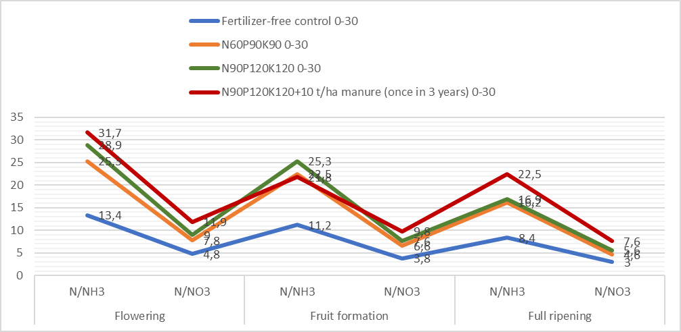

Figure 1. Effect of Mineral and Organic Fertilizers on Changes in Mineral Nitrogen Content at Different Stages of Plant Development, mg/kg (“Cardinal” Grape Variety)
In the N₆₀P₉₀K₉₀ and N₃₀P₆₀K₆₀ + 10 t/ha manure variants, the content of available phosphorus and exchangeable potassium during the flowering phase of the grape plants was approximately similar.

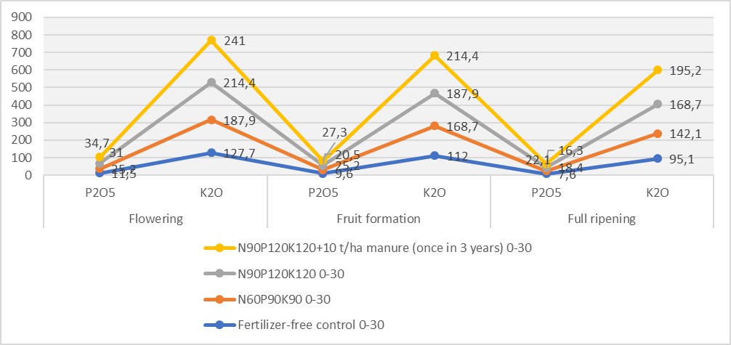

Figure 2. Effect of mineral and organic fertilizers on changes in available phosphorus and exchangeable potassium at different stages of plant development, mg/kg (“Cardinal” grape variety)
In the N₆₀P₉₀K₉₀ variant, available phosphorus was 25.2 mg/kg and exchangeable potassium 187.9 mg/kg, while in the manure variant N₃₀P₆₀K₆₀ + 10 t/ha, these values were 21.5 mg/kg and 191.5 mg/kg, respectively. In the variants where N₆₀P₉₀K₉₀ and N₆₀P₁₂₀K₁₂₀ mineral fertilizers were applied together with 10 t/ha of manure, the content of available phosphorus and exchangeable potassium increased compared to the other variants, reaching 25.2-31.0 mg/kg and 187.9-214.4 mg/kg, respectively. In the variant where N₉₀P₁₂₀K₁₂₀ was applied separately, and N₆₀P₉₀K₉₀ was applied together with 10 t/ha of manure, the differences in nutrient content were minimal.
Separate and combined application of mineral fertilizers with manure improved soil fertility at all stages of plant development. In periods of rising mineral fertilizer prices, to maintain stable soil fertility, it is advisable to apply N₆₀P₉₀K₉₀ + 10 t/ha of manure (once every three years) instead of annually applying mineral fertilizers at the higher rates of N₉₀P₁₂₀K₁₂₀.
Thus, the study of nutrient dynamics in the soil during the developmental stages of the “Cardinal” grape variety showed that both separate and combined applications of mineral and organic fertilizers increased nutrient content. The amounts of assimilable nutrients decreased over the stages of development and along the soil profile, being utilized for the restoration of grapevine organs and the production of high yields. The uptake of mineral nitrogen primarily continued until the fruit formation phase, while the majority of exchangeable potassium and available phosphorus was absorbed during the period between fruiting and full ripening.
F.H.Akhundov studied the balance of nitrogen, phosphorus, and potassium under grapevines in the Nagorno-Karabakh region of the Republic of Azerbaijan. The author showed that nutrients are most often accumulated in the grape yield, as well as in the roots of two-year-old and one-year-old shoots. As a perennial plant, grape cultivation leads to the depletion of nutrient content in the soil. A significant amount of nutrients is removed from the soil through leaves, shoots, and grape clusters. The high or low nutrient requirements of plants (N, P, K) also depend on the soil’s texture. The need for organic matter in soils should be determined by the amount of nitrogen contained in the organic fertilizer and the quantity of humus, which is the primary indicator of soil fertility. In the territory of the Republic of Azerbaijan, a decline in soil fertility has been observed due to both natural and anthropogenic impacts. Since nitrogen fertilizers do not fully meet the requirements of cultivated plants and nitrogen is in a negative balance, it is important to expand the sown areas of leguminous crops to ensure nitrogen input into the crop rotation. For the main and additional yields of agricultural crops grown in the country, the following amounts of nutrients are removed from the soil per 10 centners of harvest: for cereal crops (barley, wheat) - 30.3-30.7 kg of nitrogen, 10.6-11.0 kg of phosphorus, and 237-240 kg of potassium; for potato yield - 6.0 kg of nitrogen, 1.4 kg of phosphorus, and 7.9 kg of potassium; for raw cotton yield - 29.8 kg of nitrogen, 9.0 kg of phosphorus, and 24.0 kg of potassium (F.H.Akhundov 1989).
Vineyard soils are sensitive to soil changes due to the intensive chemical input. This study assesses the soil fertility changes in vineyard soils of the São Francisco valley in Northeastern Brazil during different cultivation time spans. The results showed that soil fertility changes were closely related to cultivation time spans (Welka Preston et.al 2017).
The influence of grapevine cultivation on the morphogenetic profile and fertility indicators of brown soils was studied in the Ganja-Gazakh region, on irrigated gray-brown (chestnut) soils of the Mountainous Shirvan zone, and in the Lankaran-Mughan area. In the morphogenetic profile of ancient irrigated gray-brown (chestnut) soils of the Ganja-Gazakh region, which have been under vineyards for a long time, the formation of a highly humified (3.6-4.0%) accumulative irrigation layer (45-50 cm) with a well-aggregated granular-cloddy structure was observed. It was established that these soils possess sufficient potential fertility and favorable agronomic properties.
Based on comparative-geographical studies conducted by various authors, it was found that in the profile of mountain-brown soils cultivated under vineyards, a thick (40-45 cm) horizon predominates, consisting of a loose (density 1.15-1.22 g/cm³), highly humified (4.1-5.6%) arable layer with optimal agronomic properties (25-30 cm) and a weakly compacted (1.30-1.38 g/cm³) subarable layer. Carbonates are leached into the lower horizons down to a depth of 60-70 cm; in particular, in the soil-forming sedimentary deposits, CaCO₃ content increases from 5-8% to 19-25%. These soils are also sufficiently supplied with available nutrients (N/NH₃ = 28-31; N/NO₃ = 9-11; P₂O₅ = 21-24; K₂O = 188-265 mg/kg) (Mammadov M.I. 2023).
The portion of the nutrient balance that is removed (through harvest collection and leaching measured by lysimeters), along with gaseous nitrogen losses, also includes nutrients accumulated in the dry and green pruning materials of grapevines. During the autumn-winter period, grape leaves fall, and during agronomic practices, the fallen leaves are mixed into the soil. However, pruning residues are collected from the vines and removed from the site. A certain portion of nutrients extracted from the soil accumulates in the leaves and fruits. Field and laboratory experiments were conducted to return the nutrients removed from the soil through pruning materials (F.H.Akhundov 1989).
In the plant, nitrogen, phosphorus, and potassium exist in a total form as compounds. For these nutrients to convert into assimilable forms, plant residues were collected and incorporated into the soil. As a result, the nutrients accumulated in the plant and present in total form gradually mineralize during decomposition.
To return nutrients to the soil that are taken up by plants and to restore soil fertility, the annual application of 10-12 t/ha of organic fertilizers-or 30-36 t every three years-prevents soil depletion, stabilizes the humus balance, supplies the soil with nutrients, improves its structure, and thus helps prevent disruption of the ecological balance in the soil (Zamanov P.V. 2013).
To restore soil fertility under grapevines using plant residues, studies were conducted on gray-brown (chestnut) soils of the Tovuz district in the Ganja-Gazakh region with the “Tebrizi” grape variety and continued in the experimental plots. Pruning residues and leaves were collected in 200 m² plots and weighed. The smallest amount of pruning material was 32.0 kg in the control variant and 43.0 kg in the variant with a high rate of mineral fertilizers (N₉₀P₁₂₀K₁₂₀), which corresponds to 2,150 kg per hectare. The total content of nitrogen, phosphorus, and potassium in the collected grapevine pruning material was analyzed across the variants (Tables 1 and 2).
With increasing rates of mineral fertilizers, the content of nitrogen, phosphorus, and potassium in pruning materials and leaves also increased. In the control variant, nitrogen content in the pruning material was 0.59%, phosphorus 0.32%, and potassium 0.33%, whereas in the variant with mineral fertilizers applied at N₉₀P₁₂₀K₁₂₀, nutrient content increased to 0.72%, 0.42%, and 0.57%, respectively. The moisture content of the pruning materials was 15%, based on which the dry mass of the plant materials was determined. The removal of nitrogen, phosphorus, and potassium through one-year pruning materials was studied across variants on a dry matter basis. The lowest nutrient removal was observed in the control variant without fertilizers: 8.02 kg/ha of nitrogen, 4.35 kg/ha of phosphorus, and 4.49 kg/ha of potassium. With the application of mineral fertilizers at the rate of N₉₀P₁₂₀K₁₂₀, the removal of nutrients amounted to 13.16, 7.67, and 10.41 kg/ha of nitrogen, phosphorus, and potassium, respectively.
The content and removal of nitrogen, phosphorus, and potassium were also studied in the fallen leaves of grapevines (Table 2). In the control variant, where no mineral fertilizers were applied, the amount of leaves collected from the plot was 18.0 kg, whereas with the N₉₀P₁₂₀K₁₂₀ fertilizer rate, 29.0 kg were obtained. When scaled to a per-hectare basis, the amount of fallen leaves was 900 and 1,450 kg/ha, respectively.

Table 1. Nitrogen, phosphorus, and potassium content in one-year grapevine pruning materials and their removal (based on dry matter)
Variants | Pruning material |  | Content, % |  |  | Removal, kg/hа
Variants | kg/plot | kg/hа | N | P₂O₅ | K₂О | N | P₂O₅ | K₂О
Control (no fertilizers) | 32 | 1600 | 0,59 | 0,32 | 0,33 | 8,02 | 4,35 | 4,49
N₃₀ P₆₀ K₆₀ | 38 | 1900 | 0,61 | 0,37 | 0,43 | 9,85 | 5,97 | 6,94
N₆₀ P₉₀ K₉₀ | 40 | 2000 | 0,65 | 0,39 | 0,53 | 11,05 | 6,63 | 9,01
N₉₀ P₁₂₀ K₁₂₀ | 43 | 2150 | 0,72 | 0,42 | 0,57 | 13,16 | 7,67 | 10,41

Table 2. Nitrogen, phosphorus, and potassium content in fallen grapevine leaves and their removal (based on dry matter)
Variants | Pruning material |  | Content, % |  |  | Removal, kg/hа
Variants | kg/plot | kg/hа | N | P₂O₅ | K₂О | N | P₂O₅ | K₂О
Control (no fertilizers) | 18 | 900 | 0,51 | 0,27 | 0,33 | 4,59 | 2,43 | 2,97
N₃₀ P₆₀ K₆₀ | 24 | 1200 | 0,54 | 0,30 | 0,43 | 6,48 | 3,60 | 5,16
N₆₀ P₉₀ K₉₀ | 26 | 1300 | 0,57 | 0,34 | 0,53 | 6,89 | 4,42 | 6,89
N₉₀ P₁₂₀ K₁₂₀ | 29 | 1450 | 0,60 | 0,38 | 0,62 | 8,70 | 5,51 | 8,99

In the control variant, the total nitrogen content in fallen leaves was 0.51%, phosphorus 0.27%, and potassium 0.33%, whereas in the N₉₀P₁₂₀K₁₂₀ variant, these values were 0.60%, 0.38%, and 0.62%, respectively. In the control variant, the removal of nutrients by fallen leaves was 4.59 kg/ha of nitrogen, 2.43 kg/ha of phosphorus, and 2.97 kg/ha of potassium, while in the variant with N₉₀P₁₂₀K₁₂₀ mineral fertilizer application, nutrient removal amounted to 8.70, 5.51, and 8.99 kg/ha, respectively (Table 2).

Table 3. Effect of mineral fertilizers on the mineralization of pruning material and fallen leaves

Variants | Term I |  |  |  | Term II |  |  |  | Term III
Variants | N/NH₃ | N/NO₃ | P₂O₅ | K₂O | N/NH₃ | N/NO₃ | P₂O₅ | K₂O | N/NH₃ | N/NO₃ | P₂O₅ | K₂O
Soil | 20,54 | 7,17 | 18,18 | 286,0 | 19,40 | 7,17 | 19,41 | 286,0 | 19,40 | 7,17 | 19,41 | 286,0
Soil+pruning material and fallen leaves (control) | 21,68 | 7,38 | 19,41 | 286,0 | 21.68 | 7,60 | 20,00 | 286,0 | 22,82 | 8,05 | 21,11 | 294,0
Soil +N₁₂₀P₂₀₀K₂₀₀ | 31,61 | 12,16 | 35,10 | 325,3 | 31,61 | 12,16 | 36,73 | 336,1 | 30,10 | 11,73 | 36,73 | 336,1
Control + N₁₂₀P₂₀₀K₂₀₀ | 31,95 | 12,16 | 36,73 | 336,1 | 33,09 | 13,05 | 38,15 | 344,6 | 34,12 | 14,21 | 40,54 | 350,0
Soil + N₉₀P₁₇₃K₂₁₀ | 29,67 | 9,34 | 33,15 | 336,1 | 29,67 | 9,34 | 35,10 | 344,6 | 28,52 | 9,12 | 35,10 | 344,6
Control + N₉₀P₁₇₃K₂₁₀ | 29,67 | 9,34 | 34,50 | 344,6 | 30,10 | 9,99 | 36,73 | 350,0 | 31,95 | 11,73 | 36,73 | 359,0

In addition to traditional organic fertilizers used to replenish nutrients regularly removed from the soil by agricultural crops, the use of new organic fertilizers-namely composts produced through bioconversion of locally sourced organic waste - is very important.
Soil microorganisms also play a major role along with the effect of fertilizers on the mineralization of pruning materials and fallen leaves. Considering that the soil type is grey-brown, with a pH ranging from 7.4 to 8.4 in the Ganja-Gazakh massif. Bacteria are richer in species and number among soil microorganisms in such a weakly alkaline environment. Usually, soil microbiota is the main factor that evaluates the soil and affects the humification process. The activity of microorganisms varies depending on hydrothermal indicators and the amount of humus.
Being a perennial crop, the vines are fertilized with organic fertilizers to ensure a supply of organic carbon, improved soil organic matter content, and enhanced soil microorganisms. Globally, fertilizers with different NPK ratios and micronutrients are used to achieve a better yield and desirable quality of grapes (Armachius James et al. 2022.)
Periodically, these changes depend on the seasons of the year (reaching a maximum level in spring and autumn), soil temperature, the amount of humus in the soil, the degree of tillage of the soil, and fertilizers applied to the soil (Rzayeva A.L 2022 ). The amount of microorganisms is unevenly distributed across the layers.
According to research, it has been found that the main area has 1601 thousand/g of soil, and the cultivated area has 2901 thousand/g of soil.
Total number of bacteria, with spores and without spores
In untilled soils – 826 thousand/g of soil (51.5%)
In cultivated soils – 1724 thousand/g of soil (89.3%)
Actinomycetes:
In untilled soils – 744 thousand/g of soil (46.7%)
In cultivated soils – 1154 thousand/g of soil (53.3%)
Microscopic fungi:
In untilled soils – 31 thousand/g of soil (1.9%)
In cultivated soils – 23 thousand/g of soil (0.3%)
Dominant bacterial species- Bac idosus, Bac megaterium, Bac mesen, soil fungi include Penicillium and Trichoderma.
As a result, intracellular and extracellular enzymes synthesized by bacteria and fungi present in the soil stimulate the fermentation process. Finally, oxidation-reduction reactions occur in organic matter, mineral transformations, and the phosphorus and nitrogen cycle occurs.
Based on the bioconversion method (Zamanov P.V. 2013), laboratory and field experiments were conducted using grapevine pruning materials and fallen leaves. The laboratory experiments were set up according to the following scheme:
1. Soil (Control - no fertilizers)
2. Soil + pruning material and fallen leaves (control)
3. Soil + N₁₂₀ P₂₀₀ K₂₀₀
4. Control + N₁₂₀ P₂₀₀ K₂₀₀
5. Soil + N₉₀ P₁₇₃ K₂₁₀
6. Control + N₉₀ P₁₇₃ K₂₁₀
In the laboratory experiments, soil taken from the field research plots was used, and its agrochemical properties were studied. The amounts of nutrients in the soil were as follows: absorbed ammonium - 20.54 mg/kg, nitrate nitrogen - 7.17 mg/kg, available phosphorus - 18.18 mg/kg, and exchangeable potassium - 286.0 mg/kg.
After collecting the pruning materials and fallen leaves, they were ground in a mill, mixed with the soil, and the dynamics of nutrient changes were studied over three periods spanning 18 months. In the soil-only variant, nutrient content did not change significantly over 18 months. In the experimental variant, where fallen leaves and grapevine pruning materials were mixed with the soil, over eighteen months the content of absorbed ammonium increased from 21.68 mg/kg to 22.82 mg/kg; nitrate nitrogen from 7.38 to 8.05 mg/kg; available phosphorus from 19.41 to 21.11 mg/kg; and exchangeable potassium from 286.0 to 294 mg/kg (Table 3, Figure 3).
The amounts of assimilable nutrients in the soil + N₁₂₀P₂₀₀K₂₀₀ variant did not change significantly over time. Absorbed ammonium decreased from 31.91 mg/kg to 30.10 mg/kg, and nitrate nitrogen decreased from 12.16 mg/kg to 11.73 mg/kg. The content of available phosphorus and exchangeable potassium also remained nearly unchanged, at 35.10 mg/kg and 325.3 mg/kg, respectively.
In the experimental variant (Control + N₁₂₀P₂₀₀K₂₀₀), over eighteen months, the soil content of absorbed ammonium increased from 31.95 to 34.12 mg/kg; nitrate nitrogen from 12.16 to 14.2 mg/kg; available phosphorus from 36.73 to 40.54 mg/kg; and exchangeable potassium from 336.1 to 350.0 mg/kg. Compared with the soil + N₁₂₀P₂₀₀K₂₀₀ variant, it was found that the addition of pruning materials and leaves increased the amount of assimilable nutrients, with differences of 4.02 mg/kg for absorbed ammonium, 2.48 mg/kg for nitrate nitrogen, 3.81 mg/kg for available phosphorus, and 13.9 mg/kg for exchangeable potassium (Table 3, Figure 3, 4).

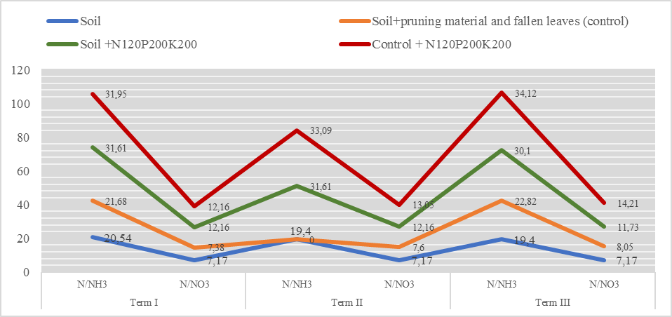

Figure 3. Mineralization of pruning materials and fallen leaves in soil (N/NH₃, N/NO₃)

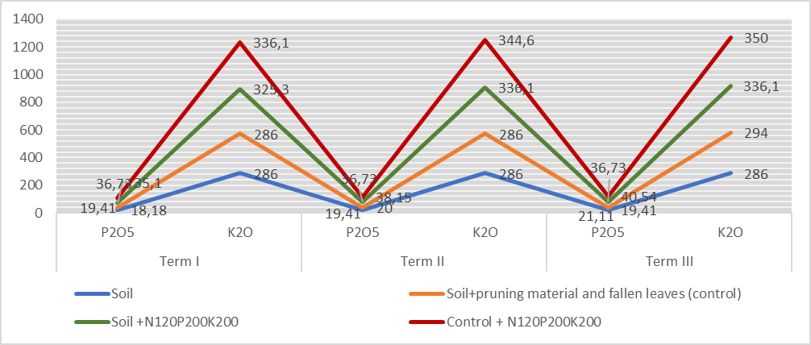
Figure 4. Mineralization of pruning materials and fallen leaves in soil (P₂O₅, K₂O)

As a result of long-term experiments on calcareous soils in Azerbaijan, 15-20% of nitrogen applied as fertilizer to crops volatilizes into the atmosphere and is lost, while about 15% of nitrogen is conditionally returned to the soil through precipitation. Nutrient removal from the soil by different crops is divided into three parts: irreversible losses; nutrients that are returned to the soil; and nutrients that remain in the soil. Irreversible losses occur in wheat and maize grains and in tobacco leaves. About 50% of nutrients are returned to the soil with straw from cereals, maize, and alfalfa seeds. These are used by animals as feed, and animal manure serves as an organic fertilizer. This process is described as the nutrient cycle in agriculture.
On the other hand, nutrients that do not leave the soil remain in the root system and in aboveground biomass that the harvester cannot collect during harvest. Potassium deficiency in Azerbaijani soils primarily arises from insufficient potassium fertilizer application. Part of the released potassium is replenished through fertilizer application, and some is returned to the soil with manure. Despite these measures, potassium remains deficient under all agricultural crops in the country (F.H.Akhundov 1989).
In atmospheric precipitation, the amount of nitrogen entering gray-brown soils annually was 5.85-7.38 kg/ha, the majority of which was ammonium nitrogen. Nitrate nitrogen accounted for 1.39-1.64 kg/ha, phosphorus 0.99-1.41 kg/ha, and potassium 2.95-3.02 kg/ha. Changes (increase or decrease) in nutrient amounts from year to year depend on the amount of precipitation (Table 4).

Table 4. Amount of nitrogen, phosphorus, and potassium entering the soil with atmospheric precipitation, kg/ha (Shamkir district conditions)
Months | 2022 |  |  |  |  |  | 2024
Months | Precipitation amount (mm) | N |  |  | P₂O₅ | K₂O | Amount of precipitation (mm) | N |  |  | P₂O₅ | K₂O
Months | Precipitation amount (mm) | N/NH₃ | N/NO₃ | N/NH₃+  +N/NO₃ | P₂O₅ | K₂O | Amount of precipitation (mm) | N/NH₃ | N/NO₃ | N/NH₃+  +N/NO₃ | P₂O₅ | K₂O
I-II | 23,5 | 0,47 | 0,15 | 0,62 | 0,16 | 0,34 | 23,0 | 0,52 | 0,14 | 0,66 | 0,16 | 0,38
III-IV | 60,1 | 1,25 | 0,35 | 1,60 | 0,40 | 0,72 | 53,0 | 1,17 | 0,31 | 1,48 | 0,38 | 1,02
V-VI | 37,5 | 0,74 | 0,24 | 0,98 | 0,23 | 0,56 | 35.3 | 0,82 | 0,19 | 1,01 | 0,24 | 0,63
VII-VIII | 32,1 | 0,65 | 0,21 | 0,86 | 0,21 | 0,52 | 6.5 | 0,15 | 0,04 | 0,19 | 0,04 | 0,13
IX-X | 47,4 | 0,86 | 0,29 | 1,15 | 0,28 | 0,49 | 35.5 | 0,79 | 0,22 | 1,01 | 0,23 | 0,59
XI-XII | 22,7 | 0,49 | 0,15 | 0,64 | 0,13 | 0,32 | 17.9 | 0,39 | 0,09 | 0,48 | 0,11 | 0,27
Total: | 223,3 | 4,46 | 1,39 | 5,85 | 1,41 | 2,95 | 171,2 | 3,84 | 0,99 | 4,83 | 0,16 | 3,02

Table 5. Amount of nitrogen, phosphorus, and potassium entering the soil with irrigation water (2023)
Historical rate | Irrigation rate, m³/ha | N |  | P₂O₅ | K₂O | N |  |  | P₂O₅ | K₂O
Historical rate | Irrigation rate, m³/ha | N/NH₃ | N/NO₃ | P₂O₅ | K₂O | N/NH₃ | N/NO₃ | N/NH₃+N/NO₃ | P₂O₅ | K₂O
Historical rate | Irrigation rate, m³/ha | mg/kg |  |  |  | kg/ha
28.I.2024 | 1000 | 0,27 | 0,22 | 0,22 | 4,21 | 0,270 | 0,220 | 0,490 | 0,220 | 3,072
15.IV.2024 | 1200 | 0,38 | 0,29 | 0,26 | 6,62 | 0,456 | 0,348 | 0,804 | 0,312 | 5,052
07.VI.2024 | 1200 | 0,36 | 0,28 | 0,25 | 6,02 | 0,432 | 0,336 | 0,768 | 0,300 | 4,338
11.VII.2024 | 1100 | 0,33 | 0,26 | 0,24 | 5,42 | 0,330 | 0,286 | 0,616 | 0,264 | 3,976
08.VIII.2024 | 1000 | 0,30 | 0,24 | 0,23 | 4,82 | 0,300 | 0,240 | 0,540 | 0,230 | 3,072
Total: | 5500 |  |  |  |  | 1,788 | 1,430 | 3,218 | 1,326 | 19,51

Conclusions
Based on the conducted comparative-geographical studies, it has been established that gray-brown and mountain-brown soils cultivated under vineyards possess sufficient potential fertility and favorable agronomic properties. Soil characteristics include clay content of 1.15-1.22 g/cm³, humus 3.6–5.6%, CaCO₃ ranging from 5.0-8.0% up to 19-25%, N/NH₄ 28.0-31.0 mg/kg, N/NO₃ 21.0-24.0 mg/kg, and K₂O 188.0-265.0 mg/kg.
Soil fertility increased with the application of mineral fertilizers, as well as equivalent amounts of combined mineral and organic fertilizers for grape varieties. Field and laboratory studies using pruning materials and fallen leaves showed that mineralization returns a sufficient amount of nutrients to the soil.
Atmospheric precipitation and irrigation water also have a significant effect on soil fertility. Accordingly, the contribution of nutrients was as follows: N/NH₄ + N/NO₃ - 0.66 kg/ha, P₂O₅ - 0.16 kg/ha, K₂O - 0.38 kg/ha, totaling 3.21 kg/ha. Yield reached 1.32-19.51 c/ha.

References
Akhundov F.G. Agrochemistry of Concentrated and Complex Fertilizers. Baku, Elm, 1989, 189 p.
Armachius James, Athuman Mahinda, Andekelile Mwamahonje, Elvillah William Rweye-mamu, Emmanuel Mrema, Kobusinge Aloys, Elirehema Swai, Felista Joseph Mpore & Cornel Massawe. A review on the influence of fertilizers application on grape yield and quality in the tropics. Journal of Plant Nutrition, DOI: 10.1080/01904167.2022.2160761.
Arinushkina E.V. Manual on Chemical Analysis of Soils. Moscow, Moscow State University Press, 1970, 487 p.
Dospekhov B.A. Field Experiment Methodology. Moscow, Agropromizdat, 1985, 351 p.
Ferreira Carla SS, Veiga Adélcia, Caetano Ana, Gonzalez-Pelayo Oscar, Karine-Boulet Anne, Abrantes Nelson, Keizer Jacob & Ferreira António JD. Assessment of the Impact of Distinct Vineyard Management Practices on Soil Physico-Chemical Properties. Air, Soil and Water Research Volume 13: 1–13. The Author(s) 2020. https://doi.org/10.1177/1178622120944847
Hajimammadov I.M., Talai J.M., Kosayev E.M. “Methods of agrochemical analysis of soil, plants and fertilizers”. Baku: "Teacher" publishing house, 2016, 132 pages.
Kulzhanov Shokan N., Kazybayeva Saule Z., Tazhibaev Tolepbergen S., Azhitaeva Laura A., Yessenaliyeva Maira. Effect of climatic conditions on the productive and biochemical characteristics of grape varieties grown on sierozem soil. Eurasian Journal of Soil Science. Volume 11, Issue 2, Mar 2022, Pages 174-183. DOI: 10.18393/ejss.1057156
Mammadov M.I. Accumulation of Nutrient Elements in the Vegetative Organs of Grape-vines Depending on the Nutritional Regime of Gray-Brown (Chestnut) Soils of Azerbaijan. “Nauka”, No. 4, 2014, pp. 74-79.
Mammadov M.I. The Effect of Combined Application of Mineral Fertilizers with Bentonite to Prevent Nutrient Losses and Convert Them into Available Forms. No. 1, 2021, pp. 54-58.
Mammadov M.I. Morphogenetic Diagnosis of Soils in the Dry Subtropical Zones of Azerbaijan and the Effect of Grapevines on Changes in Fertility Parameters. Ecology and Construction, No. 3, 2023, pp. 4-12.
Mammadov M.I. Effect of the fertilizing system on the yield and quality of grapes. Russ. Agricult. Sci. 41, 434–436 (2015). https://doi.org/10.3103/S1068367415060142
Mamedov, M.I. Effect of the fertilizing system on the yield and quality of grapes. Russ. Agricult. Sci. 41, 434–436 (2015). https://doi.org/10.3103/S1068367415060142
Movsumov Z.R. Scientific Foundations of Plant Nutrient Efficiency and Their Balance in Crop Rotation Systems. Baku, Elm, 2006, 245 p.
Shafran S.A. Forecast of Phosphorus and Potassium Content in Soils of the Central Region of the Non-Chernozem Zone. Journal of Agrokhimiya, Moscow, No. 9, 2006, pp. 5-12.
Welka Preston, Clístenes Williams Araújo do Nascimento, Yuri Jacques Agra Bezerra da Silva, Davi José Silva, Hailson Alves Ferreira. Soil fertility changes in vineyards of a semiarid region in Brazil. J. Soil Sci. Plant Nutr. vol. 17 no. 3 Temuco set. 2017. http://dx.doi.org/10.4067/S0718-95162017000300010
Yuxia Wu, Zhengcheng Luo, Liang Qi, Rui Zhang, and Yanxiu Wang. A Study of the Relationship between Initial Grape Yield and Soil Properties Based on Organic Fertilization. Agronomy 2024, 14, 861. https://doi.org/10.3390/agronomy14040861
Zaman Mamadov, Maya Abdullayeva and Araz Gasimov. Spreading soils of different landscape type and their ecological situation (on of Lesser Caucasus). BIO Web Conf. Volume 118, 2024/III International Scientific and Practical Conference “Concept of Sustainable Development: Agriculture and Environment” (TAEE-III-2024). https://doi.org/10.1051/bioconf/202411802001
Zamanov P.V., Pashaev R.A., Aliyeva A.R. Local Reserve Resources for Restoring Fertility of Depleted Farm and Municipal Lands in Modern Agroecosystems and Their Preparation, Use, and Effectiveness as Organic Fertilizers. In: Proceedings on Soil Science and Agrochemistry, Vol. XVII, Baku, Nauka, 2007, pp. 264-267.
Zamanov P.V. Soil and Plant Requirements for Major Nutrient Elements. In: Proceedings on Soil Science and Agrochemistry, Vol. XIX, Baku, Nauka, 2011, pp. 367-371.
Zamanov P.V. Agrochemical Foundations of the Effects of Nutrient Elements and Fertilizers on Soil Properties and Crop Yield. Monograph, Baku, 2013, 268 p.

