Production technology and microbiological quality of kilichi produced in five locations in Burkina Faso
Cissé Hama ¹*, Zongo Oumarou^{1,2}, Djibrine Adoum Oumar³, Ouédraogo Issouf¹, Sawadogo Adama¹, Savadogo Aly¹

¹Department de Biochimie-Microbiologie, UFR/SVT, Université Joseph KI-ZERBO, 03BP7021 Ouagadougou 03, Burkina Faso
²Unité de Formation et de Recherche en Sciences et Techniques (UFR/ST), Université Thomas SANKARA, 12 BP 417 Ouagadougou 12, Burkina Faso
³Laboratoire de Recherche sur les Substances Naturelles, Faculté des Sciences Exactes et Appliquées (FSEA), Université de N’Djamena, BP 1117, Chad

*Corresponding author, Cissé Hama, Email address: cissehama70@gmail.com

Abstract
Kilichi, a dried meat product originating in Niger, is increasingly consumed in Burkina Faso. However, the hygienic quality of this product raises many questions among consumers. The objective of this study was to determine the production technology and hygienic quality of kilichi produced in five locations in Burkina Faso. Information on production technology was collected using a questionnaire. Hygienic quality was assessed by testing for indicator bacteria of contamination. Total mesophilic aerobic flora, total coliforms, thermotolerant coliforms, yeasts and molds, spore-forming flora, staphylococci, salmonella, and shigella were tested using standard microbiological analysis methods. A total of 13 kilichi producers were interviewed. Thirty-two kilichi samples were collected for microbiological analysis. The survey revealed three types of kilichi produced. All producers are male. The production process involves five main stages, from cutting to smoking the meat. Total mesophilic aerobic flora, total coliforms, staphylococci, spore-forming flora, and yeasts and molds ranged from 3x102 CFU/g to 105 CFU/g, 0 to 3.70x103 CFU/g, 0 to 6.20x103 CFU/g, 0 to 1.67x105 CFU/g, and 0 to 4x102 CFU/g, respectively. Compliance with and application of good hygiene practices during the production and sale of this popular food would improve the sanitary quality of kilichi and prevent health risks to consumers.
Keywords: Meat, Production technology, Kilichi, Microbiological quality, Burkina Faso.
- Introduction
Meat is a source of animal protein thanks to its high content of essential amino acids (leucine, isoleucine, valine, etc.), iron, zinc, and vitamins (A, B12, B6, D, and E) (Kimassoum et al., 2017; Hissein et al., 2023). Consumed in sauces, grilled or fried, meat contributes to nutritional balance. Its sale helps to combat poverty in developing countries. Halagarda and Wojciak (2021) reported that meat consumption has been steadily increasing since 1960. This consumption represents more than 58% of the global protein intake. In most developing countries, meat is considered a food of choice by households. However, this food of choice can often be unfit for human consumption. This is due to a failure to comply with hygiene rules at various stages, from evisceration to cutting. Similarly, poor storage conditions can lead to a deterioration in its organoleptic and nutritional quality. However, meat can be a source of transmission of animal zoonoses to humans. This transmission is a major and recurring public health problem in sub-Saharan Africa (Kimassoum et al., 2017). To mitigate the problems of meat loss, people use several techniques such as fermentation, drying, and smoking. The latter two techniques are ways of transforming fresh meat into long-life meat products. In rural areas, they are an alternative means of preserving meat. In these areas, the most common meat product is kilichi. It is a ready-to-eat product, traditionally made with fresh beef, camel, sheep, or even goat meat (Boubacar Seydou et al., 2019). It is used by local populations as a flavor enhancer in sauces and in other dishes. It is often eaten with bread and used in ceremonies (baptisms, weddings, etc.) as an appetizer. It can also be eaten on its own as a food during travel (Idowu et al., 2010). Nowadays, kilichi production has intensified in various areas of West Africa, such as Burkina Faso, Mali, and Niger. This activity is an important source of income for producers. In Burkina Faso, kilichi production is still in its infancy. It is produced using traditional methods. Numerous studies have been conducted on kilichi and the potentially pathogenic microorganisms that may be found in it (Mbawala et al., 2010; FAO, 2014; Seini et al., 2018). However, little data exists on the production technology and microbiological characteristics of kilichi in Burkina Faso. Hence the interest of this study, whose overall objective was to assess the sanitary quality of kilichi produced in five production areas in Burkina Faso.
2. Materials and methods

2.1. Study site

The study was conducted in five areas spread across three provinces of Burkina Faso : Kadiogo (Ouagadougou), Yatenga (Ouahigouya), and Kouritenga (Sapaga, Koupéla, and Pouytenga) (Figure 1).

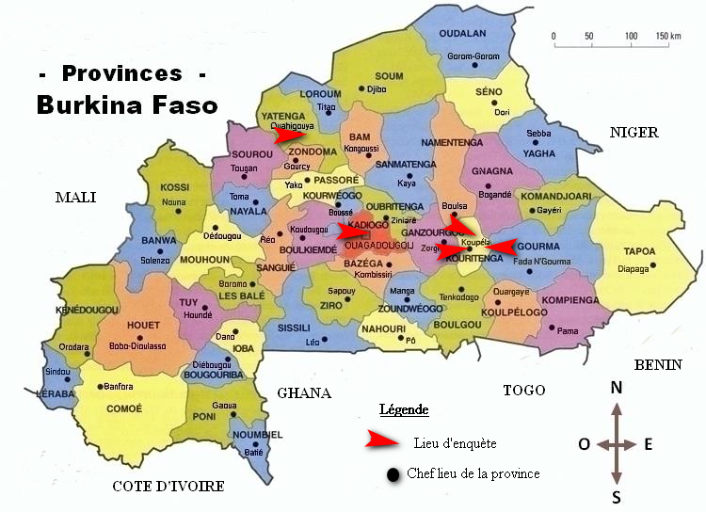
Figure 1. Study site
2.2. Sampling
Samples were taken at random from kilichi production and sales sites. For each sample, we took two 40- or 50-gram bags of the same type of kilichi from the same production site. Sampling was carried out at production and sales sites in Ouagadougou, Ouahigouya, Sapaga, Koupéla, and Ouahigouya. A total of 32 kilichi samples were collected under normal production and sales conditions. All samples collected were packaged in sterile stomacher bags, labeled, placed in coolers containing melting ice, and transported to the Laboratory for microbiological analysis.

2.3. Collection of data on kilichi production
An investigation was carried out at the kilichi production sites. This investigation was conducted unannounced and consisted of two parts: the first was an oral interview with thirteen kilichi producers based on a questionnaire contained in a survey form. The questions on the survey form focused first on the identity of the producer, then on the technology used to produce kilichi, and finally on compliance with good hygiene practices.
The second part consisted of direct observation of the entire production process: the meat used, the production site, the equipment used, the production methods, the staff, and the products obtained. All the information was recorded in a notebook for future use.
2.4. Determination of kilichi production technology
The process of implementing production technology was carried out thanks to the collaboration of kilichi producers in Ouahigouya, Ouagadougou, and Koupéla. To do this, during our investigations, we made appointments with producers to fully monitor the production technology from fresh meat to the finished product. As we were unable to verify this with all producers, we selected one producer in Ouahigouya and another in Koupéla. At these two producers' facilities, we monitored unit operations, took photos, and asked questions to ensure our understanding. It should be noted that we also asked questions about kilichi unit operations at all other producers surveyed.

2.5. Assessment of the sanitary quality of kilichi
The analyses focused on counting various microbial flora in kilichi in order to assess the hygienic quality of the product. The flora investigated were: total mesophilic aerobic flora, total coliforms, thermotolerant coliforms, yeasts and molds, staphylococci, spore-forming flora, Salmonella, and Shiguella (Table 1).
Table 1. Microorganisms researched or counted and methodologies used
Targeted germs | References | Culture media used | Incubation
Total mesophilic aerobic flora | ISO 4833-1 (2014) | Plate Count Agar | 37°C during 24H
Total coliforms | ISO 21528-2. (2017) | Violet-Red Bile Lactose Agar | 37°C during 48H
Thermotolerant coliforms | ISO 21528-2. (2017) | Violet-Red Bile Lactose Agar | 44°C during 48H
Staphylococci | ISO 6888-1. (2021). | Chapman Stone Agar | 37°C during 24H
Spore-forming flora | ISO 4833-1 (2014) | Plate Count Agar | 37°C during 24H
Yeasts and molds | ISO 21527-2. (2008) | Sabouraud chloramphenicol | 30°C during 72H
Salmonella and Shigella | ISO 6579-1 (2017) | Salmonella-Shigella Agar | 37°C during 24H

The results of microbiological analyses were interpreted using a three-class or two-class plan. For salmonella and shigella, the two-class plan was used, which involved searching for these microorganisms in 25 g of kilichi. If present, sample would be deemed unsatisfactory, and if absent, it would be deemed satisfactory. For mesophilic aerobic flora, total and thermotolerant coliforms, yeasts, molds, and staphylococci, the three-class plan was used according to criteria m (Table 2).
Table 2. Microbiological criteria used for interpreting results
Microorganisms | Norms (m) | References
Total mesophilic aerobic flora | 3.10⁵ UFC/g | Luxembourg Ministry of Health (2015)
Total coliforms | 10³ UFC/g | Luxembourg Ministry of Health (2015)
Thermotolerant coliforms | 10² UFC/g | Luxembourg Ministry of Health (2015)
Staphylococcus aureus | 10² UFC/g | Luxembourg Ministry of Health (2015)
Salmonella-Shiguella | Absence/25g | Luxembourg Ministry of Health (2015)
Yeasts and molds | 10⁴ UFC/g | Luxembourg Ministry of Health (2015)

2.6. Statistical data processing and analysis
Excel 2013 was used for data entry and to create tables and graphs of microbiological data, and XL Stat 2016 software was used for statistical analyses at a significance level of 0.05%.
- Results and discussion
  - Sociodemographic characteristics of kilichi producers
Table 3 presents the sociodemographic characteristics of the respondents. The field survey conducted among kilichi producers gathered as much information as possible about the producers themselves and the technology used to produce kilichi. The survey revealed that the largest kilichi production area in Burkina Faso is Koupéla, which accounts for nearly 46% of the country's producers (Table 3). This could be explained by the fact that kilichi originated in Niger and the largest commercial area in Burkina Faso that is close to this country is Koupéla. Kilichi and its production technology were likely to have been quickly passed on to the inhabitants of this area by Nigeriens and traffickers.
This study also revealed that kilichi producers are men (Table 3). This could indicate the cultural aspect of kilichi production, which does not encourage women to take an interest in it. Indeed, it is rare to see women working with raw meat in Burkina Faso. These results differ from those of Bambara (2008), who reported that women were more involved in kilichi production than men. Since 2008, these women have reportedly withdrawn from kilichi production to devote themselves to other activities considered more feminine. This could explain their absence from the production of this commodity in 2020.
The survey also shows that 36% of kilichi producers in the area visited are Nigeriens (Table 3). They reportedly brought the production technology with them and decided to engage in this activity to support their families in Burkina Faso and also in their country of origin. In addition, 92% of kilichi producers are married and therefore have family responsibilities. If we add to this the kilichi sellers and resellers throughout Burkina Faso, we can say that kilichi production is an activity that deserves close monitoring by the authorities, as it contributes to the well-being of a large part of the Burkinabe population.
This study also showed that 85% of the kilichi producers interviewed had no formal education (Table 3). This could mean that the kilichi sector has been taken over by people who did not have the opportunity to receive a good education. The low level of education among producers could result in poor product hygiene and even difficulty in understanding new production technologies. This result is similar to that reported by Hissein et al. (2023) in Chad, which states that 87% of charmout producers in Chad have no formal education.
This survey found that more than 77% of kilichi producers have more than 10 years of experience (Table 3). This could mean that knowledge about kilichi production is passed down from father to son. This has an advantage in terms of kilichi quality, as the saying goes: experience is better than science. However, training should not be overlooked, as mistakes can also be passed down over many years.
The survey revealed that more than 77% of producers purchase their meat from slaughterhouses (Table 3). This could be due to the quality and quantity of meat sought from the animals. In fact, producers only use the two legs and two shoulders of the animal. Therefore, most producers believe that purchasing an entire animal for only these parts would be wasteful. The 23% of producers who buy animals for slaughter are butchers or work in collaboration with butchers to facilitate the sale of the rest of the production. This result corroborates that reported by Seini et al. (2018) in Niger, who state that the meat used for kilichi production is mainly purchased at the slaughterhouse.
This survey also shows that more than 92% of kilichi producers prefer beef (Table 3). This is because beef is easier to cut into strips and is less fatty. It therefore facilitates the production of kilichi, as cutting the meat into strips is the most labor-intensive part of the process. In addition, beef is cheaper than other meats used in production. This is why other researchers such as Seini et al. (2018) define kilichi as dried and spiced beef.
The surveys conducted as part of this study showed that more than 40% of the samples were either too tough to chew or too fatty (Table 3). Kilichi is a product that must undergo certain processing steps, including the removal of fat and tough parts during trimming. These parts were found in the products inspected. We also noticed that most of the fatty or tough samples were in the batch of coated kilichi. The presence of fat and tough parts in kilichi shows that certain steps (consisting of removing these parts) during processing have been neglected. These types of kilichi are common among processors who have less experience in the field. Some of these producers may think that removing these parts is a waste of meat, and therefore a reduction in their income. These producers may have taken advantage of the coating to hide non-compliant strips.
Good food hygiene practices are a set of conditions and rules that enable food safety to be monitored and ensured from its origin to its arrival on our plates. The survey shows that more than 54% of kilichi producers have never received training in good hygiene practices (Table 3). Most of those who have received training say they received it in Niger or in other contexts. This could indicate a lack of support for the kilichi production sector by the authorities, as training in good hygiene practices should be among the first things to learn before starting to produce a food as sensitive as kilichi. This result could have a negative effect on the quality of kilichi produced in the country. This result corroborates that reported by Halagarda and Wojciak (2021), who stated that more than 30% of traditional meat product producers in Serbia have received no education or training in food safety and hygiene.

Table 3. Sociodemographic characteristics of respondents
Variable | Characteristics | Number | Percentage
Sex | Male | 13 | 100%
Sex | Female | 0 | 0%
Nationality | Burkinabè | 8 | 61.54%
Nationality | Nigerian | 5 | 38.46%
Localities | Koupéla | 6 | 46.15%
Localities | Ouagadougou | 1 | 07.69%
Localities | Ouahigouya | 2 | 15.38%
Localities | Pouytenga | 3 | 23.07%
Localities | Sapaga | 1 | 07.69%
Marital status | Married | 12 | 92.13%
Marital status | Singles | 1 | 07.69%
Level of education | Not enrolled in school | 11 | 84.61%
Level of education | Primary | 2 | 15.38%
Level of education | Secondary | 0 | 0%
Level of education | Superior | 0 | 0%
Years of experience | Less than 10 years | 3 | 23.07
Years of experience | More than 10 years | 10 | 76.92%
Training in good hygiene practices | Yes | 6 | 46.15%
Training in good hygiene practices | No | 7 | 53.85%
Meat origin | Purchase (slaughterhouse) | 10 | 76.92%
Meat origin | Slaughter (slaughterhouse) | 3 | 23.07%
Favorite type of animal | Beef | 12 | 92.30%
Favorite type of animal | Sheep or goat | 1 | 07.69%
Technological quality of the samples analyzed | Hard or too greasy | 13/32 | 40.63%
Technological quality of the samples analyzed | Good | 19/32 | 59.36%

  - Diversity and production technology of kilichi
    - Diversity of kilichi
Three types of kilichi are produced according to the techniques used by producers in the areas surveyed. These are : regular kilichi, peanut paste kilichi, and ginger kilichi. Peanut paste kilichi (Figure 2) is produced using a peanut paste sauce in which it is immersed for a period of time before being removed and dried. There are two types of peanut paste kilichi: the first type, which is generally the most widely produced, has a reddish color. It is produced by adding a coloring agent (Bixa orellana) to the peanut paste (Figure 2a). The second type has a yellowish color (Figure 2b). It is produced without coloring agents. Peanut paste kilichi may or may not be spicy.
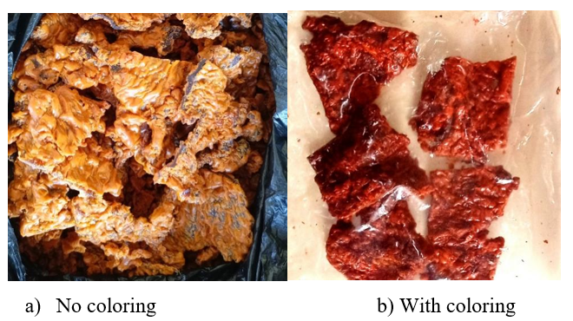
Figure 2. Peanut paste kilichis

Ginger kilichi is produced, as its name suggests, with a ginger-based sauce. It has a yellowish color and is always spicy (Figure 3a). Regular kilichi is produced without sauce. The dried meat is simply coated with a thin layer of oil. The product therefore retains its brown color. It may or may not be spicy (Figure 3b).
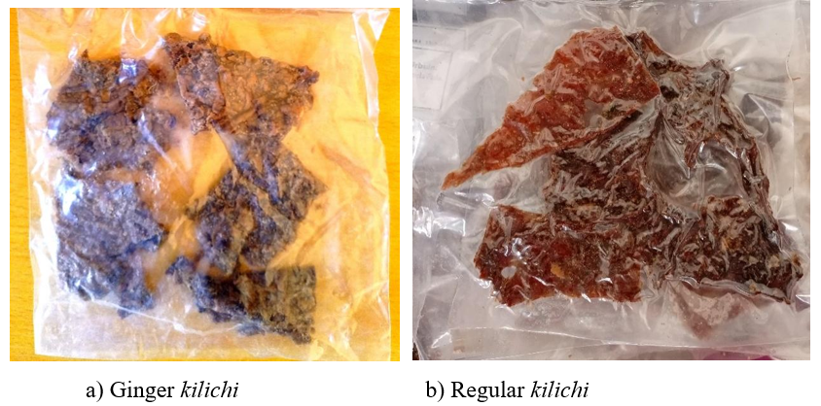
Figure 3. Ginger and regular kilichi
This result differs from that reported by Bambara (2008) in Burkina Faso and that reported by Yacouba (2009) in Niger, who only counted plain kilichi and kilichi with peanut paste. Ginger kilichi was not detected in these studies because this product or its technology is unknown or less developed.
    - Kilichi production technology
The processes developed for the production of the three types of kilichi have similarities and differences depending on the producer. Figure 4 shows the kilichi production diagram established after interviews with producers.
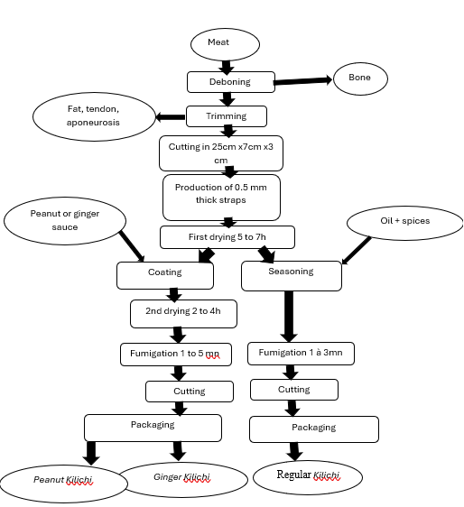
Figure 4. Technological diagram of Kilichi production

This diagram differs from that reported by Bambara (2008) in Burkina Faso, who stated that there is a washing stage after cutting into strips. This difference could be due to a modification of the production diagram by these producers. Indeed, these producers would see that washing the meat is in a way moistening it, and wetting food that one wants to dry would seem pointless. This diagram also differs from the one reported by Yacouba (2009) in Niger, who noted that there are two types of kilichi: “Maiyagi” kilichi (kilichi coated with peanut paste) and “Dan kalambé” kilichi (plain kilichi). The diagram for ginger kilichi was not presented. This type of kilichi was unknown in Niger at the time of the study.
  - Sanitary quality of the kilichi produced
Tables 4, 5, and 6 shows the microorganism load in CFU/g of the kilichi samples collected .
Table 4. Microorganism load in peanut-coated kilichi samples
Samples | TMAF | TC | TTC | S. aureus | SF | YM | SS
2YA | 1x10³ | <10 | <10 | <10 | <10 | <10 | Absence
3KA | 1x10³ | <10 | <10 | <10 | <10 | <10 | Absence
4KA | 3x10² | <10 | <10 | <10 | <10 | <10 | Absence
6SA | 1.9x10³ | <10 | <10 | <10 | <10 | <10 | Absence
7KA | 1.3x 10⁴ | <10 | <10 | <10 | <10 | <10 | Absence
8KA | 2.8x10⁴ | <10 | <10 | <10 | <10 | 10² | Absence
9KA | 5x10⁴ | <10 | <10 | <10 | <10 | <10 | Absence
10KA | 5x10² | <10 | <10 | <10 | <10 | <10 | Absence
11KA | 1.5x10⁴ | <10 | <10 | <10 | <10 | <10 | Absence
12KA | 2.9x10⁴ | <10 | <10 | <10 | <10 | <10 | Absence
14OA | 3x10³ | <10 | <10 | 1,5x10³ | <10 | 10² | Absence
15KA | 1x10⁴ | <10 | <10 | <10 | 2x10² | 10² | Absence
17KA | 6.73x10⁴ | <10 | <10 | <10 | 3.9x10⁴ | 2x10² | Absence
18KA | 4.2x10⁴ | <10 | <10 | <10 | <10 | 2x10² | Absence
33KA | 1x10³ | <10 | <10 | 6x10² | <10 | <10 | Absence
Average | 1.75x10⁴ | - | - | - | - | - | Absence
Legend : TMAF: Total Mesophilic Aerobic Flora; TC: Total Coliforms; TTC: Thermotolerant coliforms; S. aureus : Staphylococcus aureus; SF: Sporulating Flora; YM: Yeasts and Molds; SS: Salmonella-Shiguella
Table 5. Microorganism load in uncoated kilichi samples
Samples | TMAF | TC | TTC | S. aureus | SF | YM | SS
13KS | 5x10³ | <10 | <10 | 3x10² | 2,9x10³ | <10 | Absence
19OS | 4x10⁴ | 2x10² | <10 | <10 | <10 | <10 | Absence
20KS | 1,5x10⁴ | <10 | <10 | 2x10² | 6x10⁴ | 4x10² | Absence
21KS | 2,9x10⁴ | <10 | <10 | <10 | <10 | 10² | Absence
22SS | 2,2x10³ | <10 | <10 | 1,5x10³ | <10 | <10 | Absence
23SS | 10³ | <10 | <10 | <10 | <10 | <10 | Absence
24KS | 4,73x10⁴ | <10 | <10 | 6,2x10³ | <10 | 2x10² | Absence
25SS | 6x10³ | <10 | <10 | <10 | <10 | 10² | Absence
26KS | 2,2x10⁴ | 1,2x10³ | <10 | <10 | 7,5x10⁴ | 3x10² | Absence
27KS | 7,6x10⁴ | 1,1x10³ | <10 | 10² | 1.67x10⁵ | 5x10² | Absence
28KS | 4,8x10³ | <10 | <10 | <10 | 1,5x10³ | <10 | Absence
29KS | 3,9x10³ | 3,7x10³ | <10 | 1,3x10³ | <10 | 2x10² | Absence
30KS | 7x10² | 10² | <10 | 7x10² | <10 | <10 | Absence
32KS | 2x10³ | 1,8x10³ | <10 | 2x10² | 10³ | <10 | Absence
34SS | 2x10³ | <10 | <10 | 10² | <10 | <10 | Absence
Average | 1,71x10⁴ | - | - | - | - | - | Absence
Legend : TMAF: Total Mesophilic Aerobic Flora; TC: Total Coliforms; TTC: Thermotolerant coliforms; S. aureus : Staphylococcus aureus; SF: Sporulating Flora; YM: Yeasts and Molds; SS: Salmonella-Shiguella

Table 6. Microorganism load in ginger-coated kilichi samples
Samples | TMAF | TC | TTC | S. aureus | SF | YM | SS
5KG | 2,5x10³ | <10 | <10 | <10 | 1.4x10⁴ | <10 | Absence
31KG | 10⁵ | <10 | <10 | <10 | 4x10³ | <10 | Absence
Average | 5,13x10⁴ | - | - | - | 9x10³ | - | Absence
Legend : TMAF: Total Mesophilic Aerobic Flora; TC: Total Coliforms; TTC: Thermotolerant coliforms; S. aureus : Staphylococcus aureus; SF: Sporulating Flora; YM: Yeasts and Molds; SS: Salmonella-Shiguella
The results showed that the average TMAF (Total Mesophilic Aerobic Flora) load of peanut-coated kilichi was 1.74x10⁴ CFU/g, that of ginger-coated kilichi was 5.13x10⁴ CFU/g, and that of plain kilichi was 1.71x10⁴ CFU/g. The average TMAF load of the coated kilichi samples is higher than that of plain kilichi. This is likely due to the ingredients used in the production of this food product. The production of coated kilichi requires the use of a coating sauce, which can always have an effect on the microbiological quality of the final product. In addition to the ingredients used in the production of the sauce, failure to comply with hygiene rules in the production chain promotes the proliferation of bacterial flora. If the production of this sauce is not carried out in accordance with hygiene rules, the final product may be contaminated. Also, the average bacterial load of ginger-coated kilichi samples is higher than that of other types of kilichi studied. This could be explained by the fact that ginger kilichi is a less developed product than the other types of kilichi studied. In fact, this type of kilichi was produced by only two of the 13 producers surveyed. It is a type of kilichi that is unfamiliar to most producers. As a result, those who have started producing this product may not fully understand the hygiene rules that must be applied to the ginger paste to prevent contamination. Producers are therefore not as proficient in its production technology as they are in that of other types of kilichi. The same findings were also made by Boubacar Seydou et al. (2019) in Niger, who reported a higher load of coated kilichi than plain kilichi. Yacouba (2009) also reported that “Maiyagi” kilichi, which was equivalent to coated kilichi, had a higher TMAF content than “Dan kalambé” kilichi, which was equivalent to plain kilichi. With regard to total mesophilic aerobic flora, these analyses yielded CFU/g values below the limit recommended by the Luxembourg Ministry of Health (2015) for cooked meat products, which is 3×10⁵ CFU/g for total mesophilic aerobic flora. All samples (100%) were therefore deemed satisfactory for this flora. The lower load of this total mesophilic aerobic flora could be due to the fact that the study was conducted during a very hot period. This would have allowed the meat to dry quickly, minimizing product contamination and exposing the existing flora to sunlight, which has a bactericidal effect. These results are similar to those reported by Tiendrebeogo et al. (2016), who also found values below the limit recommended by the same ministry.
In this study, the total coliform and thermotolerant coliform counts were consistently below 10 in the coated samples analyzed. This could be due to the spices used in the production of coated kilichi. Indeed, some spices used in the production of kilichi sauce have been reported by certain authors to have an antibacterial effect. Sawadogo et al. (2021) reported that chili peppers, garlic, ginger, and mint have antibacterial properties. According to these researchers, these spices and aromatic plants can even be used to eliminate total and thermotolerant coliforms in peanut paste. The same observations were also made by Mbawala et al. (2010), who reported that non-spicy kilichi is subject to more contamination than spicy kilichi. Our results corroborate those found by Yacouba (2009), who also found no coliforms in his samples analyzed in Niger. Yacouba (2009) also stated that spices, in addition to their contribution to flavoring, also have antioxidant, antifungal, and, above all, antiseptic properties.
With regard to total coliforms, the Luxembourg Ministry of Health (2015) recommends a limit of 10³ CFU/g for cooked meat products. On this basis, only 4 of the 32 samples analyzed were deemed acceptable. This represents a rate of 12.5%. The other samples (87.5%) were deemed satisfactory. With regard to thermotolerant coliforms, formerly known as fecal coliforms, the Luxembourg Ministry of Health (2015) recommends a limit of 10² CFU/g for this germ in cooked meat products. In this study, given that the number of thermotolerant coliforms in the samples analyzed was always less than 10, we can say that all samples are considered satisfactory with regard to this germ.
Suspicions of Staphylococcus aureus were found in coated and plain kilichi. Staphylococcus aureus is a highly toxinogenic species which, if ingested, can produce toxins with toxic and antigenic properties. This contamination could be explained by the quality of the meat used to prepare the kilichi and also by the various handling operations during and after production of the product. Staphylococcus aureus are commensal bacteria found in humans and animals, which can be present in the nostrils and other mucous membranes. Contamination by these microorganisms therefore occurs from fresh meat or when hygiene rules are not followed during the production of kilichi. A review reports that the total prevalence of Staphylococcus aureus in meat products in Africa was 24.5% (Thwala et al., 2021). These results are also similar to those reported by Mbawala et al. (2010) in Cameroon and by Tiendrebeogo et al. (2016) in Burkina Faso, who also found suspected Staphylococcus aureus in the kilichi samples analyzed. For Staphylococcus aureus, the Luxembourg Ministry of Health (2015) recommends a limit of 10² CFU/g of Staphylococcus aureus for cooked meat products. Based on this standard, 1 sample was deemed acceptable (3.13%), 4 samples were deemed unsatisfactory (12.50%), and 27 samples were therefore deemed satisfactory (84.4%).
Spore-forming flora were found in all types of kilichi analyzed. This indicates the presence of a number of bacteria in these products, including Bacillus, Sporosarcina, and Clostridium. Since these spores are resistant to smoking, hygiene rules must be followed to prevent contamination of the meat by these bacteria before and after cooking.
Yeast and mold were found in 12 samples of kilichi analyzed. This could be explained by the fact that dried meat is stored in humid places and sometimes without significant protection. As Burkina Faso is a hot country, these microorganisms easily reach their optimal temperature for growth. With regard to the presence of Salmonella and Shigella strains in food products, the Luxembourg Ministry of Health (2015) recommends that they should not be present in 25g of cooked meat products. In this study, none of these germs were found in a 25g sample of kilichi. All samples (100%) were therefore deemed satisfactory with regard to these germs.
We suggest the diagram in Figure 5 below to producers for the production of an improved quality product.
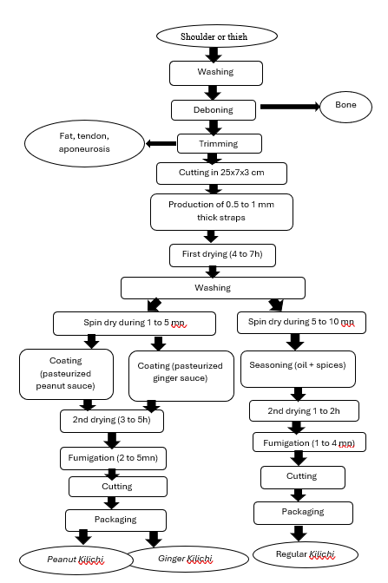
Figure 5. Improved technological diagram for kilichi production
- Conclusion
Ultimately, we can say that kilichi is a food whose production involves several stages that can be summarized as meat selection, cutting into strips, drying, coating, and smoking. Three types of kilichi are produced in our country : regular kilichi, ginger-coated kilichi, and peanut-coated kilichi. From a microbiological point of view, we noticed that coated kilichis were more contaminated with total mesophilic aerobic flora than regular kilichi. However, the latter was more contaminated with total coliforms, Staphylococcus aureus, and yeast and mold than coated kilichi. The microbiological quality of kilichi produced in Burkina Faso is acceptable. Of the 32 samples analyzed, only four were of unsatisfactory quality due to a high level of suspected Staphylococcus aureus. It is necessary to provide regular training in good hygiene practices for producers, most of whom have not had the opportunity to attend school. It is also necessary to consider the use of gas dryers for perfect, rapid drying in all seasons and in complete safety.

Competing interests
The authors declare that they have no competing interests.
Authors’ contributions
CH and OI analysed the data and wrote the manuscript. ZO, DAO reviewed the manuscript. SA contributed to the discussion and reviewed the manuscript. SA managed the project and reviewed the manuscript.
Acknowledgements:
We thank all Kilichi vendors for agreeing to participate in this study.

References
Bambara, H. (2008). Détermination de la qualité microbiologique du kilichi produit dans la région du Centre Est du Burkina Faso. Ouagadougou. Available at: https://www.biblio ujkz.com/entity/document/8811.
Boubacar S, R., Harouna, A., Kpoclou, Y. E., Douny, C., Brose, F., Hamani, M., & Hounhouigan, D. J. (2019). Assessment of the physicochemical characteristics, chemical and microbiological safety of two types of kilichi, a grilled meat produced in Niger. Food Science & Nutrition, 7(10), 3293-3301.
FAO (2014). Techniques traditionelle de conservation / préservation de produit d ’ elevage. Dakar. Available at: http://www.fao.org/fileadmin/user_upload/food-security-capacity building/docs/Nutrition/Livestock_workshop/Jour_2/FAO_Techniques_Transformation.p df.
Halagarda, M. & Wojciak, K. M. (2021). ‘Health and safety aspects of traditional European meat products. A review’. Meat Science, 102. https://www.doi:10.1016/j.meatsci.2021.108623.
Hissein, A. H., Tapsoba, F., Makhlouf, H., Hama, C., Tankoano, A., Ali, H. M., ... & Savadogo, A. (2023). Production and Microbial Quality of “charmout”, a Dried Meat Produced in Chad. American Journal of Food Science and Technology, 11(1), 1-7.
Idowu, A. O., Omobuwajo, T. O. & Falades, K. O. (2010). ‘Production proximate analysis and shelf life studies of ready-to-eat rice and kilishi’. African Journal of Food Science, 4(5), 5. http://www.academicjournals.org/ajfs.
ISO 4833-1 (2014) Microbiology of the food chain: Horizontal method for the enumeration of microorganisms. Part 1: Colony count at 30 degrees C by the pour plate technique.
ISO 21528-2. (2017). Microbiology of the food chain - Horizontal method for the detection and enumeration of Enterobacteriaceae. Part 2: Colony counting technique.
ISO 6579-1. (2017). Microbiology of the food chain-Horizontal method for the detection, enumeration and serotyping of Salmonella. Part 1: Detection of Salmonella spp.
ISO 21527-2. (2008). Microbiology of food-Horizontal method for the enumeration of yeasts and moulds at 25°C.
ISO 6888-1. (2021). Microbiology of the food chain - Horizontal method for enumerating coagulase-positive Staphylococci (Staphylococcus aureus and other species) Part 1: Method using Baird-Parker agar medium.
Kimassoum, D. et al. (2017). ‘Evaluation of microbial adverse effects on fresh and processed bovine meat in NDjamena (Chad) and Yaound (Cameroun)’. African Journal of Microbiology Research, 11(16), 637–643. doi:10.5897/ajmr2017.8455.
Luxembourg Ministry of Health. (2015). Ministry of Health and Social Security of Activity report. 233p. https://m3s.gouvernement.lu/en/publications.gouvernement2024+en+publications+rapport-activite+minist-sante+msan+2015-rapport-activite-sante.html
Mbawala, A., Daoudou, B. & Ngassoum, M. (2010). ‘Qualité microbiologique du kilishi (produit carné séché) produit dans la ville de Ngaoundéré (Cameroun)’. Tropicultura, 28(3), 153–160. doi: 10.3109/09637489709012589.
Sawadogo, A. Y. et al. (2021). ‘Reduction of Aflatoxins and Microorganisms in the Koura- Koura Produced in Burkina Faso with Spices and Aromatic Leaves’, Journal of Food Technology Research, 8, 17. doi: 10.18488/journal.58.2021.81.9.17.
Seini, S. H. et al. (2018). ‘Influence of Manufacturing Methods on the Microbiological and Nutritional Characteristics of Kilichi, Dry Meat of Niger’, International Journal of Current Microbiology and Applied Sciences, 7(12), 11. doi: 10.20546/ijcmas.2018.712.029.
Thwala, T., Madoroba, E. & Butaye, A. B. P. (2021). ‘Prevalence and Characteristics of Staphylococcus aureus Associated with Meat and Meat Products in African Countries : A Review’, MDPI, 16. doi: 10.3390/ antibiotics10091108.
Tiendrebeogo, S. C. W. et al. (2016). ‘Assessment of the impact of gas dryer bb equipment on the quality of kilichi a traditional dried beef Science et Technique’, Wageningen Agricultural University, 2, p. 16. Available at: https://works.bepress.com/dicko/61/.
Yacouba, I. (2009). ‘Memoire Analyse des techniques traditionnelles de transformation de la viande en Kilichi dans la commune urbaine de Madaoua (Madaoua, Niger): Mémoire Online, p. 45.

