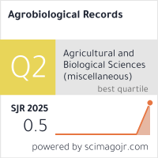
https://www.scimagojr.com/journalsearch.php?q=21101373147&tip=sid&clean=0
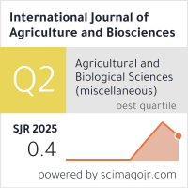
https://www.scimagojr.com/journalsearch.php?q=21101162543&tip=sid&clean=0
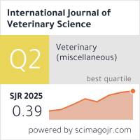
https://www.scimagojr.com/journalsearch.php?q=21100820608&tip=sid&clean=0

