APPLICATION OF HALOTOLERANCE OF PGPR CONSORTIUM TO INCREASING THE TOLERANCE OF RICE PLANTS TO SALINITY STRESS

Purwanto^{1*}, Aqilah Faizah Shafa¹, Ni Wayan Anik Leana¹, Lafi Na’imatul Bayyinah¹, Risqa Naila Khusna Syarifah¹, Hanim Rahayuani Ratnangsih¹

¹Department of Agrotechnology, Faculty of Agriculture, Jenderal Soedirman University

Jl. Dr. Suparno KP 125 Purwokerto, Central Java, Indonesia 53122.
*Correspondence: purwanto0401@unsoed.ac.id

ABSTRACT

Salinity negatively affects rice growth and yield by causing nutritional imbalances, osmotic stress, and ion toxicity. This study aimed to examine the synergy between diazotrophic bacteria and P-solubilizing bacteria in increasing rice plant growth and yield in high salinity. The research was conducted at the Agronomy & Horticulture Laboratory and Experimental Farm, Faculty of Agriculture, Jenderal Soedirman University, Indonesia, from July to December 2024, using a floating raft hydroponic system with AB mix, and salinity was maintained at 6.5 dS m⁻¹ using NaCl. The research used a Randomized Block Design with four replications. The treatments include Diazotrophic bacteria, including Acinetobacter junii strain WR4 (A) and Bacillus tropicus strain CU96 (B), while the P-solubilizing bacteria used are Priestia megaterium strain NRRL B-350 (P). The results showed that the application of diazotrophic and phosphate-solubilizing bacteria significantly improved the agronomic and physiological performance of rice plants under high salinity stress. The consortium of diazotrophic and P-solubilizing bacteria increased resistance to salinity stress by increasing proline levels by 173.36% and increasing the K⁺/Na⁺ ratio. Inoculation of diazotrophic and P-solubilizing bacteria was able to increase yield by an average of 61.79%.
Keywords: diazotrophic bacteria, phosphate-solubilizing bacteria, rice yield, salinity stress.

INTRODUCTION

Rice is a significant food commodity and a staple food source for Indonesians. Rice is considered the primary food source by the Indonesian people, with 98 percent of the population relying on it (Wardani et al., 2019). This causes rice consumption to be very high, with per capita consumption reaching 1.539 kg capita⁻¹ week⁻¹ in the period 2019 to 2023 (Purnama et al., 2024). This makes it the country with the highest rice consumption above the world average consumption of only 53.3 kg capita⁻¹ year⁻¹ (Prasetyo et al., 2023). This trend is expected to persist, with rice demand rising in line with population growth. National rice demand is projected to reach 37.8 million tons by 2035, and increase to 39.80 million tons by 2045 (Arifin et al., 2021).

The increasing need for rice must be met with domestic production as an effort to achieve food self-sufficiency. Current rice production reaches 53.14 million tons with a productivity level of only 5.29 tons ha⁻¹ (BPS Indonesia, 2024). Efforts to fulfill production will face the constraint of the area of ​​productive agricultural land, which is always shrinking every year due to land conversion. The rate of conversion of irrigated rice fields in Indonesia reaches 150,000 to 200,000 ha year⁻¹, and until 2018, the area of ​​productive rice fields was only 7.1 million ha (Angraini et al., 2020). It is estimated that every 1000 ha of rice fields that are converted will reduce rice production by 4370 tons, and every year, rice production is expected to decline by 174,800 tons year⁻¹ (Kompas, 2023).

Limited productive rice fields require extensification on marginal lands. One of the marginal lands that has not been optimally used for rice production is saline rice fields. Indonesia has 140,300 ha of potential saline land for agriculture (Oelviani et al., 2024). The biggest obstacle to saline soil is the high levels of dissolved salts such as NaCl, Na₂CO₃, Na₂SO₄, which adversely affect the growth and yield of paddy (Karolinoerita & Yusuf, 2020). High salinity in rice plants causes osmotic stress and toxicity due to the influence of ions or ionic poisoning, causing oxidative stress and decreased nutrition in cells, causing decreased cell turnover pressure and decreased cell growth (Liu et al., 2022). Salinity leads to ion toxicity, osmotic stress, and nutrient deficiencies, especially N, Ca, K, P, Fe, and Zn, decreased P separators as a result of P ions settling with Ca ions, and plants having difficulty in absorbing water (Shrivastava & Kumar, 2015). Plants experience nutrient deficiencies or nutritional imbalances as a result of an imbalance in the Na⁺/Ca²⁺ ratio or excessive absorption of Na⁺, Cl⁻, B⁺, and SO₄²⁻ ions (Van Tan & Thanh, 2021). This causes a decrease in several plant physiological variables, such as a decrease in leaf chlorophyll levels. This is in line with the results of previous research. Sassine et al., (2022) reported that chlorophyll a and b contents in tomato plants decreased drastically under salinity conditions, where chlorophyll contents decreased from 1.6 mg g⁻¹ at a salinity of 2 dS m⁻¹ down to 1.01 mg g⁻¹ at a salinity level of 8 dS m⁻¹. Therefore, it has a significant impact on metabolic processes, resulting in decreased plant growth and yield. Li et al., (2023) reported that salinity up to 0.2% had a significant impact on reducing rice yields by up to 50.14%. Yield decline as a result of declining yield components and photosynthetic ability of plants, and assimilate distribution (Zhang et al., 2022). Furthermore, Gerona et al., (2019) also stated that the decline in rice grain yield is the impact of a combination of various factors, namely a decrease in the rate of photosynthesis and a decrease in the partition of assimilates to the grain, thereby reducing filled grain and increasing flower sterility. Decreased photosynthetic activity as a result of leakage and damage to cell membranes as a result of accumulation of Cl⁻ ions in cells, so that NaCl damages photosynthetic components (Karolinoerita & Yusuf, 2020).

The development of technology to optimize saline land for rice production has been widely carried out through the cultivation of stress-resistant plant varieties, as well as the application of soil conditioners. Another alternative that is currently not widely used is the biological approach by utilizing beneficial microbes that are tolerant to salinity, so that they can encourage plant growth and increase plant resistance to salinity. The consortium technology of diazotrophic bacteria and P-solubilizing bacteria is an environmentally friendly and sustainable technological approach. Microbial inoculation can enhance the tolerance of rice plants in saline conditions through various mechanisms, such as increasing nutrient absorption, minimizing the harmful effects of salt stress, and enhancing plant growth and development (Yang et al., 2024). Purwanto et al., (2024) reported that inoculation of Bacillus subtilis on rice plants can increase resistance to salinity by decreasing the K/Na ratio by 113.31% compared to the control and increasing nutrient absorption

P-solubilizing bacteria contribute significantly to the remediation of saline soil through the synthesis of organic acids that are effective in dissolving calcium phosphate compounds, so that P becomes more available (Zhang et al., 2023). In addition, the solubility of P by P-solubilizing bacteria is also through the mechanism of pH changes, and an increase in the microbial population in the soil, so that there is an increase in enzymatic activity, a change in P content in the soil, and an increase in the growth and yield of rice plants (Kalayu, 2019; Zhang et al., 2023). Phringpaen et al., (2023) reported that P. aryabhattai KNB6 is a saline-tolerant P-solubilizing bacterium, and inoculation of rice plants can increase P absorption by 121% and stimulate rice plant growth by 22%. Dat et al., (2024) also reported that inoculation of C. sphaeroides on rice plants was able to increase absorption by 19.2-30.1%, reduce Na⁺ in soil and plant tissue, and increase rice yields by 7.20-17.7%.

The use of Diazotrophic and P-solubilizing bacteria together will provide a synergistic effect in increasing rice plant yields in saline conditions. This will increase the availability of nutrients, nutrient absorption, and increase rice yields in saline conditions where nutrient availability is limited. The inoculation of barley with Erwinia sp. (diazotrophic bacterium), Chryseobacterium arthrosphaerae (P-solubilizing bacterium), and Pseudomonas gessardii can increase the root/shoot ratio, biomass, chlorophyll content, other secondary metabolite compounds, and sugar levels compared to controls (Kaur et al., 2022). This study aims to examine the consortium between diazotrophic bacteria and P-solubilizing bacteria in increasing the growth and yield of rice plants under high salinity stress.
- MATERIALS AND METHODS

The research was conducted at the Agronomy & Horticulture Laboratory and Experimental Farm, Faculty of Agriculture, Jenderal Soedirman University, Purwokerto, Central Java, Indonesia, from July to December 2024. This research used a floating raft hydroponic system method with liquid media with AB Mix nutrient sources. The rice variety used was Inpari Unsoed 79 Agritan. The AB Mix nutrient content consists of NO₃: 9.90%, NH₄; 0.48%, P₂O₅: 4.83% K₂O: 16.50%, MgO: 2.83%, CaO: 11.48%, SO₃: 3.81%, B: 0.013%, Mn: 0.025%, Zn: 0.015%, Cu: 0.002%, Mo: 0.003% Fe: 0.037%. Salinity medium was controlled by using NaCl until EC reached 6.5 mmhos cm⁻¹, starting from 2 weeks after planting.

This study used a Randomized Block Design with four replications, and the treatments were diazotrophic bacteria and P-solubilizing bacteria. Diazotrophic bacteria used include Acinetobacter junii strain WR4 (A) and Bacillus tropicus strain CU96 (B), while the P-solubilizing bacteria used are Priestia megaterium strains NRRL B-350 (P). The treatment arrangement was as follows P₀ (control), P₁ (Acinetobacter junii strain WR4), P₂ (Bacillus tropicus strain CU96), P₃ (Priestia megaterium strains NRRL B-350), P₄ (Acinetobacter junii strain WR4+ Bacillus tropicus strain CU96), P₅ (Acinetobacter junii strain WR4+ Priestia megaterium strains NRRL B-350), P₆ (Bacillus tropicus strain CU96+Priestia megaterium strains NRRL B-350), P₇ (Acinetobacter junii strain WR4+Bacillus tropicus strain CU96+Priestia megaterium strains NRRL B-350). Each experimental unit consists of 6 rice plants. Rice seeds are sown using rockwool, and transplanting is carried out at the age of 7 days after sowing.

The preparation of bacterial culture stock was carried out using NB medium for N₂-fixing bacteria and liquid Pikovskaya medium for phosphate-solubilizing bacteria. Bacterial isolates were inoculated into as many as 3 tubes of 100 mL of liquid medium in Erlenmeyer flasks and shaken for 48 hours at 120 rpm. The total plate count technique was used to calculate the number of bacterial colonies present. The density of bacteria to be inoculated was above 10⁷ CFU mL⁻¹. The treatment was carried out by inoculating 2 mL L⁻¹ of bacterial solution into the planting medium at the age of 2 weeks after planting. Plant maintenance and care are carried out by renewing the culture medium and administering bacterial isolates once a week. The nutrient levels of AB mix in the medium, EC, and pH are monitored weekly.

The variables observed included plant height, leaf area, plant dry weight, leaf chlorophyll content (Proklamasiningsih et al., 2012), width of stomatal opening, stomatal density, nutrient uptake (N, P, K, Na), and K/Na ratio (Balai Penelitian Tanah, 2005; Gharsallah et al., 2016), proline content (Pingle et al., 2022), and grain weight per hill. The data were analyzed using ANOVA, and if significantly different, continued with DMRT α: 5%.
- RESULTS AND DISCUSSION

3.1 Agronomic Traits

The use of diazotrophic and phosphorus-solubilizing bacteria, either as single inoculants or in combination (consortia), enhanced the vegetative growth of rice plants in high salinity. Total root length also increased significantly compared to the untreated plants. In conditions without bacterial inoculation, root growth was more suppressed compared to inoculation treatments, both single and consortium bacteria. Inoculation of the B+P consortium showed a higher root length, although not different from other treatments, of 6497.89 cm. In comparison, the root length of rice plants without treatment reached 4153.59 cm (Table 1).

Plant height and leaf area showed a marked increase compared to the control. The consortium of diazotrophic and phosphorus-solubilizing bacteria (A+P) produced the highest leaf area, measured in cm², achieved in the A+P consortium. The increase in plant vegetative variables was followed by an increase in rice plant canopy biomass in high salinity conditions. Plant biomass increased by bacterial inoculation, both single inoculants and the consortium, in comparison with the control. The consortia A+P, B+P, and A+B+P promoted higher plant growth than the control and other treatments.

Table 1. Agronomy traits of rice
Treatments | Plant Height (cm) | Leaf Area  (cm²) | Total Root Length (cm) | Plant Biomass (g)
Control | 71.00 b | 643.64 c | 4153.59 c | 31.63 a
A | 86.13 a | 799.37 b | 6317.63 a | 38.49 b
B | 88.63 a | 791.17 b | 6669.26 a | 41.80 b
P | 83.94 a | 802.55 b | 5317.14 abc | 43.94 b
A+B | 85.00 a | 784.31 b | 5724.37 abc | 43.51 b
A+P | 87.63 a | 907.65 a | 5907.85 ab | 58.37 c
B+P | 85.88 a | 806.81 b | 6497.89 a | 57.77 c
A+B+P | 90.88 a | 760.07 b | 4478.80 bc | 58.37 c

Note: The numbers followed by the same letter in the same column are not significantly different according to DMRT α: 5%.

Vegetative growth of rice plants in salinity conditions will be suppressed due to the negative impact of increasing salt stress. This decrease in growth is caused by osmotic stress, which reduces plant growth, including decreasing leaf area and photosynthetic apparatus, so that it decreases the rate of photosynthesis and accumulation of assimilates in the form of dry plant weight (Nadeem et al., 2025). Furthermore, Gaur & Kamakshi, (2025) stated that increasing salinity causes osmotic stress, which disrupts ion balance and water absorption, thus causing slowing of moth bean growth, such as decreasing root length, plant height, and growth of secondary roots.

The use of diazotrophic and P-solubilizing bacteria showed a positive impact by increasing the growth of integrated plants in saline conditions. Isolate diazotrophic and P-solubilizing bacteria also act as growth promoters with the ability to produce IAA, which can encourage root growth. Acinetobacter junii strain WR4 and Bacillus tropicus strain CU96 are bacteria with nitrogen-fixing abilities and are also able to produce IAA (Purwanto et al., 2022). Habibi et al., (2023) found that the use of single inoculants or a combination of PGPR can increase rice plant growth parameters such as root length, root dry weight, and shoots. Increasing the root length variable will increase the surface area of ​​the roots that interact in the soil clod so that they can absorb more water and nutrients, thus having an impact on increasing plant metabolism and vegetative growth of rice plants.

Chlorophyll Contents
The results showed that inoculating rice plants with diazotrophic bacteria and phosphorus-solubilizing bacteria, either individually or in combination as a consortium, significantly increased the levels of chlorophyll a, chlorophyll b, and total chlorophyll compared to the control treatment (Fig. 1). On average, chlorophyll a level increased by 77.96%, chlorophyll b by 102.38%, and total chlorophyll by 86.29% compared to the control treatment. Chlorophyll is a pigment involved in photosynthesis that functions to capture sunlight for energy conversion in plants. Chlorophyll a is the predominant type present in most plants. It has a chemical structure consisting of a porphyrin ring with a magnesium ion (Mg²⁺) in the center, and a long hydrocarbon chain known as phytol. This porphyrin ring consists of four pyrrole groups that bind magnesium ions, while the phytol tail functions to anchor the chlorophyll molecule to the thylakoid membrane within the chloroplast (Martins et al., 2023). The functional groups affixed to the porphyrin ring are the main difference between chlorophyll a and chlorophyll b; chlorophyll a has a methyl group (-CH₃), whereas chlorophyll b contains a formyl group (-CHO).

Nitrogen is a crucial macronutrient for rice plants and is a component of chlorophyll molecules. The availability of nitrogen will directly affect chlorophyll synthesis, which will affect the efficiency of photosynthesis. The increase in chlorophyll levels in rice plants under saline conditions is strongly associated with nitrogen availability and the plant's capacity to uptake nitrogen. The combination of diazotrophic and phosphorus-solubilizing bacteria will increase the availability of nitrogen and phosphorus, and the ability as a growth stimulant will increase growth, so that root growth increases and increases the root surface area, thereby increasing nutrient absorption. P nutrients play a role in stimulating root growth, especially young roots, and can increase the length and number of roots (Rahmawati et al., 2019; Yama et al., 2021).

Increasing N levels in plant tissue will stimulate chlorophyll synthesis, where in chlorophyll synthesis, there must be factors such as light intensity, nitrogen, magnesium, iron, water, and temperature, as well as several micronutrients (Setiawati et al., 2021). This is because the majority of chloroplasts contain nutrients, and leaf nitrogen levels are in chloroplasts for C3 plants (Purwanto & Suharti, 2021). Chinachanta et al., (2023) It was found that Rhizoactinobacteria inoculation increased chlorophyll levels in rice seedlings under salt stress conditions. The highest increase was achieved with Sinomonas sp.ORF15-23 inoculation, reaching 15.26 to 27.50% compared to the control. Hartatik et al., (2025) reported that increasing the dose of rhizobacteria consortium in saline conditions was able to increase the chlorophyll content of sugarcane plants, and a dose of 4 mL of rhizobacteria consortium had the highest increase in chlorophyll content compared to without the application of rhizobacteria consortium.

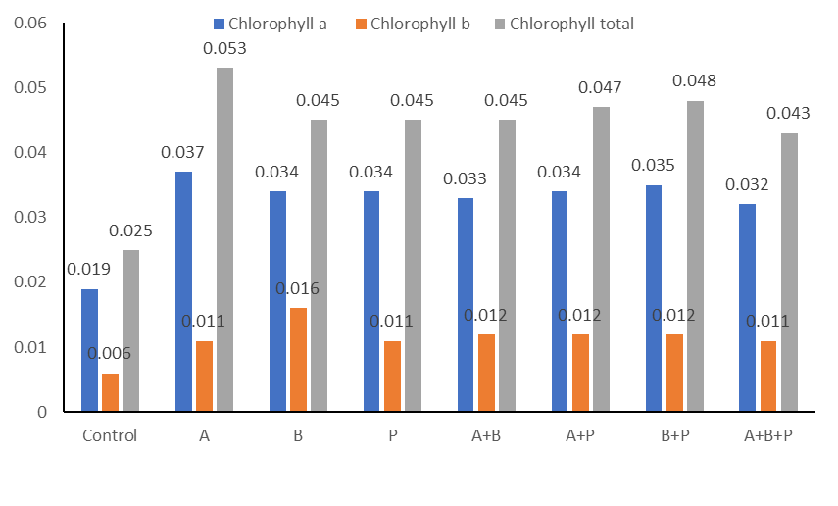
Chlorophyll Content (mg g⁻¹)

Figure 2. Chlorophyll Content

3.2 Nutrient Uptake

The results showed that the inoculation treatment of diazotrophic and phosphorus-solubilizing bacteria was effective in significantly enhancing the uptake of nitrogen, phosphorus, and potassium. Based on the findings of this study, the combination of diazotrophic and phosphorus-solubilizing bacteria was able to increase nutrient absorption greater than single inoculation or control treatment. Inoculation of diazotrophic and phosphorus-solubilizing bacteria in the form of a consortium was able to provide higher N absorption compared to control, single inoculant or a combination of bacteria A and B. Inoculation of the B+P consortium was able to provide the highest N absorption of 1.46 g plant⁻¹ although this result did not show any difference with the A+P or A+B+P bacterial consortium of 1.31 and 1.39 g plant⁻¹, respectively (Table 3). It indicates that inoculation of halotolerant diazotrophic bacteria and halotolerant P-solubilizing bacteria can enhance N absorption in comparison to the control, with an increase of 32.01%. The combination of diazotrophic and phosphorus-solubilizing bacteria was able to increase N uptake more than other treatments, with an average increase of 39.51%.

The P uptake of rice plants with inoculation treatment of diazotrophic and phosphorus-solubilizing bacteria was seen to increase significantly in comparison to the control. The consortium of diazotrophic and phosphorus-solubilizing bacteria was seen to be able to increase uptake higher than the control treatment, single inoculant, or consortium of diazotrophic bacteria individually. The highest P uptake was achieved in the B+P treatment of 0.341 g plant⁻¹, followed by the A+B+P and A+P treatments of 0.298 and 0.210 g plant⁻¹, respectively (Table 3). Similar results were seen in K uptake, where the consortium of diazotrophic and phosphorus-solubilizing bacteria was able to increase K uptake higher than the control or other treatments. Based on Table 3, it can be seen that the A+B+P consortium was able to provide the highest K uptake of 3.04 g plant⁻¹, although it was not different from the A+P and B+P consortia of 3.04 and 3.01 g plant⁻¹, respectively.

Table 3. Nutrient uptake
Treatments | N (g plant⁻¹) | P (g plant⁻¹) | K (g plant⁻¹)
Control | 0.88 a | 0.13 a | 1.65 a
A | 0.95 a | 0.17 b | 2.01 b
B | 0.93 a | 0.15 ab | 2.18 b
P | 0.95 a | 0.14 a | 2.29 b
A+B | 1.16 b | 0.15 ab | 2.27 b
A+P | 1.32 c | 0.21 c | 3.04 c
B+P | 1.46 c | 0.34 e | 3.01 c
A+B+P | 1.39 c | 0.29 d | 3.04 c

Note: The numbers followed by the same letter in the same column are not significantly different according to DMRT α: 5%.

These results indicate a synergistic effect so that the consortium of diazotrophic and phosphorus-solubilizing bacteria can increase nutrient absorption of N, P, and K. In addition, the bacterial consortium has the ability as a growth promoter, namely as an IAA producer, that can increase root growth, thereby increasing nutrient absorption (Purwanto et al., 2022; Khoso et al., 2024). This aligns with de Andrade et al., (2023), where the direct influence of rhizobacteria through root growth promoters can directly influence the plant's metabolic process by enhancing the uptake of water and mineral nutrients. Under salt stress conditions, microbes are able to increase plant tolerance through key mechanisms, namely by facilitating nutrient acquisition through processes such as nitrogen fixation, phosphate solubilization, and iron chelation (Waheed et al., 2024).

The synergy between diazotrophic and phosphorus-solubilizing bacteria on nutrient absorption is supported by the ability of these bacteria to increase the availability of N and P nutrients in the soil under saline conditions, where there is an imbalance of nutrients and decreased microbial activity due to increased salt levels (Jiang et al., 2021). In saline conditions, P is in a fixed condition, so it is not available. With the presence of P-solubilizing bacteria, it will produce organic acids and enzymes, so that it will be released from the form of insoluble compounds, making it available and can be absorbed by plants under salinity (Ibarra-galeana et al., 2017). Teles et al., (2024) reported that Kushneria sp. and Enterobacter sp. originating from the rhizosphere of Salicornia fruticosa can dissolve P in salinity. Fitriatin et al., (2022) reported that the combination of Burkholderia sp. and Penicillium sp. can increase P levels in rice plant tissue.

Application of diazotrophic bacteria will increase their activity and increase the population in the rice rhizosphere, so that this interaction will allow increased N-fixing activity that can provide N for plants. Purwanto et al., (2024) reported that halotolerant strains effectively increased nitrogen and potassium uptake in rice plants grown under high salinity conditions. Mattos et al., (2023) also found that co-inoculating rice with Azospirillum brasilense and Pseudomonas fluorescens significantly enhanced nitrogen use efficiency.

Inoculation of diazotrophic and phosphorus-solubilizing bacteria to rice plants under saline conditions showed significant results in increasing K uptake and increasing the K⁺/Na⁺ ratio. The results showed that the K⁺/Na⁺ ratio increased with inoculation of diazotrophic and phosphorus-solubilizing bacteria, both in single inoculants and in the form of consortia (Fig. 2). These results indicate that the consortium of diazotrophic and phosphorus-solubilizing bacteria can increase the resistance of rice plants to salt stress by maintaining ion homeostasis and reducing the adverse effects of salt stress (Siddika et al., 2024). Rhizobacteria increase K absorption and K⁺/Na⁺ ratio through the mechanisms of ion homeostasis regulation, organic acid production, and stress hormone modulation (Mehrabi et al., 2024). Siddika et al., (2024) reported that inoculation of Bacillus subtilis and B. aryabhattai significantly enhanced ion homeostasis in rice under salt stress, and application of B. subtilis reduced Na⁺ accumulation by 81% and increased K⁺ uptake by 67% under 100 mM NaCl stress, restoring the K⁺/Na⁺ ratio by approximately 89% compared to untreated stressed plants.

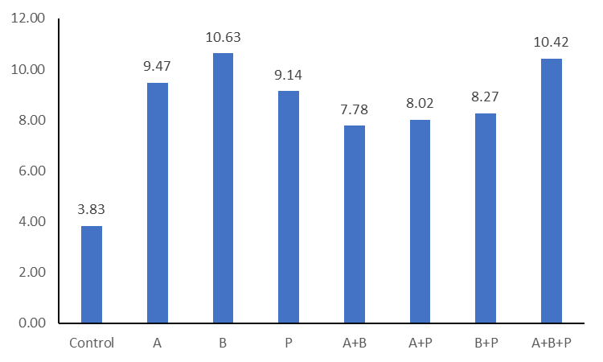

Figure 2. K⁺/Na⁺ Ratio

3.3 Proline Content
The results showed that inoculation of diazotrophic and P-solubilizing bacteria increases proline accumulation in rice plant leaf tissue under salinity stress conditions. Proline content increased significantly in comparison to the control. Inoculation of diazotrophic and P-solubilizing bacteria, both single and combined, was able to increase proline levels by an average of 14.32 µmol g⁻¹ or an increase of 173.36% compared to the control treatment, which was only 5.24 µmol g⁻¹. The combination treatment of diazotrophic and P-solubilizing bacteria induced higher proline production than single inoculants. The combination of diazotrophic and P-solubilizing bacteria had an average proline content of 18.31 µmol g⁻¹, and single inoculants had an average proline content of 9.01 µmol g⁻¹. This indicates an increase in proline accumulation of 103.32%. The combination of Acinetobacter junii strain WR4 + Priestia megaterium strains NRRL B-350 (A + P) was able to induce the highest proline accumulation of 23.75 µmol g⁻¹, followed by the treatment of Bacillus tropicus strain CU96 + Priestia megaterium strains NRRL B-350 (B + P) of 22.91 µmol g⁻¹ (Fig. 2). The combination of diazotrophic bacteria with P-solubilizing bacteria was able to induce higher proline than the combination of diazotrophic bacteria alone, or the combination of the three bacteria.

These results indicate synergy between diazotrophic bacteria and P-solubilizing bacteria in increasing resistance to salinity stress by increasing proline accumulation in plant tissue. Under salinity stress conditions, plants will respond by accumulating proline, which is a form of amino acid in the cell solution. High proline accumulation in plant tissue can increase plant tolerance to salt stress through osmotic adjustment in cell solution, stabilization of cellular structure, and neutralization of reactive oxygen species (ROS) (Mansour & Ali, 2017). El Moukhtari et al., (2020) stated that enhanced proline accumulation in plant tissues positively affects plants under salt stress by boosting antioxidant activity, limiting the uptake and movement of Na⁺ and Cl⁻, and promoting greater assimilation of K⁺.

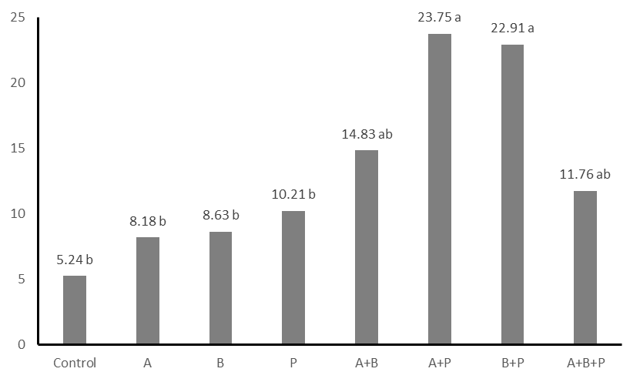
Proline Content (µmol.g⁻¹)
Treatments

Fig 2. Proline content of rice in different treatments of consortium diazotrophic bacteria and P-solubilizing bacteria (The numbers followed by the same letter are not significantly different according to DMRT α: 5%).

These findings are consistent with earlier research, indicating that inoculation with plant growth-promoting rhizobacteria can positively influence salt stress by enhancing proline accumulation. Mahmoud et al., (2020) found that inoculation of Bacillus sp. on barley plants can increase proline levels in 100 mM NaCl salt stress. Halotolerant PGPR produces osmolytes that are suitable for helping plants during salt stress by accumulating proline, where plants lack organic osmolytes such as trehalose, and in this condition, proline as the main osmolyte will be formed as a result of protein hydrolysis to reduce osmotic stress (Abbas et al., 2019). Abulfaraj & Jalal, (2021) also reported that inoculation of P. fluorescens, P. putida, and Bacillus subtilis can increase proline levels in soybean plants experiencing salt stress.

3.4 Grain Yield

The results of the study showed that inoculation of Diazotrophic and P-solubilizing bacteria, both single inoculants and in the form of consortia, can increase grain yield per plant in comparison with the control. Consortium A+B was able to produce grain of 41.05 g plant⁻¹, followed by consortium B+P and A+B+P of 34.64 and 37.50 g/plant, respectively (Fig. 3). Based on these results, inoculation of Diazotrophic and P-solubilizing bacteria was able to increase yield by an average of 61.79%, however, the consortium of diazotrophic and P-solubilizing bacteria was higher than the single inoculant, namely each was able to increase rice yield by 73.32 and 46.42% in high salinity conditions.

The application of a consortium of diazotrophic and P-solubilizing bacteria can increase effectiveness with synergistic effects between microbes. This is seen that the consortium of diazotrophic bacteria and P-solubilizing bacteria can increase plant growth, photosynthesis, and nutrient absorption, specifically N, P, and K, under salinity stress. N, P, and K are the main macronutrients that are needed for the growth and yield of rice plants.

The combination of diazotrophic and PSBs can have a synergistic effect, where each type of bacteria enhances the activity of the other, leading to greater nutrient availability and plant growth. By enhancing the availability of nitrogen and phosphorus, these bacteria can boost rice growth, development, and yield, particularly under saline conditions. Dat et al., (2025) found that inoculation of C. sphaeroides ST16 and ST26 on rice plants under saline conditions was able to increase P availability and P uptake by 8.33-27.8% and 29.4-56.1%, respectively, and increase rice yields by 26.5-51.0%.

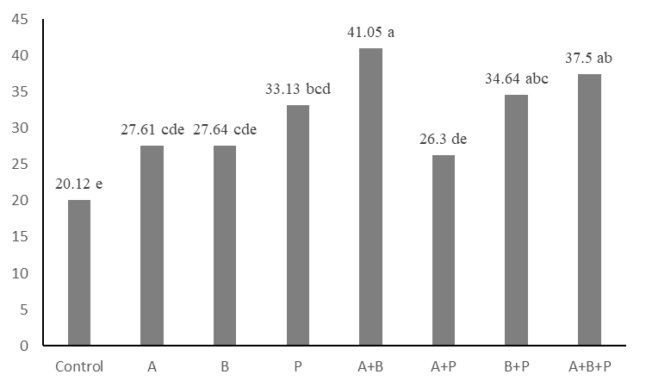
Treatments
Yield (g/clump)

Fig 2. Rice yield (The numbers followed by the same letter are not significantly different according to DMRT α: 5%).
- CONCLUSIONS
The application of diazotrophic and phosphate-solubilizing bacteria significantly improved the agronomic and physiological performance of rice plants under high salinity stress. The application of diazotrophic and phosphate-solubilizing bacteria significantly improved the agronomic and physiological performance of rice plants under high salinity stress. The consortium of diazotrophic and P-solubilizing bacteria increased resistance to salinity stress by increasing proline levels by 173.36% and increasing the K⁺/Na⁺ ratio. Inoculation of diazotrophic and P-solubilizing bacteria was able to increase yield by an average of 61.79%.

Declarations

Funding: All the authors acknowledge partial funding from the Research and Community Service Institute of Jenderal Soedirman University through the fundamental research scheme 2024 under contract number 26.497/UN23.35.5/PT.01/11/2024.

Conflict of Interest: The authors declare no conflict of interest.

Data Availability: Data will be available upon request.
Author’s Contribution:
Generative AI Statement: The authors declare that no Gen AI/DeepSeek was used in the writing/creation of this manuscript.
REFERENCES
Abbas, R., Rasul, S., Aslam, K., Baber, M., Shahid, M., Mubeen, F., & Naqqash, T. 2019. Halotolerant PGPR: A hope for the cultivation of saline soils. Journal of King Saud University - Science 31(4), 1195–1201. https://doi.org/10.1016/j.jksus.2019.02.019
Abulfaraj, A. A., & Jalal, R. S. 2021. Use of plant growth-promoting bacteria to enhance salinity stress in soybean (Glycine max L.) plants. Saudi Journal of Biological Sciences 28(7), 3823–3834. https://doi.org/10.1016/j.sjbs.2021.03.053
Angraini, F., Selpiyanti, S., & Walid, A. 2020. The impact of land conversion on environmental degradation: a case study of rice fields being converted into non-agricultural land. Jurnal Swarnabhumi 5(2), 36–43.
Arifin, Z., Hanani, N., Kustiono, D., Syafrial, S., & Asmara, R. (2021). Forecasting the basic conditions of Indonesia’s rice economy 2019-2045. Agricultural Social Economic Journal 21(02), 111–120. https://doi.org/10.21776/ub.agrise.2021.021.2.4
Balai Penelitian Tanah. 2005. Technical Instructions: Chemical Analysis of Soil, Plants, Water, and Fertilizer. Balai Penelitian Tanah, Bogor.
BPS Indonesia. 2024. Rice Harvested Area, Production, and Productivity by Province - Statistical Table - Statistics Indonesia. 2024. https://www.bps.go.id/id/statistics-table/2/MTQ5OCMy/luas-panen--produksi--dan-produktivitas-padi-menurut-provinsi.html
Chinachanta, K., Shutsrirung, A., Santasup, C., Pathom-Aree, W., Luu, D. T., Herrmann, L., Lesueur, D., & Prom-u-thai, C. 2023. Rhizoactinobacteria enhance growth and antioxidant activity in Thai Jasmine Rice (Oryza sativa) KDML105 Seedlings under Salt Stress. Plants 12(19), 1–17. https://doi.org/10.3390/plants12193441
Dat, L. T., Chinh, L. T., Xuan, L. N. T., Quang, L. T., Thao, P. T. P., Xuan, D. T., Thu, L. T. M., Trong, N. D., Nguyen, T. T. K., & Khuong, N. Q. 2025. Phosphate-solubilizing bacteria Cereibacter sphaeroides ST16 and ST26 enhanced soil phosphorus solubility, rice growth, and grain yield in acidic-contaminated saline soil. Biology 14(4), 1–18. https://doi.org/10.3390/biology14040443
Dat, L. T., Huong, T. T. C., Xuan, L. N. T., Quang, L. T., Thao, P. T. P., Xuan, D. T., & Khuong, N. Q. 2024. Cereibacter sphaeroides ST16 and ST26 were used to solubilize insoluble P forms to improve P uptake, growth, and yield of rice in acidic and extreme saline soil. Open Agriculture 9(1), 1–13. https://doi.org/10.1515/opag-2022-0353
de Andrade, L. A., Henrique, C., Santos, B., Frezarin, E. T., & Sales, L. R. 2023. Plant growth-promoting rhizobacteria for sustainable agricultural production. Microorganisms 11(1088), 1–16.
El Moukhtari, A., Cabassa-Hourton, C., Farissi, M., & Savouré, A. 2020. How does proline treatment promote salt stress tolerance during crop plant development? Frontiers in Plant Science 11, 1–16. https://doi.org/10.3389/fpls.2020.01127
Gaur, K., & Kamakshi, S. 2025. Exploring salinity effects on moth beans in response to physiological parameters. Journal of Ecological Engineering 26(7), 261–273. https://doi.org/10.12911/22998993/203400
Gharsallah, C., Fakhfakh, H., Grubb, D., & Gorsane, F. 2016. Effect of salt stress on ion concentration, proline content, antioxidant enzyme activities, and gene expression in tomato cultivars. AoB PLANTS 8: plw055; doi:10.1093/aobpla/plw055
Habibi, S., Yokoyama, T., Haidari, M. D., Torii, A., Yasuda, M., & Ohkama-Ohtsu, N. 2023. Analyzing single and combined cultures of plant growth-promoting rhizobacteria isolates from Afghanistan as a potential biofertilizer for rice growth and development. Agriculture (Switzerland) 13(12), 1–14. https://doi.org/10.3390/agriculture13122252
Hartatik, S., Wildana, F., Gusti, A.A.H., Aurela, R.D., Setiyono, Avivi, S., Kim, K.M., & Ubaidillah, M. 2025. Evaluation of salt tolerance in sugarcane mutant clone M4 through the application of a rhizobacterial consortium. Agronomy Research, 23(X), xxx–ccc. https://doi.org/10.15159/AR.25.053
Ibarra-galeana, J. A., Castro-martínez, C., & Fierro-coronado, R. A. 2017. Characterization of phosphate-solubilizing bacteria exhibiting the potential for growth promotion and phosphorus nutrition improvement in maize ( Zea mays L) in calcareous soils of Sinaloa, Mexico. Ann Microbiol 67(250), 801–811.
Jiang, H., Li, S., Wang, T., Chi, X., Qi, P., & Chen, G. 2021. Interaction between halotolerant phosphate-solubilizing bacteria (Providencia rettgeri Strain TPM23) and rock phosphate improves soil biochemical properties and peanut growth in saline soil. Frontiers in Microbiology 12(777351), 1–12. https://doi.org/10.3389/fmicb.2021.777351
Kalayu, G. 2019. Phosphate-solubilizing microorganisms: Promising approach as biofertilizers. International Journal of Agronomy 2019, 1–8. https://doi.org/10.1155/2019/4917256
Karolinoerita, V., & Yusuf, W. A. 2020. Salinisasi Lahan dan Permasalahannya di Indonesia. Jurnal Sumberdaya Lahan 14(2), 91. https://doi.org/10.21082/jsdl.v14n2.2020.91-99
Kaur, T., Devi, R., Kumar, S., Sheikh, I., Kour, D., & Yadav, A. N. 2022. Microbial consortium with nitrogen-fixing and mineral-solubilizing attributes for the growth of barley (Hordeum vulgare L.). Heliyon 8(4), 1–7. https://doi.org/10.1016/j.heliyon.2022.e09326
Khoso, M. A., Wagan, S., Alam, I., Hussain, A., Ali, Q., Saha, S., Ram, T., Manghwar, H., & Liu, F. 2024. Impact of plant growth-promoting rhizobacteria (PGPR) on plant nutrition and root characteristics: Current perspective. Plant Stress 11, 1–15.
Kompas. 2023. Land Conversion Threatens National Rice Production. https://www.kompas.id/artikel/alih-fungsi-lahan-mengancam-produksi-padi-nasional
Li, Z., Zhou, T., Zhu, K., Wang, W., Zhang, W., Zhang, H., Liu, L., Zhang, Z., Wang, Z., Wang, B., Xu, D., Gu, J., & Yang, J. 2023. Effects of salt stress on grain yield and quality parameters in rice cultivars with differing salt tolerance. Plants 12(18). https://doi.org/10.3390/plants12183243
Liu, C., Mao, B., Yuan, D., Chu, C., & Duan, M. 2022. Salt tolerance in rice: Physiological responses and molecular mechanisms. The Crop Journal 10, 13–25. https://doi.org/10.1071/FP23023
Mahmoud, O. M., Hidri, R., Talbi-Zribi, O., Taamalli, W., Abdelly, C., & Djébali, N. 2020. Auxin and proline-producing rhizobacteria mitigate salt-induced growth inhibition of barley plants by enhancing water and nutrient status. South African Journal of Botany 128, 209–217. https://doi.org/10.1016/j.sajb.2019.10.023
Mansour, M. M. F., & Ali, E. F. 2017. Evaluation of proline functions in saline conditions. Phytochemistry 140(2017), 52–68. https://doi.org/10.1016/j.phytochem.2017.04.016
Martins, T., Barros, A. N., Rosa, E., & Antunes, L. 2023. Enhancing health benefits through chlorophylls and chlorophyll-rich agro-food: a comprehensive review. Molecules 28(14), 1–21. https://doi.org/10.3390/molecules28145344
Mattos, M. L., Valgas, R. A., & Martins, J. F. da S. 2023. Coinoculation with growth-promoting bacteria increases the efficiency of nitrogen use by irrigated rice. ACS Omega 8(51), 48719–48727. https://doi.org/10.1021/acsomega.3c05339
Mehrabi, S. S., Sabokdast, M., & Bihamta, M. R. 2024. The coupling effects of PGPR inoculation and foliar spraying of strigolactone in mitigating the negative effect of salt stress in wheat plants : insights from phytochemical, growth, and yield attributes. Agriculture 14(732), 1–29.
Nadeem, M., Shahbaz, M., Ahmad, F., & Waraich, E. A. 2025. Enhancing wheat resistance to salinity: The role of gibberellic acid and β-carotene in morphological, yielding, and ionic adaptations. Journal of Ecological Engineering 26(6), 76–94. https://doi.org/10.12911/22998993/202091
Oelviani, R., Adiyoga, W., Suhendrata, T., Bakti, I. G. M. Y., Sutanto, H. A., Fahmi, D. A., Chanifah, C., Jatuningtyas, R. K., Samijan, S., Malik, A., Sahara, D., Utomo, B., Wulanjari, M. E., Winarni, E., Yardha, Y., & Aristya, V. E. 2024. Effects of soil salinity on rice production and technical efficiency: Evidence from the northern coastal region of Central Java, Indonesia. Case Studies in Chemical and Environmental Engineering 10(October). https://doi.org/10.1016/j.cscee.2024.101010
Phringpaen, W., Aiedhet, W., Thitithanakul, S., & Kanjanasopa, D. 2023. Ability of phosphate-solubilizing bacteria to enhance the growth of rice in phosphorus-deficient soils. Trends in Sciences 20(12), 1–12. https://doi.org/10.48048/tis.2023.7032
Pingle, S.N., Suryawanshi, S.T., Pawar, K.R., & Harke, S.N. 2022. The effect of salt stress on proline content in maize (Zea mays). Environ. Sci. Proc. 16(64), 1-4. https://doi.org/ 10.3390/environsciproc2022016064
Prasetyo, A., Hindami, H. N., Bintang, R. S. P., Nafisha, S. H., & Putra, Y. R. 2023. Analisis perbandingan nilai ekspor beras Indonesia & Thailand. Student Research Journal 1(1), 141–150.
Proklamasiningsih, E., Prijambada, I.D., Rachmawati, D., & Sancayaningsih, R.P. 2012. Photosynthesis rate and chlorophyll content of soybeans in acidic planting media with aluminum salt addition. Agrotrop 2(1), 17-24.
Purnama, N. E., Muhammad, F., & Rambe, J. 2024. Analysis of the impact of rice imports, rice consumption, productivity, harvest area, and rice production on the farmer’s exchange rate for food crops in 2019-2023. International Journal of Economics, Commerce, and Management 1(4), 50–59.
Purwanto, Oktaviani, E., Ulinuha, Z., Tarjoko, & Leana, N. W. A. 2024. Effectiveness of halotolerant diazotrophic bacteria in increasing nitrogen and potassium uptake of rice in high salinity medium. Bulgarian Journal of Agricultural Science 30(5), 888–892.
Purwanto, P., Oktaviani, E., & Leana, N. W. A. 2022. Isolation and molecular identification of halotolerant diazotrophic bacteria from the Northern Coastal of Pemalang, Central Java, Indonesia. Biodiversitas 23(11), 5814–5821.
Purwanto, & Suharti, W. S. 2021. Nutrient uptake, chlorophyll content, and yield of rice (Oryza sativa) under the application of PGPR consortium. Biosaintifika 13(3), 336–344. https://doi.org/10.15294/biosaintifika.v13i3.31990
Rahmawati, I. D., Purwani, K. I., & Muhibuddin, A. 2019. The effect of P fertilizer concentration on the height and length of roots of Tagetes erecta L. (Marigold) infected with mycorrhiza grown hydroponically. Jurnal Sains Dan Seni ITS 7(2), 4–8. https://doi.org/10.12962/j23373520.v7i2.37048
Sassine, Y.N., Sajyan, T.K., El Zarzour, A., Abdelmawgoud, A.M.R., Germanos, M., & Alturki, S.M. 2022. Integrative effects of biostimulants and salinity on vegetables: Contribution of bioumik and Lithovit®-urea50 to improve salt-tolerance of tomato. Agronomy Research 20(4), 793–804. https://doi.org/10.15159/AR.22.074
Setiawati, M. R., Sugiyono, L., Kamaluddin, N. N., & Simarmata, T. 2021. The use of endophytic growth-promoting bacteria to alleviate salinity impact and enhance the chlorophyll, N uptake, and growth of rice seedlings. Open Agriculture 6(1), 798–806. https://doi.org/10.1515/opag-2021-0059
Shrivastava, P., & Kumar, R. 2015. Soil salinity: A serious environmental issue, and plant growth-promoting bacteria as one of the tools for its alleviation. Saudi Journal of Biological Sciences 22(2), 123–131. https://doi.org/10.1016/j.sjbs.2014.12.001
Siddika, A., Rashid, A., Khan, S. N., Prasad, P. V. V., & Hasanuzzaman, M. 2024. Harnessing plant growth-promoting rhizobacteria, Bacillus subtilis and B. aryabhattai to combat salt stress in rice : a study on the regulation of antioxidant defense, ion homeostasis, and photosynthetic parameters. Front. Plant Sci 15(1419764), 1–14. https://doi.org/10.3389/fpls.2024.1419764
Teles, E. A., Xavier, J., Arcenio, F., Armaya, R., Goncalves, J. V., Rouws, L. F., Zonta, E., & Coelho, I. 2024. Characterization and evaluation of potential halotolerant phosphate-solubilizing bacteria from Salicornia fruticosa rhizosphere. Front. Plant Sci 14(1324056.), 1–11. https://doi.org/10.3389/fpls.2023.1324056
Van Tan, L., & Thanh, T. 2021. The effects of salinity on changes in characteristics of soils collected in a saline region of the Mekong Delta, Vietnam. Open Chemistry 19(1), 471–480. https://doi.org/10.1515/chem-2021-0037
Waheed, A., Zhuo, L., Wang, M., Hailiang, X., Tong, Z., Wang, C., & Aili, A. 2024. Integrative mechanisms of plant salt tolerance: Biological pathways, phytohormonal regulation, and technological innovations. Plant Stress 14, 1-13.
Wardani, C., Jamhari, J., Hardyastuti, S., & Suryantini, A. 2019. Determinant of Rice Consumption : International Journal of Mechanical Engineering and Technology (IJMET) 10(05), 160–168.
Yama, D. I., Ivansyah, O., & Astriy, R. 2021. The relationship between P absorption and the growth of pepper cuttings in the application of tofu dregs and rice straw compost. Agrotechnology Research Journal 5(2), 77. https://doi.org/10.20961/agrotechresj.v5i2.50899
Yang, X., Yuan, R., Yang, S., Dai, Z., Di, N., Yang, H., He, Z., & Wei, M. 2024. A salt-tolerant growth-promoting phyllosphere microbial combination from mangrove plants and its mechanism for promoting salt tolerance in rice. Microbiome 12(1), 1–20. https://doi.org/10.1186/s40168-024-01969-9
Zhang, C., Chen, H., Dai, Y., Chen, Y., Tian, Y., & Huo, Z. 2023. Isolation and screening of phosphorus-solubilizing bacteria from saline alkali soil and their potential for Pb pollution remediation. Frontiers in Bioengineering and Biotechnology 11(February), 1–12. https://doi.org/10.3389/fbioe.2023.1134310
Zhang, R., Wang, Y., Hussain, S., Yang, S., Li, R., Liu, S., Chen, Y., Wei, H., Dai, Q., & Hou, H. 2022. Study on the effect of salt stress on yield and grain quality among different rice varieties. Frontiers in Plant Science 13, 1–14. https://doi.org/10.3389/fpls.2022.918460

