Biofilm Production and Antibacterial Potential of Bacillus subtilis Isolated from Soil
Numrah Hammad¹, Aqsa Ahmad¹, Bushra Mumtaz¹, Bakhtawar Maqbool², Ishtiaq Ahmad², Muhammad Imran Arshad³*
¹Institute of Microbiology, Faculty of Veterinary Science, University of Agriculture, Faisalabad, Pakistan.
²Department of Pathobiology, University of Veterinary and Animal Sciences, Lahore, Sub-Campus Jhang, Jhang 35200, Pakistan
³Department of Veterinary Preventive Medicine, College of Veterinary Medicine, Qassim University, Kingdom of Saudi Arabia.
*Corresponding author: m.arshad@qu.edu.sa; ORCID: 0000-0003-2218-9054
Statement of novelty:
This study demonstrates selective antimicrobial activity of Bacillus subtilis isolates from soil samples against pathogenic bacteria. Soil-associated Bacillus subtilis inhibits in vitro growth of Escherichia coli but not against Staphylococcus aureus, Pseudomonas aeruginosa, Salmonella typhi, and Salmonella typhimurium. Although B. subtilis frequently forms biofilms, this study evidenced its potential biocontrol and antibacterial activities.

ABSTRACT
Bacillus subtilis (B. subtilis) is a ubiquitous soil bacterium recognized for its probiotic potential, biofilm-forming capacity, and promising bacterium for agricultural biocontrol applications. We investigated growth characteristics, biofilm formation, and antibacterial profile of B. subtilis isolated from diverse soil environments. Ten soil samples from each site including animal hospital site, fruit plant rhizosphere and laboratory surroundings were collected. The soil samples were cultured on nutrient agar, Luria-Bertani agar and rabbit blood agar. Identification was confirmed via Gram’s staining, spore staining and motility assays, revealing Gram-positive, rod-shaped, spore-forming, motile bacilli. Phenotypic characterization was performed using soil (0.7% agar), semi-solid (0.6% agar), and liquid (0.4% agar) media to assess colony morphology, motility and biofilm formation. Biofilm formation was quantitatively evaluated using a microtiter plate assay with crystal violet staining, demonstrating significantly higher mean absorbance values (0.37) compared to controls (0.086), indicative of robust biofilm production across isolates. Antibacterial activity was assessed using the spread plate method against Staphylococcus aureus, Salmonella typhi, Salmonella typhimurium, Pseudomonas aeruginosa, and Escherichia coli. Notably, selective inhibition was observed against E. coli, with no detectable activity against other tested pathogens. Spearman’s rank correlation analysis revealed a weak association (0.434-0.789) between biofilm formation and antibacterial activity.
Keywords: Biofilm, soil bacterium, B. subtilis, antimicrobial resistance
- INTRODUCTION
Bacillus subtilis is a Gram-positive, motile, ubiquitous and spore forming bacterium; commonly found in a wide range of environments, including soil, plants and digestive systems of animals and has been a focus of scientific research for more than a century (Zeng et al. 2025). Its ecological adaptability and well-characterized genetics have made it a model organism for microbiology and biotechnology. B. subtilis's strong physiological adaptations, such as endospore formation, biofilm development, and the synthesis of antimicrobial compounds, are responsible for its capacity to endure in harsh environments like high salinity and nutrient limitation. (Akinsemolu et al. 2024). In agricultural contexts, B. subtilis enhances plant growth and soil health by improving nutrient availability through nitrogen fixation and phosphorus solubilization, producing enzymes such as proteases and amylases, and suppressing soil-borne pathogens like Fusarium spp. and Rhizoctonia solani. Additionally, its probiotic effects support animal health by improving gut microbiota, digestion, and immunity, highlighting its role in sustainable agriculture and reducing reliance on chemical fertilizers and pesticides (Ren et al. 2025; Mukhopadhyay et al. 2023).
The main adaptive feature of B. subtilis is its ability to form structured biofilms, which facilitate root colonization and enhance persistence in rhizosphere and protects bacterial cells from environmental stress such as salinity stress and drought (Cam et al. 2023). Plant resilience is enhanced by biofilms, which offer a stable niche that sustains microbial activity and fortifies plant-microbe interactions.
In addition to its agricultural importance, B. subtilis exhibits significant antimicrobial activity against a broad spectrum of human and plant pathogens. This activity is largely mediated by the production of diverse antimicrobial compounds i.e. surfactin, iturin and fengycin, which disrupt pathogen cell membranes and inhibit their growth (Adjei et al. 2025). These properties highlight its potential in therapeutic applications, mainly in addressing the global challenge of antimicrobial resistance (Shinde et al. 2025).
Given the heterogeneity of soil environments, B. subtilis isolates exhibit considerable strain-level variability in growth characteristics, biofilm formation capacity, and antibacterial potential. Understanding this variability is essential for identifying efficient strains with enhanced functional traits for targeted applications. Therefore, the present study aims to characterize the growth, biofilm production, and antibacterial activity of B. subtilis isolated from varied soil ecosystems, with a view toward their potential utilization in sustainable agriculture and biomedical applications.
- MATERIALS AND METHODS
  - Sample collection
Soil samples were collected from five distinct locations i.e. animal hospital soil, fruit plant soil, roadside soil, sewage water infested soil and laboratory soil with two samples per site (n=10). All samples were collected aseptically using sterile spatulas and container and transferred to Biosafety Laboratory at the University of Agriculture, Faisalabad, Pakistan for in vitro isolation and characterization of B. subtilis. All handling was performed under sterile condition to prevent contamination.
  - Isolation and culturing of samples
Samples were homogenized in sterile distilled water and streaked onto nutrient agar. Plates were incubated at 37 °C for 24-48 hours. Colonies with characteristic morphology were selected and sub-cultured on Luria- Bertani agar and blood agar for confirmation. Media preparation and sterilization followed standard protocols.
  - Identification of B. subtilis
Isolates were identified on basis of colony morphology, Gram staining, motility and spore formation. Routine biochemical tests i.e. Catalase, Methyl red, Voges Proskauer, Indole, Glucose acid production and Maltose fermentation tests were performed to support identification, following standard microbiological protocols (Shoaib et al. 2020).
  - Growth and stress tolerance
Growth kinetics were evaluated in nutrient broth at 37 °C. Salt tolerance was assessed by inoculating isolates onto nutrient agar supplemented with increasing NaCl concentrations (up to 10%) and incubating at 37 °C. Growth patterns were compared with reference strains to differentiate B. subtilis from related species (Madigan et al. 2021).
  - Phenotypic characterization and Biofilm formation
Isolates were examined for growth on solid (0.7% agar), semi-solid (0.6% agar), and liquid (0.4%) agar media to evaluate colony morphology, motility and biofilm formation under varied conditions. Biofilm forming ability was quantified using a 96-well microtiter plate assay. Overnight cultures were standardized (OD630= 0.2), incubated at 37 °C for 24 h, stained with 0.1% crystal violet, and absorbance measured at 550 nm. Assays were performed in hexaplicate and repeated thrice (Stepanović et al. 2007).
  - Antibacterial activity
Antibacterial activity was tested against Escherichia coli, Staphylococcus aureus, Pseudomonas aeruginosa, Salmonella typhi, and Salmonella typhimurium using the spread plate method. Indicator bacteria were isolated from various sources and cultured on selective media (e.g., MacConkey agar for E. coli, Staph1-10 for S. aureus). B. subtilis was grown in nutrient broth for 24–48 hours, and sterile filter paper pieces were soaked in the broth for 2 hours. Nutrient agar plates were swabbed with indicator bacteria, and B. subtilis-soaked filter papers were placed on top, incubated at 37°C for 24–48 hours. Clear zones of inhibition were recorded (James and Cappuccino 2017), with selective activity observed against E. coli.
  - Statistical analysis
All experiments were performed in triplicate. Spearman’s rank correlation was used to assess the relationship between biofilm formation and antibacterial activity. Percentage positivity was calculated as:
Percentage Positivity = (Number of Positive Samples/Total Samples) × 100
- RESULTS
After being successfully isolated from soil samples, B. subtilis was phenotypically characterized and its ability to form biofilms and its antibacterial activity were assessed. The isolates showed morphological and physiological characteristics consistent with B. subtilis and demonstrated measurable biofilm formation and antimicrobial potential.

  - Isolation and Morphological identification of B. subtilis from soil
A total of ten soil samples were collected from different sources (as shown in table 1) for the isolation of B. subtilis. Bacterial identification was performed through the observation of culture characteristics on nutrient agar. The B. subtilis isolates produced medium sized, round, opaque, flat-drying, gray-white colonies (as shown in Figure 1).
Table 1. Number of samples collected for isolation of B. subtilis from soil
Places of sample collection | Numbers | Weight (gm/sample) | Sample (gm) | No. of isolates
Animal hospital | 2 | 10 | 2 | 2
Fruit plant soil | 2 | 10 | 2 | 2
Garbage water infested soil | 2 | 10 | 2 | 2
Road side soil | 2 | 10 | 2 | 2
Laboratory soil | 2 | 10 | 2 | 1

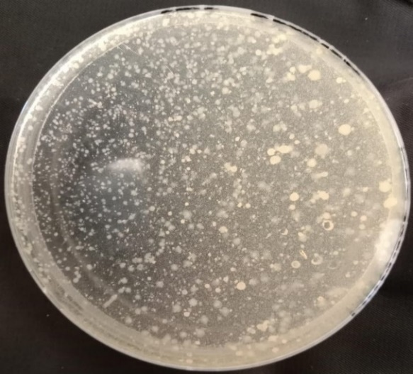
Figure 1. Representative colonies of B. subtilis on nutrient agar. Colonies from soil-derived isolates (n=10) were medium sized, round, opaque, flat and gray-white in color, displaying consistent morphology across all samples
  - Growth and colony characteristics of B. subtilis on Blood and LB agar
Colonies previously confirmed as Gram positive bacilli, motile and spore forming on nutrient agar were further streaked on LB and rabbit blood agar. Plates were then incubated for 24-48 hours at 37°C. On blood agar, colonies appeared gray-white, round, flat, opaque, and exhibited complete hemolysis. However, on LB agar, colonies appeared as round, flat, gray-white, medium sized and opaque (Figure 2).
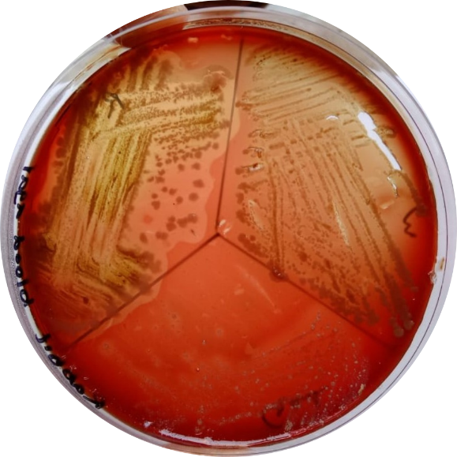 | 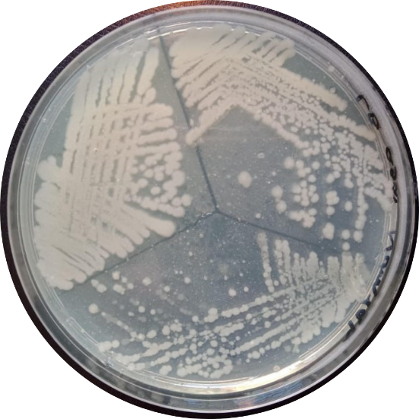
Figure 2: Representative picture of B. subtilis isolated from soil on Blood agar and LB agar (n=10).
  - Biochemical characterization of B. subtilis
Biochemical characterization of B. subtilis was performed for confirmation. The results showed that the isolates were capable of metabolizing glucose with acid production, while no fermentation was observed for lactose or maltose. The Voges-Proskauer (VP) test was positive, indicating production of acetoin, whereas both the indole production and methyl red (MR) tests were negative (table 2).
Table 2. Biochemical profile of B. subtilis isolates recovered from soil samples (n=10)
Chemical tests | Observations | Results
Catalase test | Bubble and gas development | Positive
Methyl red test | No color change | Negative
Voges Proskauer test | Color change | Positive
Indole test | No ring formation and no color change | Negative
Glucose acid production | Gas formation | Positive
Maltose fermentation | No gas production | Negative
Growth in high salt concentration | Characteristic growth observed | Positive

  - Phenotypic adaptation of B. subtilis across solid, semi solid and liquid media
The phenotypic responses and growth patterns (as shown in figure 3) of B. subtilis were evaluated across solid, semi-solid and liquid media. These conditions allowed assessment of changes in motility and biofilm formation as shown in table 3.
Table 3. Phenotypic characterization of B. subtilis on solid, semi-solid and liquid mediums isolated from soil (n=10)
Parameters | Solid media | Semi solid media | Liquid medium
Agar consistency | 0.7% | 0.6% | 0.4%
Motility | No motility | Slide motility | High motility
Biofilm | Thick biofilm | Slide biofilm | Thin biofilm
Observations | On solid media bacterial growth proliferate and colonies expanded both in vertical and horizontal directions | bacterial cells infiltration observed. on semi solid medium  Collective migration of bacteria while proliferating and consuming nutrients | In liquid interface motile cells swim individually.  B. subtilis restrict growing cells.  Construct pellicle where Oxygen is high

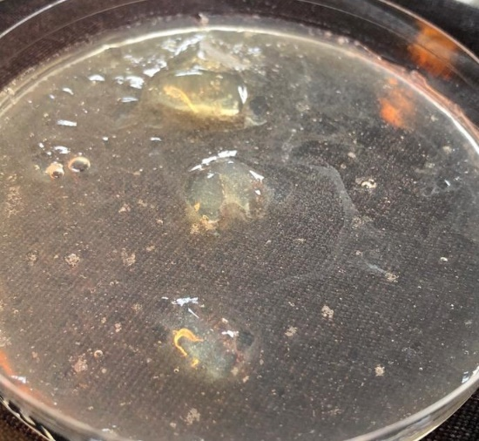  A | 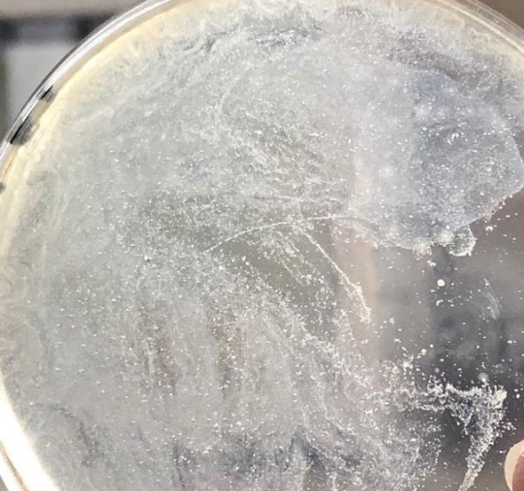  B | 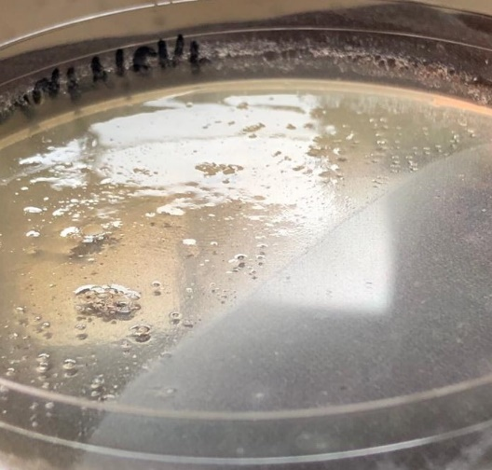  C
Figure 3. Representative figures showing the growth and phenotypic behavior of B. subtilis on (A) solid media, (B) semi-solid media and (C) liquid media, including colony formation, collective motility with ring patterns and pellicle formation at the air-liquid interface
  - Assessment of Biofilm production in B. subtilis
The biofilm forming ability of the tested B. subtilis isolates was evaluated using the crystal violet assay. Based on the calculated OD values, the isolates exhibited varying degree of biofilm formation (as shown in figure 4). Out of the total isolates, isolates 3,4 and 8 were categorized as weak biofilm producers. Isolates 1, 2, 7, 10, 11 and 12 demonstrated moderate biofilm forming ability, while isolates 4, 6 and 9 were identified as strong biofilm producers. However, isolate 13 served as the negative control and showed no significant biofilm formation.
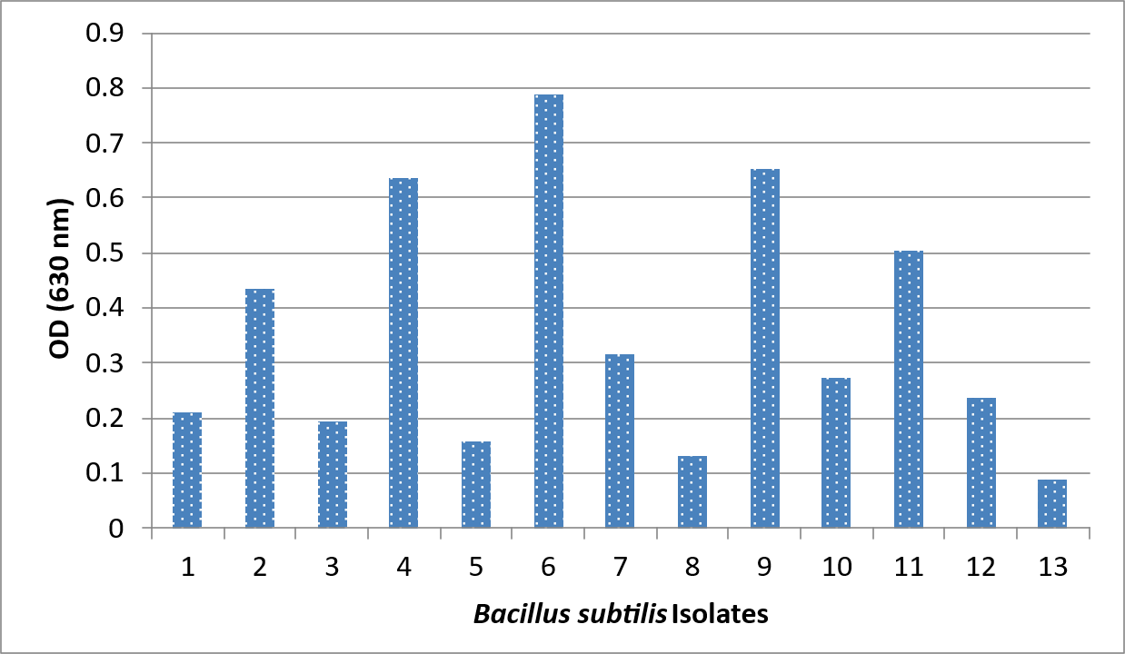
Figure 4. Biofilm formation by B. subtilis isolates assessed using a microtiter plate assay. Cultures were adjusted to OD₆₀₀=0.2, stained with crystal violet, and absorbance measured at 550nm using a Thermo Multiskan ™ FC reader (n = 10).
  - Antimicrobial activity of B. subtilis against Pathogenic microbes
The antibacterial activity of B. subtilis isolates was evaluated against five different pathogenic bacteria isolated from different sources. In result, zone of inhibition was only observed against E. coli, while no zone of inhibition was detected against S. aureus, P. aeruginosa, S. typhi and S. typhimurium depicted in figure 5. The antibacterial positivity rate was 20% (1/5). Overall, the isolates showed limited, narrow spectrum antibacterial activity despite universal biofilm formation.

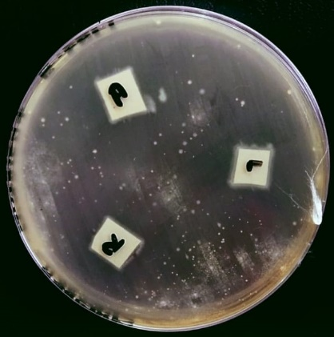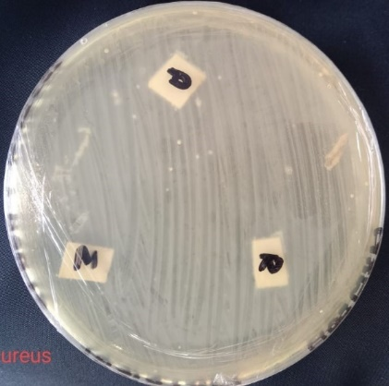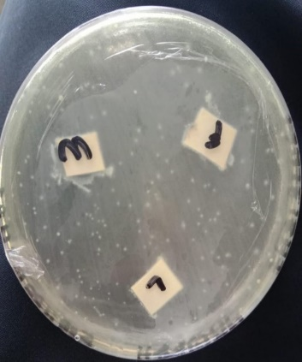
C
B
A
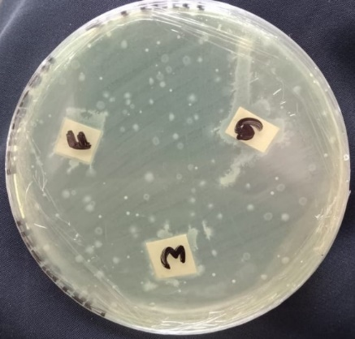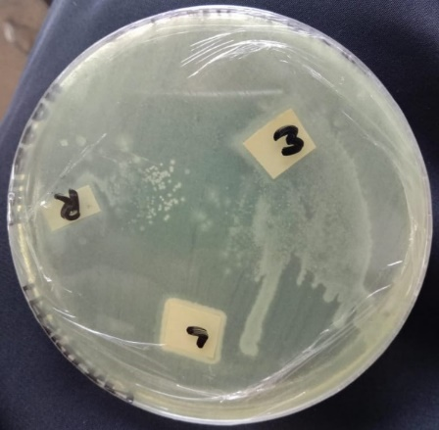
E
D
Figure 5. Antibacterial activity of B. subtilis isolates against five pathogenic bacteria. (A) a zone of inhibition was observed only against E. coli. No zone of inhibition was detected against (B) S. aureus (C) P. aeruginosa (D) S. typhi (E) S. typhimurium respectively.
- DISCUSSION
The well studied Gram positive, spore forming bacterium B. subtilis is found in soil and diverse environmental niches. Its physiological adaptability, which includes sporulation, motility, biofilm formation, and the synthesis of various bioactive secondary metabolites, is largely responsible for its ecological success (Zhang et al. 2025). Because of these characteristics, it is a valuable organism in biotechnology, agriculture, and biomedical applications, especially as a probiotic substitute for antibiotic growth promoters and a biocontrol agent (Gayithri et al. 2026). In current study B. subtilis was isolated from soil samples in the current investigation and identified using morphological, microscopic, and biochemical traits. The isolates' rod-shaped, Gram-positive morphology, motility, and spore formation were all in line with the species' typical taxonomic descriptions. Biochemical profiling (catalase positive, Voges-Proskauer positive, indole and methyl red negative) further verified their identity, while colony morphology on LB and blood agar displayed typical opaque, irregular growth patterns. These results align with the phenotypic traits of environmental Bacillus isolates that have been previously documented (Zeigler and Perkins 2021).
The isolates exhibited unique developmental behaviors on solid, semi-solid, and liquid media, demonstrating strong adaptability across various growth conditions. Interestingly, pellicle formation at the air–liquid interface was seen, which is indicative of B. subtilis developing structured biofilms in oxygen-rich environments. This species' highly coordinated multicellular process of biofilm formation is controlled by intricate genetic networks and environmental cues (Vlamakis et al. 2013). In soil ecosystems, these surface-associated communities promote long-term persistence and improve survival under stress.
The ability to form biofilms was demonstrated by every isolate in this investigation, suggesting that soil-derived B. subtilis populations share this trait. Extracellular polymeric substances (EPS), such as polysaccharides and structural proteins, which offer mechanical stability and environmental protection, are the main mediators of biofilm formation in B. subtilis (Vlamakis et al. 2013). The ecological fitness of B. subtilis as a dominant member of soil microbial communities and its potential role in plant-microbe interactions and rhizosphere colonization are highlighted by the universal presence of biofilm formation among isolates (Sharma et al. 2026; Gayithri et al. 2026).
The current study found limited antibacterial activity despite strong biofilm-forming ability. Only E. coli was inhibited, while S. aureus showed no activity. This implies strain-dependent variability in the production of antimicrobial compounds, a phenomenon in B. subtilis populations that has been extensively studied. The production of antimicrobial metabolites such as surfactin, iturin, and fengycin is highly regulated and strongly influenced by environmental conditions and genetic background (Qin et al. 2025).
The calculated antibacterial positivity rate of 20% (1/5) further supports the limited antimicrobial spectrum observed under the experimental conditions. The absence of activity against S. aureus may be attributed to its clinical origin and potential resistance mechanisms, as pathogenic strains often exhibit increased tolerance to antimicrobial peptides and metabolic inhibitors (Alam et al. 2025). This highlights how crucial target strain variability is when assessing environmental isolates' antimicrobial efficacy.
Crucially, the findings show a weak relationship between antibacterial activity and biofilm formation. Antibacterial activity is dependent on the biosynthesis of specialized secondary metabolites, whereas biofilm formation is mainly linked to environmental adaptation, surface colonization, and survival strategies. Strong biofilm producers do not always have high antimicrobial activity because these processes are independently regulated (Saiyam et al. 2024). Therefore, in B. subtilis isolates, biofilm formation should not be regarded as a direct predictor of antibacterial potential.
This study demonstrates that, in laboratory settings, B. subtilis is a highly adaptive, potent biofilm-forming bacterium with limited, strain-dependent antibacterial activity. Its antimicrobial potential is contingent and necessitates additional molecular research to maximize metabolite synthesis and regulatory comprehension.
- CONCLUSION
In conclusion, soil derived B. subtilis isolates demonstrated significant phenotypic diversity across various environments and a strong capacity to form biofilms. Only E. coli was susceptible to their restricted and selective antibacterial activity, with a weak correlation to biofilm formation. These results underline the need for additional molecular-level research while supporting its potential in biocontrol and agriculture.
DECLARATIONS
Funding:
All authors declared no funding to disclose.
Acknowledgment:
This work was carried out at the BSL laboratory, University of Agriculture Faisalabad. The authors would like to thank the laboratory staff and faculty for their support and for providing the necessary resources to conduct this research.
Conflicts of interests:
The authors declare that there are no conflicts of interest.
Ethics Approval
This study did not require ethical review, as it did not involve human or animal subjects.
Data Availability:
All the data is available in the article.
Author’s Contribution:
MIA conceptualized the study. NH performed laboratory work and analyzed the results. AA contributed to writing, reviewing and proofreading the manuscript.
Generative AI Statements:
The authors declare that no Gen AI/Deep Seek was used in the writing/creation of this manuscript.
REFERENCES
- Adjei MO, Yu R, Cao X, Fan B, 2025. The mechanisms of Bacillus subtilis as a Plant-Beneficial rhizobacterium in Plant–Microbe interactions. Microorganisms 13: 2823-2840. https://doi.org/10.3390/microorganisms13122823
- Akinsemolu AA, Onyeaka H, Odion S, Adebanjo I, 2024. Exploring Bacillus subtilis: Ecology, biotechnological applications, and future prospects. Journal of Basic Microbiology 64: 1-19. https://doi.org/10.1002/jobm.202300614
- Alam J, Olofintila OE, Moen FS, Noel ZA, Liles MR, Goodwin DC, 2025. Broad antibiosis activity of Bacillus velezensis and Bacillus subtilis is accounted for by a conserved capacity for lipopeptide biosynthesis. Frontiers in Microbiology 16: 1-10. doi: 10.3389/fmicb.2025.1636481
- Çam S, Küçük Ç, Almaca A, 2023. Bacillus strains exhibit various plant growth promoting traits and their biofilm-forming capability correlates to their salt stress alleviation effect on maize seedlings. Journal of Biotechnology 369: 35-42. https://doi.org/10.1016/j.jbiotec.2023.05.004
- Gayithri M, Singh S, Pradhan B, Boorla V, Chand S, 2026. Multifunctional Roles of Bacillus spp. in Sustainable Agriculture: Advances in Biocontrol, Omics, and Ecological Applications. Microbial Ecology 89: 1-20. https://doi.org/10.1007/s00248-026-02709-2
- James G, Cappuccino CW. Microbiology—a laboratory manual, 11th edn),). ISBN No. 978129217578-2.
- Madigan MT, Bender KS, Buckley DH, Sattley WM, Stahl DA, 2021. Ecological Diversity of Bacteria. Brock Biology of Microorganisms 16th Edition; Pearson: Hoboken, NJ, USA 478-518.
- Mukhopadhyay M, Mukherjee A, Ganguli S, Chakraborti A, Roy S, Choudhury SS, Subramaniyan V, Kumarasamy V, Sayed AA, El-Demerdash FM, Almutairi MH, 2023. Marvels of Bacilli in soil amendment for plant-growth promotion toward sustainable development having futuristic socio-economic implications. Frontiers in microbiology 14:1-7. doi: 10.3389/fmicb.2023.1293302
- Qin WQ, Liu YF, Zhou L, Liu JF, Fei D, Xiang KH, Yang SZ, Gu JD, Mu BZ, 2025. Genome mining, structural elucidation and surface-active property of a new lipopeptide from Bacillus subtilis. Microbial Cell Factories 24: 1-10. doi: 10.1186/s12934-025-02723-y
- Ren C, Meng Y, Liu Y, Wang Y, Wang H, Liu Y, Liu C, Fan X, Zhang S, 2025. Probiotic Bacillus subtilis enhances silkworm (Bombyx mori) growth performance and silk production via modulating gut microbiota and amino acid metabolism. Animal Microbiome 7:103-116. https://doi.org/10.1186/s42523-025-00473-1
- Saiyam D, Dubey A, Malla MA, Kumar A, 2024. Lipopeptides from Bacillus: Unveiling biotechnological prospects—Sources, properties, and diverse applications. Brazilian Journal of Microbiology 55: 281-295. DOI:10.1007/s42770-023-01228-3
- Sharma G, Ahmed MM, Ali T, Boudreau PD, Curtis PD, 2026. Microgravity effects on secondary metabolism of plant-affecting bacteria. Microbiology Spectrum 1-24. https://doi.org/10.1128/spectrum.02239-25
- Shinde SS, Gaonkar VV, Mukadam HM, Gaikwad SV, 2025. Bacillus subtilis: A Biological Marvel in the Domain of Agriculture and Environmental Science. In Bacillus subtilis-Functionalities and One Health Applications. Intech open DOI: 10.5772/intechopen.1007131
- Shoaib M, Muzammil I, Hammad M, Bhutta ZA, Yaseen I, 2020. A mini-review on commonly used biochemical tests for identification of bacteria. International Journal of Research Publications 54: 1-7. DOI:10.47119/IJRP100541620201224
- Stepanović S, Vuković D, Hola V, Bonaventura GD, Djukić S, Ćirković I, Ruzicka F, 2007. Quantification of biofilm in microtiter plates: overview of testing conditions and practical recommendations for assessment of biofilm production by staphylococci. Acta Pathologica, Microbiologica, et Immunologica Scandinavica 115: 891-899. https://doi.org/10.1111/j.1600-0463.2007.apm_630.x
- Vlamakis H, Chai Y, Beauregard P, Losick R, Kolter R, 2013. Sticking together: building a biofilm the Bacillus subtilis way. Nature Reviews Microbiology 11: 157-168. doi: 10.1038/nrmicro2960
- Zeigler DR, Perkins JB, 2021. The genus bacillus. In Practical handbook of microbiology. CRC Press. 249-278
- Zeng Q, Zhao Y, Zhuang L, Jiang W, Wang L, Zhang J, Wang L, Guo H, Li Y, Wang Z, Li Y, 2025. Comparative genomics of Bacillus velezensis and Bacillus subtilis reveals distinction and evolution of lipopeptide antimicrobial gene clusters. BioMed Central genomics 26: 1-14. https://doi.org/10.1186/s12864-025-12234-0
- Zhang T, Gong Z, Zhou B, Rao L, Liao X, 2025. Recent progress in proteins regulating the germination of Bacillus subtilis spores. Journal of Bacteriology 207: 1-18. https://doi.org/10.1128/jb.00285-24

