Interactive Effects of Altitude and Liquid Organic Fertilizer on the Growth and Yield of Topo Tidore Shallot in a Clove Plantation System
Sofyan Samad^{1*}, Radhiatunnisa S. Samad²
¹Department of Agrotechnology, Faculty of Agriculture, Khairun University, Ternate, North Maluku, Indonesia
²Department of Forestry, Faculty of Agriculture, Palangka Raya University, Palangka Raya, Central Kalimantan, Indonesia
*Corresponding Author: sofyansamad12@gmail.com
radhiatunnisa.samad@faperta.upr.ac.id
Abstrak
The Topo Tidore shallot variety is a leading horticultural commodity in North Maluku with high economic potential. However, its productivity remains relatively low due to suboptimal cultivation practices and cultivation under the shaded agroecosystem of clove stands. This study aimed to evaluate the effect of the interaction between altitude and liquid organic fertilizer (LOF) on the growth and yield of the Topo Tidore shallot variety. The research was conducted at two altitudes, namely, 50 m and 500 m above sea level, with six levels of LOF doses: 0 (control), 5, 10, 15, 20, and 25 mL L⁻¹. The observed parameters included plant height, number of leaves, number of tillers, and fresh and dry weights of the plants. The results showed that altitude had a significant effect on all parameters at 50 m above sea level, and growth and yield were higher than those at 500 m above sea level. The application of LOF improved growth at both locations, with the optimum dose of 15 mL L⁻¹ providing the best results: plant height reaching 44.67 cm (at 40 days after planting), seven leaves, 10 tillers, and fresh and dry weights of 52.67 g and 28.33 g, respectively. Overall, the best treatment combination was obtained at an altitude of 50 m asl with a LOF dose of 15 mL L⁻¹, which was optimal for enhancing the growth and yield of shallots.
Keywords: Allium ascalonicum L., altitude, clove stand, liquid organic fertilizer, Topo Tidore shallot

Introduction
Red onions (Allium ascalonicum L.) are a strategic horticultural commodity of high economic value and play a vital role as a primary cooking ingredient in the Indonesian diet. The relatively stable and increasing demand, both for household needs and the food industry, makes this commodity a contributor to inflation stability and national food security (Muis et al. 2023; Domingo, 2023). One local genetic resource with promising development potential is the Topo Tidore red onion variety, which originates from Topo Village, Tidore Island, North Maluku Province, Indonesia. This variety has long been sustainably cultivated by local farmers and demonstrates a high level of adaptation to local agroecosystem conditions, including dryland areas and cultivation systems under perennial tree canopies. Morphologically and chemically, local varieties possess distinctive characteristics, particularly relatively high levels of sulfur and phenolic compounds, resulting in a stronger aroma and sharper flavor than introduced varieties (Santoso et al. 2026; Zhao et al. 2021). Local varieties generally exhibit better tolerance to specific environmental conditions, such as temperature fluctuations, low light intensity, and limited soil fertility, making them suitable for development within sustainable agricultural systems based on local knowledge (Gupta et al. 2024; Rahmawan et al. 2025).
Nevertheless, the productivity of Topo Tidore shallots remains relatively low compared to that of national high-yielding varieties. This situation is influenced by traditional cultivation practices, declining soil fertility due to continuous planting without land improvement, and limited application of fertilization technology. The cultivation system under clove canopies also creates a shaded microclimate with low light intensity, thereby reducing the rate of photosynthesis and plant growth (Fukuda, 2019; Shafiq et al. 2021). Elevation is also a key environmental factor influencing variations in temperature, light intensity, humidity, and soil characteristics, which directly impact plant physiological processes, including photosynthesis, metabolism, and water-use efficiency (Pise et al. 2025; Elouattassi et al. 2024; Sun et al. 2026).
Increasing productivity under these conditions requires effective and environmentally friendly fertilization strategies, one of which is the use of liquid organic fertilizer (LOF). LOFs, such as , which contain decomposing microorganisms and essential nutrients, have been shown to increase nutrient availability and soil microbial activity, thereby supporting plant growth and productivity (Saparso et al. 2021; Liang et al. 2022; Qiang et al. 2025). However, the effectiveness of fertilization in shaded systems is determined not only by the dose but also by interactions with environmental conditions, particularly elevation, which influences plant physiological responses (Yeshiwas et al. 2023; Zhang et al. 2024). Therefore, this study was conducted to evaluate the interaction between elevation and LOF concentration on the growth and yield of the Topo Tidore onion variety under clove canopies as a location-specific, adaptive, and sustainable cultivation technology.
Research Methodology
Time and Location of the Study
The study was conducted from September to November 2025 in the North Tidore District, Tidore Islands City, North Maluku Province. The study sites included two neighborhoods representing different elevations: Rum (50 m asl) and Jaya (500 m asl). Both locations are situated on red onion cultivation plots beneath 15-20 years old clove tree stands with relatively uniform shading levels (±40-50%). These locations were selected based on their contrasting elevations and the suitability of the land for examining the influence of environmental factors on plant growth and yield.
Equipment and Materials
The equipment used in this study included a measuring tape, analytical balance, vernier caliper, thermometer, hygrometer, lux meter, and agricultural tools such as a hoe, machete, rake, and bucket, along with writing materials and documentation tools for data recording. The materials used included Topo Tidore variety red onion seed bulbs with a diameter of 1.5-2.0 cm, liquid organic fertilizer (LOF), mature chicken manure (10 tons ha⁻¹), topsoil (0-20 cm), water for irrigation and fertilizer application, and botanical pesticides for pest and disease control.
Research Design
This study used a factorial randomized block design (RBD) with two factors: elevation (K: 50 and 500 m asl) and liquid organic fertilizer concentration (N: 0, 5, 10, 15, 20, and 25 cc L⁻¹). The 2 × 6 treatment combinations (12 total) were replicated three times, resulting in 36 experimental units. Each unit consisted of a 1.5 × 2 m plot (3 m²) with 20 × 20 cm spacing, accommodating 50 plants per plot.

Research Implementation
The field was cleared, tilled (20–30 cm), and left for 3–5 days before forming raised beds (1.5 × 2 m; 30 cm height; 50 cm spacing) and applying 10 t ha⁻¹ of chicken manure (±3 kg plot⁻¹). Red onion bulbs of the Topo Tidore variety (1.5–2.0 cm diameter; 2–3 months dormancy) were soaked in a botanical fungicide for 15 min and planted at 2–3 cm depth with 20 × 20 cm spacing, followed by light irrigation. liquid organic fertilizer was applied to the root zone weekly from 7 to 40 days after sowing (six applications; 1 L plot⁻¹). Crop maintenance included daily watering, periodic weeding and hilling (10, 20, 30, and 40 DAS), and preventive pest and disease control using neem and soursop leaf extracts every 10 days. Harvesting was conducted at 60–70 days after planting when 70–80% of leaves had yellowed and wilted; bulbs were then cleaned and air-dried for about seven days prior to yield assessment.

Observation Parameters

The observed parameters comprised environmental, growth, and yield variables. Environmental parameters included air temperature, relative humidity, light intensity under the clove canopy, and rainfall. Growth parameters consisted of plant height (measured at 10–50 DAP), number of leaves, and number of suckers (observed at 30 and 40 DAP). Yield parameters included fresh and dry tuber weights per clump, measured at harvest and after 7 days of drying, respectively. Data were analyzed using a factorial model based on Douglas C. Montgomery (2017), expressed as:

$$Y_{ijk}=μ+K_{i}+N_{j}+(KN)_{ij}+β_{k}+ε_{ijk}$$
$Y_{ijk}$is the observed value; $μ$is the overall mean; $K_{i}$and $N_{j}$are the main effects of factors K and N; $\left(KN)_{ij}\right.$is their interaction effect; $β_{k}$is the block/replication effect; and $ε_{ijk}$is the experimental error.
Data Analysis
Observational data were analyzed using analysis of variance (ANOVA) at a 5% significance level to determine the effects of each factor and its interactions. If the analysis results indicated a significant effect, a post hoc comparison of means was performed using Duncan’s test at a 5% significance level. All data analyses were performed using IBM SPSS Statistics version 25 and Orange Data Mining software.
Results and Discussion
Environmental Conditions
Environmental conditions at the two study sites, namely, K1 (50 m asl) and K2 (500 m asl), differed and could potentially influence plant growth and yield. These differences in elevation are associated with variations in temperature, humidity, light intensity, and rainfall, which play a crucial role in determining plant physiological responses, as shown in Table 1.
Table 1. Average environmental conditions during the study at two elevations
Parameter | K1: Elevation 50 m asl | K2: Elevation 500 m asl
Air temperature (°C) | 28.4 ± 1.2 | 25.6 ± 0.8
Relative humidity (%) | 82.5 ± 3.4 | 85.2 ± 2.9
Light intensity (lux) | 12.45 ± 1.850 | 15.32 ± 2.100
Rainfall (mm/month) | 185.5 ± 25.3 | 210.8 ± 30.6
The differences in environmental conditions between locations K1 and K2, as shown in Table 1, reflect variations in microclimate that could potentially influence the success of Topo shallot (A. ascalonicum L.) cultivation under clove stands. In general, lowlands with higher temperatures tend to support plant physiological activities, such as photosynthesis, respiration, and bulb formation (Gedam et al. 2021), whereas highlands with lower temperatures can suppress plant metabolic rates (Havey, 2024). An elevation difference of approximately 450 m results in a vertical temperature gradient (±0.6 °C per 100 m), creating distinct environmental conditions that impact habitat suitability and plant productivity (Faticov et al. 2024). This is reflected in the higher average temperature at K1 (28.4 °C) compared with K2 (25.6 °C), indicating that conditions at higher elevations tend to slow respiration and transpiration rates, yet can enhance water-use efficiency and extend the vegetative growth phase (Denney et al. 2024; Irshad et al. 2024).
Based on the research results, the relative humidity in K2 (85.2 %) was higher than that in K1 (82.5%), as it is inversely related to temperature. Humidity above 80% creates an environment conducive to the development of airborne pathogens such as Phytophthora infestans and Colletotrichum spp. (Garnica & Ojiambo, 2024; Ma et al. 2025). At the elevation of K2 (500 m above sea level), light intensity is higher (15,320 lux) compared to K1 (12,450 lux) due to reduced atmospheric thickness. High light intensity has the potential to increase photosynthetic productivity, but it also increases the risk of photorespiration and oxidative stress if plant defense mechanisms are not optimally activated (Streb, P., et al. 2025; Arif & Riadi, 2024). Additionally, higher humidity and rainfall in highland areas also potentially increase the risk of pathogen development, necessitating adaptive cultivation management strategies tailored to local environmental conditions.
The light intensity at K2 was higher than that at K1, indicating that solar radiation conditions at higher elevations have the potential to increase the photosynthetic efficiency of plants growing beneath clove canopies (Samad et al. 2025). In the cultivation system under clove canopies, the light intensity received by shallot plants is greatly influenced by the canopy structure of the shade trees, such that variations in height can create different microclimatic conditions.
Higher rainfall in Plot K2 also increases soil moisture availability; however, it can also lead to excessive soil moisture and potentially trigger root or tuber diseases. Conversely, the relatively lower rainfall in Plot K1 allows for better soil drainage, thereby supporting optimal root development and tuber formation (Shafiq et al. 2021). Microclimatic differences between lowland and upland areas within clove agroforestry systems must be considered (Samad et al. 2026) in the management of shallot cultivation, including shade management, water management, and disease control, to optimize plant growth and productivity (Marsh et al. 2022; Fan et al. 2023). Rainfall in K2 is higher (210.8 mm/month) than that in K1 (185.5 mm/month) due to orographic rainfall. The higher rainfall variability in K2 poses a challenge for water management; however, the greater water availability supports highland agricultural systems (Gong et al. 2025; Baghanam & Mohebbi, 2025). The 450-m elevation difference results in two distinct microclimate typologies. K2 (500 m asl) is more suitable for highland horticulture, although it faces disease management challenges due to high humidity. K1 (50 m asl) is better suited for lowland crops tolerant of warm temperatures (Mohanapriya et al. 2025; Cristina et al. 2022).
Plant height
The results of the observations of the height of Topo Tidore onion plants in response to various concentrations of liquid organic fertilizer at elevations K1 (50 m asl) and K2 (500 m asl), observed at 10, 20, 30, 40, and 50 days after planting, are presented in Figure 1.
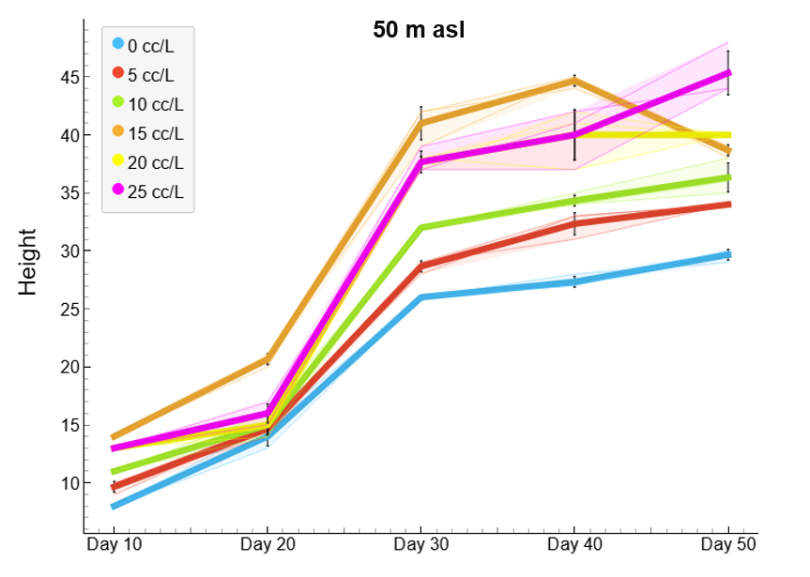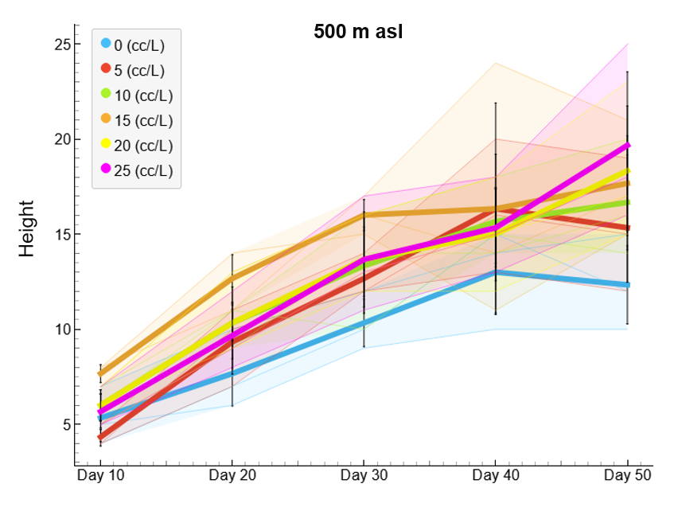
- (b)
Figure 1. Growth curves of Topo onion at elevations of 50 m above sea level (a) and 500 m above sea level (b) with various LOF concentrations
Observations of the plant height of the Topo Tidore red onion variety at the two elevations showed consistently different growth patterns as the plants aged, as presented in Figure 1. In general, plants at K1 (50 m asl) exhibited faster growth and greater height than those at K2 (500 m asl) at every observation time point (10-50 days after sowing). This indicates that the environmental conditions in the lowlands are more conducive to plant physiological activity. Conversely, growth at K2 was relatively slower, with lower plant heights, reflecting the presence of limiting factors, such as lower temperatures and higher humidity, that can affect plant metabolism. Additionally, both locations were situated under clove canopies, resulting in limited light intensity, which further suppressed the rate of photosynthesis, particularly at K2.
LOF is a biofertilizer containing decomposing microorganisms and bioactive compounds that enhance nutrient availability, support plant biological activity, and stimulate root growth (Yang et al. 2020). At different elevations, environmental factors, such as temperature and light intensity, influence the rate of photosynthesis and nutrient uptake. This indicates that the effectiveness of liquid organic fertilizers is highly influenced by local agroecological conditions. Plant responses to the application of LOF at both locations showed different patterns, as shown in Figure 1. At K1 (50 m asl), treatment N3 (15 mL L⁻¹ of water) produced the tallest plants (14 cm) in the early phase and differed significantly from the control, indicating that this dose is the optimal level to support early growth (Fan et al. 2023). Increasing the dose beyond N3 to N4 and N5 did not result in a significant increase; in fact, growth tended to stagnate or decline, likely due to disruptions in osmotic balance or mild toxicity effects during the early growth phase. At K2 (500 m asl), plant height was generally lower than that at K1, where the control (N0) reached only 5 cm, indicating the strong influence of environmental factors (Table 1) as growth limiters.
Nevertheless, the application of still resulted in improved growth, particularly in the N3 treatment, which reached 8 cm, thus demonstrating the important role of liquid organic fertilizer in improving plant physiological conditions in suboptimal environments (Akhmad et al. 2024). Subsequently, at 20 days after sowing at height K1, all treatments exhibited relatively uniform plant height (14-16 cm), indicating that the effects of fertilizer dose began to converge as the root system developed and nutrient uptake efficiency increased. Conversely, at K2, the N3 treatment again showed the highest value (13 cm) and was significantly different from the control (8 cm) compared to K1, indicating that the variability in response among treatments remained high owing to environmental stress. This increase indicates the cumulative effect of the optimal liquid organic fertilizer during the late vegetative phase, related to the role of in providing nutrients sustainably, as well as its phytohormone content that stimulates cell division and elongation (Samad et al. 2022; Enujeke & Anwuli-Okoh, 2024). This reinforces that under suboptimal environmental conditions, such as in highland areas, the application of liquid organic fertilizer plays a crucial role in enhancing nutrient availability and helping plants adapt to stress (Chowdhury et al. 2025; Faticov et al. 2024).
Overall, the 15 mL L⁻¹ water dose (N3) consistently emerged as the best treatment at both locations, although the growth response was more optimal at K1 than at K2. Thus, the use of LOF at this dose is recommended to enhance the early growth of shallots, particularly under favorable conditions. However, at sites with environmental constraints, additional management support, such as adjusting planting distances and water management, is required to optimize yields (FAO, 2024).

Number of Leaves
The number of leaves on Topo Tidore onion plants treated with various concentrations of liquid organic fertilizer at elevations K1 (50 m above sea level) and K2 (500 m above sea level) observed at 30 and 40 days after planting (DAP) showed varying responses across treatments. The differences in the number of leaves formed reflect the interaction between elevation and fertilizer concentration, as shown in Figure 2.
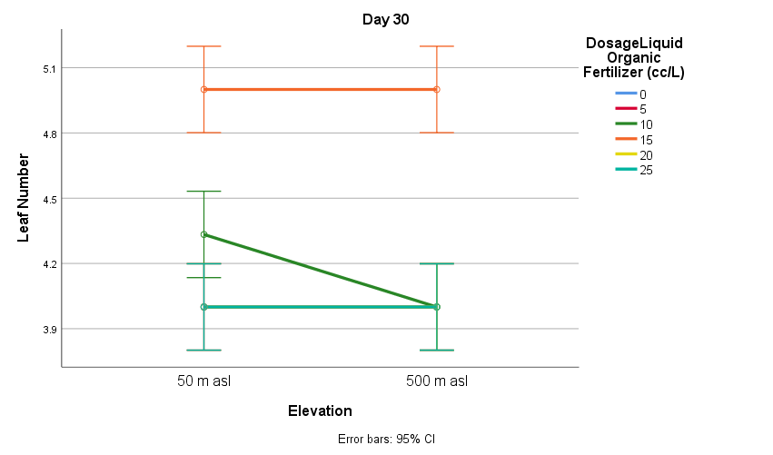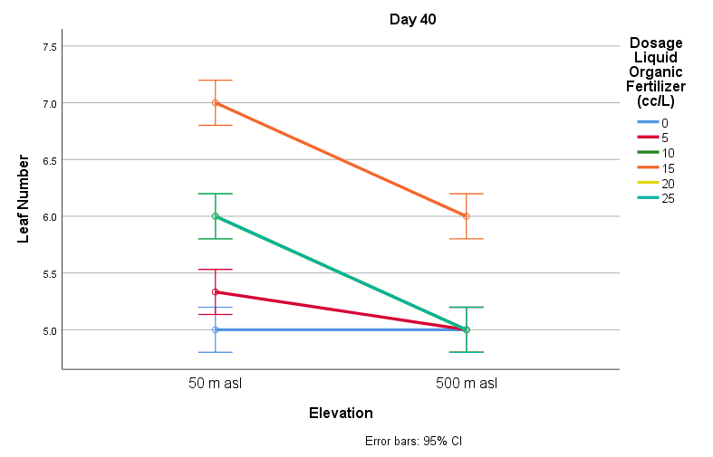
Figure 2. Comparison of the number of leaves at various LOF doses and elevations
Figure 2 shows the dynamics of the number of leaves of the Topo Tidore red onion variety at 30 and 40 days after sowing in response to the interaction between elevation and LOF dose. The results indicate that the number of leaves was generally higher at 50 m asl than at 500 m asl, particularly at doses of 1525 mL L⁻¹. At 30 DAS, an increase in leaf number began to be observed at doses of 10–15 mL L⁻¹, reaching an optimum at 15–20 mL L⁻¹ in the lowlands, and continuing to increase at 40 DAS with more progressive vegetative growth in K1. These conditions indicate that the lowland environment is more conducive to fertilizer effectiveness, primarily because of more optimal temperature and light intensity for enhancing photosynthesis (Fukuda, 2019; Wu et al. 2025). However, both study sites were located under clove tree canopies; therefore, the plants experienced shading. Nevertheless, the light intensity at K1 was relatively more favorable than that at K2, whereas in the highlands, greater variations in temperature and humidity, along with shading, reinforced growth-limiting factors (Pise et al. 2025).
Number of Thillers
The results of observations on the number of thillers of Topo Tidore onion plants in response to various concentrations of liquid organic fertilizer at elevations K1 (50 m above sea level) and K2 (500 m above sea level), observed at 30 and 40 days after planting (DAP), are presented in Figure 3.
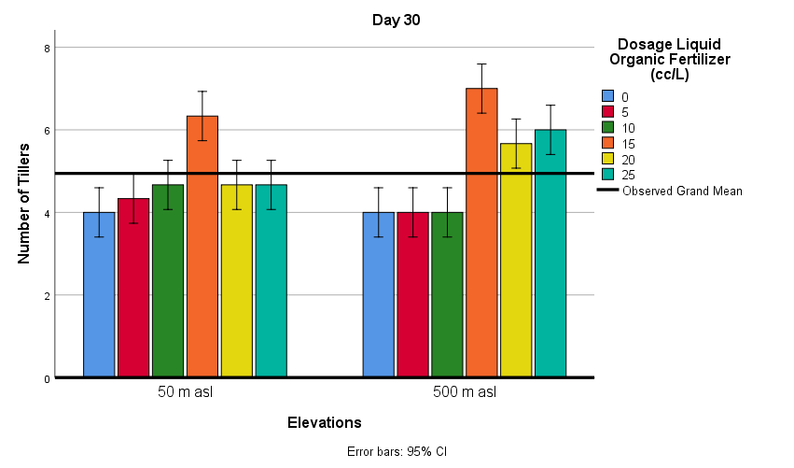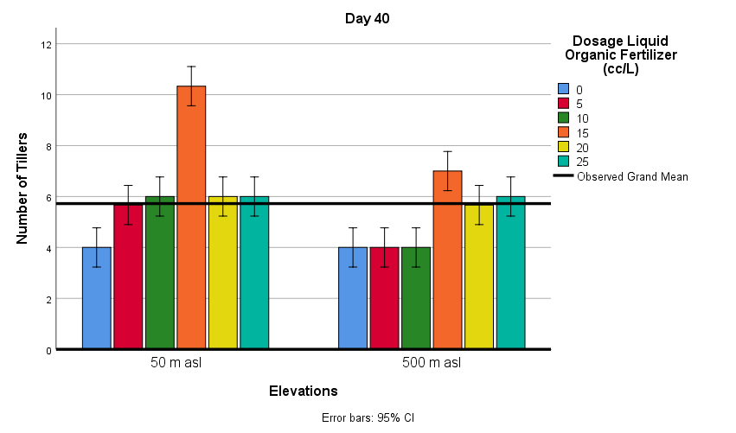
Figure 3. Graph of the number of shallot tillers
The number of shallot tillers showed different responses to LOF doses at the two elevations. At 50 m above sea level, the number of tillers ranged from 4 to 6 (at 30 days after transplanting) and increased to about 10 at 40 days after transplanting, with the highest value observed at the 15 mL L⁻¹ dose, while at higher doses the number tended to plateau. At the 500 m asl location, the number of bulbs was lower and more stable, at around 4-7 bulbs at both observation times, with the highest value also at the 15 mL L⁻¹ dose but without a significant increase (Figure 3). In general, the 15 mL L⁻¹ dose was the most optimal, and the higher results at 50 m above sea level indicate that environmental conditions were more conducive to tiller formation (Shah et al. 2025).
Physiologically, tillering is related to lateral meristem activity and the distribution of photosynthates, which are influenced by temperature and light intensity (Chachar et al. 2025); thus, lowland conditions (K1) with more optimal temperatures tend to enhance photosynthetic activity and tillering (Yeshiwas et al. 2023). The increase in the number of tillers in the LOF treatment also indicates that liquid organic fertilizer can enhance nutrient availability and soil microorganism activity, which support vegetative growth (Ali et al. 2025; Fan et al. 2023). However, the response in K2 was relatively lower, indicating that environmental factors related to elevation differences resulted in lower temperatures and became the primary limiting factor, even though the fertilizer dose was increased (Gupta et al. 2024). The results of the study regarding tiller number were determined by the combination of an appropriate fertilizer dose (optimum 15 mL L⁻¹) and suitable elevation conditions.
Plant biomass
Figure 4 shows the response to the application of liquid organic fertilizer at two elevations, namely K1 (50 m above sea level) and K2 (500 m above sea level), on the fresh weight and dry weight of Topo Tidore shallots at harvest.
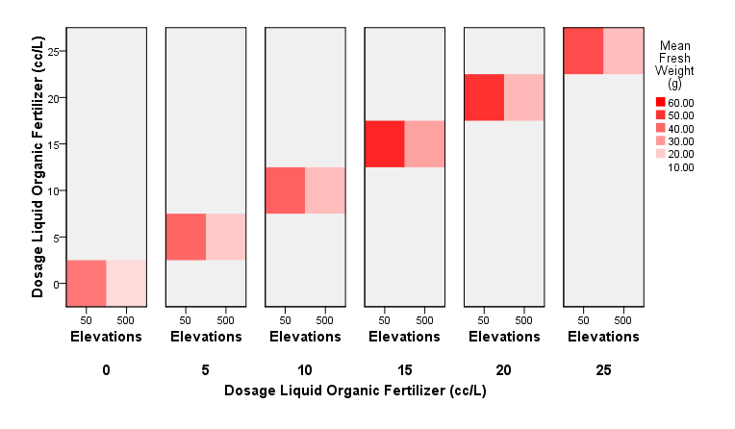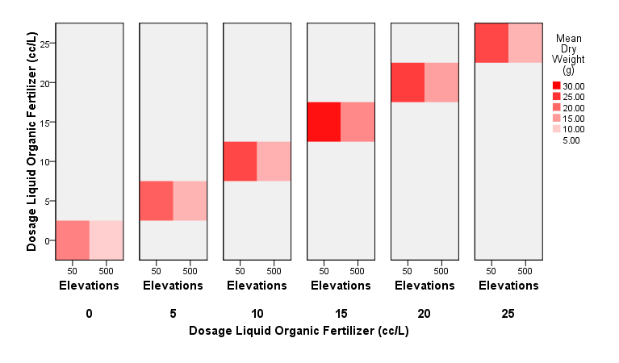
Figure 4. Graph of fresh weight and dry weight at different elevations
The results of the study indicate that increasing the dose of liquid organic fertilizer (LOF) generally increases the number of leaves and tillers, particularly at an elevation of 50 m above sea level with an optimal dose of 15 mL L⁻¹. At an elevation of 500 m above sea level, the plant response was relatively more stable within the dose range of 15–25 mL L⁻¹. Based on the research results, an increase in the LOF dose correlated with increased vegetative growth, which in turn supported biomass accumulation and fresh plant weight, as shown in Figure 4. Fresh weight was used as the primary parameter to evaluate plant growth, reflecting water accumulation and fresh tissue, whereas dry weight indicated a more stable accumulation of biomass resulting from photosynthesis. Measurements of these two parameters indicated the efficiency of organic matter formation under various LOF dosage treatments. These findings demonstrate that LOF can optimally supply macro- and micronutrients, making them easily absorbed and thereby enhancing photosynthetic efficiency and biomass formation (Liang et al. 2022; Zhang et al. 2024).
Plant responses are also influenced by environmental conditions (Ashfaq et al. 2024); both study sites were located under clove tree canopies, resulting in lower light intensity. Shade conditions affect plant physiological activity; therefore, the effectiveness of LOF is highly dependent on the appropriate dosage to optimize nutrient uptake. Furthermore, LOF improves soil properties and helps plants adapt to environmental stress; therefore, differences between treatments remain evident until the final phase (Mutia et al. 2024; Afaf et al. 2024).
Conclusion
The elevation and application of liquid organic fertilizer (LOF) significantly affected the growth and yield of the Topo Tidore onion variety in a cultivation system under clove trees. At an elevation of 50 m above sea level, more optimal environmental conditions were provided compared with those at 500 m above sea level, which improved plant growth parameters and yield. The application of LOF improved plant performance at both elevations, with an optimal dose of 15 mL L⁻¹ consistently yielding the highest growth and biomass. Therefore, a combination of 50 m asl and a LOF dose of 15 mL L⁻¹ is recommended as an effective and sustainable fertilization strategy to increase the productivity of Topo Tidore shallots under shaded conditions.

Reference

Afaf S, Suwarto, Qadir A and Maharijaya A, 2024. Growth and production of shallot (Allium ascalonicum L.) at various planting space and fertilizers dose of NPKMg. Jurnal Hortikultura Indonesia 15(2): 62–69. https://doi.org/10.29244/jhi.15.2.62-69

Akhmad ZA, Yassi A, Bahrun AH and Zaenab S, 2024. Effect of liquid organic fertilizer and urea on the growth and productivity of rice with asymmetrical irrigation. SABRAO Journal of Breeding and Genetics 56(4): 1597–1608. https://doi.org/10.54910/sabrao2024.56.4.25

Ali WM, Sultan SME, Ali AM, Hassan FAS, El-Sayed AA and Abd El-Mageed TA, 2025. Organic fertilizers and Azotobacter: Effects on onion growth, yield, metabolites, and soil fertility. AMB Express 15: 86. https://doi.org/10.1186/s13568-025-01895-5

Arif SH, Haring F and Riadi M, 2024. Improving growth and productivity of shallot (Allium ascalonicum L.) applied using organic and inorganic fertilizer. Journal of Agriculture Faculty of Ege University 61(3): 297–305. https://doi.org/10.20289/zfdergi.1385019

Ashfaq W, Brodie G, Fuentes S, Pang A and Gupta D, 2024. Silicon improves root system and canopy physiology in wheat under drought stress. Plant and Soil 502: 279–296. https://doi.org/10.1007/s11104-023-06202-4

Baghanam AH and Mohebbi A, 2025. Understanding orographic precipitation pattern in Arizona: Implications for climate change. Journal of Hydrology: Regional Studies 62: 102793. https://doi.org/10.1016/j.ejrh.2025.102793

Cardarelli M, El Chami A, Iovieno P, Rouphael Y, Bonini P and Colla G, 2023. Organic fertilizer sources distinctively modulate productivity, quality, mineral composition, and soil enzyme activity of greenhouse lettuce grown in degraded soil. Agronomy 13(1): 194. https://doi.org/10.3390/agronomy13010194

Chachar Z, Xue X, Fang J, Chen M, Chen W, Li X, Ahmed N, Chachar S, Ali A, Chen Z, Fan L, Lai R and Qi Y, 2025. Genetic and molecular insights into tiller development and approaches for crop yield improvement. Frontiers in Plant Science 16: 1532180. https://doi.org/10.3389/fpls.2025.1532180

Chowdhury M, Watson O, Samarakoon UC, Altland JE and Moine J, 2025. Evaluation of liquid organic fertilizers for containerized production under controlled environment. HortScience 60(5): 757–764. https://doi.org/10.21273/HORTSCI18466-25

Cristina EF, Inonu I and Khodijah NS, 2022. Utilization of liquid organic fertilizer of pineapple peel waste for shallots cultivation (Allium ascalonicum L.). Journal of Suboptimal Lands 11(1): 1–13. https://doi.org/10.36706/jlso.11.1.2022.570

Denney DA, Patel P and Anderson JT, 2024. Elevated CO₂ and temperature augment gas exchange and shift the fitness landscape in a montane forb. New Phytologist 243(1): 58–71. https://doi.org/10.1111/nph.19765

Domingo A, 2023. Economic appraisal and strategic analysis of the onion industry in the Philippines. International Journal of Advanced and Applied Sciences 10(8): 78–90. https://doi.org/10.21833/ijaas.2023.08.009

Elouattassi Y, Ferioun M, El Ghachtouli N, Derraz K and Rachidi F, 2024. Enhancing onion growth and yield through agroecological practices: Organic fertilization and intercropping. Ecological Frontiers 44(3): 547–557. https://doi.org/10.1016/j.chnaes.2023.09.004

Enujeke EC and Anwuli-Okoh LA, 2024. Early growth of soursop (Annona muricata) as affected by different levels of powerplant liquid organic fertilizer in Abraka, Delta State, Nigeria. Sahel Journal of Life Sciences FUDMA 2(3): 170–176. https://doi.org/10.33003/sajols-2024-0203-22

Fan H, Zhang Y, Li J, Jiang J, Waheed A, Wang S, Rasheed SM, Zhang L and Zhang R, 2023. Effects of organic fertilizer supply on soil properties, tomato yield, and fruit quality: A global meta-analysis. Sustainability 15(3): 2556. https://doi.org/10.3390/su15032556

FAO, 2024. The impact of humidity on crop health and disease management. Food and Agriculture Organization of the United Nations, Rome. https://doi.org/10.4060/cc8549en

Faticov M, Amorim JH, Abdelfattah A, Garbelotto M and Bulgarelli D, 2024. Local climate, air quality and leaf litter cover shape foliar fungal communities on an urban tree. Ambio 53: 1673–1685. https://doi.org/10.1007/s13280-024-02041-4

Fukuda N, 2019. Plant growth and physiological responses to light conditions. In Anpo M, Fukuda H and Wada T (eds.), Plant factory using artificial light: 71–77. Elsevier. https://doi.org/10.1016/B978-0-12-813973-8.00008-7

Garnica VC and Ojiambo PS, 2025. Leveraging window-pane analysis with environmental factor loadings of genotype-by-environment interaction to identify high-resolution weather-based variables associated with plant disease. Frontiers in Plant Science 16: 1637130. https://doi.org/10.3389/fpls.2025.1637130

Gedam PA, Thangasamy A, Shirsat DV, Ghosh S, Bhagat KP, Sogam OA, Gupta AJ, Mahajan V, Soumia PS, Salunkhe VN, Khade YP, Gawande SJ, Hanjagi PS, Ramakrishnan RS and Singh M, 2021. Screening of onion (Allium cepa L.) genotypes for drought tolerance using physiological and yield-based indices through multivariate analysis. Frontiers in Plant Science 12: 600371. https://doi.org/10.3389/fpls.2021.600371

Gong Y, Dong R, Li X, Wei Z, Luo K and Hu A, 2025. Topographic controls on soil nutrient spatial variability in a mango orchard of China’s dry-hot valley: Effects of slope gradient, position, and aspect. Agronomy 15(10): 2295. https://doi.org/10.3390/agronomy15102295

Gupta AJ, Benke AP, Mahajan V, Chauhan H and Singh M, 2024. Assessment of genetic diversity and stability performance of 38 genotypes of onion (Allium cepa L.). The Journal of Horticultural Science and Biotechnology 99(5): 560–569. https://doi.org/10.1080/14620316.2024.2315941

Havey MJ, 2024. Genetic analyses of the shape and volume of onion bulbs and day length effects on bulbing. Journal of the American Society for Horticultural Science 149(2): 86–91. https://doi.org/10.21273/JASHS05362-23

Irshad M, Hameed M, Iqbal U, Kaleem M, Ameer A, Asghar N, Mahmoud EA, Ullah F, Moussa IM, Al-Yafrasi M, Elansary HO and Ahmad KS, 2024. Elevation-driven modifications in tissue architecture and physiobiochemical traits of Panicum antidotale Retz. in the Pothohar Plateau, Pakistan. Plant Stress 11: 100430. https://doi.org/10.1016/j.stress.2024.100430

Liang Q, Shi X, Li N, Shi F, Tian Y, Zhang H, Hao X and Luo H, 2022. Fertilizer reduction combined with organic liquid fertilizer improved canopy structure and function and increased cotton yield. Agronomy 12(8): 1759. https://doi.org/10.3390/agronomy12081759

Liu H, Chen J, Fu L, Zhang Y, Wang X and Li Q, 2025. Effects of different combinations of organic fertilizers on the yield and quality of four leafy vegetables. Scientific Reports 15: 25994. https://doi.org/10.1038/s41598-025-09671-y

Ma J, Chai A, Shi Y, Xie X, Li L, Xiang S, Sun X, Fan T and Li B, 2025. Diurnal release of airborne pathogen spores in greenhouses via the synergistic effects of relative humidity and wind. Advanced Science 12(25): e2501500. https://doi.org/10.1002/advs.202501500

Marsh CD, Hill RA, Nowak MG, Hankinson E, Abdullah A, Gillingham P and Korstjens AH, 2022. Measuring and modelling microclimatic air temperature in a historically degraded tropical forest. International Journal of Biometeorology 66(6): 1283–1295. https://doi.org/10.1007/s00484-022-02276-4

Mohanapriya S, Vanitha S, Geethalakshmi V, Pazhanivelan S, Ragunath KP, Sendhilvel V and Vanitha G, 2025. Plant health dynamics in accordance with climate change. Physiological and Molecular Plant Pathology 138: 102655. https://doi.org/10.1016/j.pmpp.2025.102655

Montgomery DC, 2017. Design and analysis of experiments (9th ed.). Wiley.

Muis A, Lutfi M, Jokolelono E, Nurnaningsih N, Rafika I and Haprin N, 2023. The impact of production factor and costs on business income of red onion farming business as an icon of fried red onion production in Sigi District, Central Sulawesi. Agro Ekonomi 34(1): 24–35. https://doi.org/10.22146/ae.83362

Mutia YD, Thesiwati AS and Ermawati E, 2024. The production of shallots (Allium ascalonicum L.) in response to the application of liquid organic fertilizer from marine fish waste and Tithonia. JERAMI: Indonesian Journal of Crop Science 6(2): 43–47. https://doi.org/10.25077/ijcs.6.2.43-47.2024

Pangestuti R, Sulistyaningsih E, Kurniasih B, Murti RH, Harper S and Subandiyah S, 2023. Phenological growth stage of tropical shallot (Allium cepa L. Aggregatum group) planted from seed in lowland area based on the BBCH scale. Annals of Applied Biology 182(2): 257–266. https://doi.org/10.1111/aab.12799

Pise N, Badgujar G and Saxena A, 2025. Effects of environmental and agronomic factors on crop yield at different phenological stages. In Saraswat M, Tiwari R, Pavone M and Zaveri M (eds.), Proceedings of International Conference on Computational Intelligence (ICCI 2024) (Algorithms for Intelligent Systems). Springer. https://doi.org/10.1007/978-981-96-4539-8_13

Putri F, Aziz S, Andarwulan N, Melati M and Suwarto S, 2021. Leaf pigment, phenolic content, and production of green shallot of five different shallot varieties. Planta Tropika: Jurnal Agrosains (Journal of Agro Science) 9(1): 48–57. https://doi.org/10.18196/pt.v9i1.8045

Qiang B, Yan Z, Zhang X, Cheng M, Wu Y, Tang N, Timbang BC, Cai T, Liu E, Zhao X, Ren X and Chen X, 2025. Elevating crop productivity and sustainability: The role of organic fertilizers in shaping wheat's nitrogen economy and photosynthetic response. European Journal of Agronomy 170: 127757. https://doi.org/10.1016/j.eja.2025.127757

Rahmawan, Hatika, Arista N, Awanis S and Arofah Deli S, 2025. Resilient onions: Adapting onion cultivation to climate change. Holistic: Journal of Tropical Agriculture Sciences 3(1): 59–78. https://doi.org/10.61511/hjtas.v3i1.2025.2135

Samad S, Mahmud SA, Hasbullah and Maricar F, 2020. Response of SS multipurpose liquid fertilizer to growth and production of petsai plants (Brassica chinensis L.). In Proceedings of the 5th International Conference on Food, Agriculture and Natural Resources (FANRes 2019): 13–16. Atlantis Press. https://doi.org/10.2991/aer.k.200325.003

Samad S, Sofyan A, Abdullatif Z, Mandea R, Mahmud SA and Haryanto S, 2025. Optimization of dried nutmeg leaf compost on the growth and productivity of red potatoes (Solanum tuberosum L.) in the highlands. Tropical Journal of Natural Product Research 9(8): 3898–3904. https://doi.org/10.26538/tjnpr/v9i8.52

Samad S, Sofyan A, Melati R, Syafi S, Mahmud A, Abdullah H and Udin M, 2026. Evaluation of a novel liquid organic fertiliser for enhancing upland (Gogo) rice (Oryza sativa L.) productivity under dryland conditions. Research on Crops 27(1): 1–6. https://doi.org/10.31830/2348-7542.2026.ROC-1275

Santoso TJ, Nugroho K, Handayani T, Ambarwati AD, Azmi C, Murtiningsih R, Sisharmini A, Apriana A, Ali Z, Utami DW and Reflinur R, 2026. Morphological and molecular assessment of Indonesia’s shallot (Allium cepa L. var. aggregatum) genotypes based on microsatellite and start codon targeted markers. Genetic Resources and Crop Evolution 73: 124. https://doi.org/10.1007/s10722-026-02733-8

Saparso, Kartini and Apriliyanto I, 2021. Growth and yield of shallots (Allium ascalonicum L.) Lokananta in various doses of nitrogen fertilizers and number of plant per hole in coastal sandy land. IOP Conference Series: Earth and Environmental Science 653: 012145. https://doi.org/10.1088/1755-1315/653/1/012145
Shafiq I, Hussain S, Raza MA, Iqbal N, Asghar MA, Raza A, Fan YF, Mumtaz M, Shoaib M, Ansar M, Manaf A, Yang WY and Yang F, 2021. Crop photosynthetic response to light quality and light intensity. Journal of Integrative Agriculture 20(1): 4–23. https://doi.org/10.1016/S2095-3119(20)63227-0
Shah M, Sher H, Ali H, Ullah R, Law D, Elsadek MF, Al-Numair KS, Tan DKY and Yasin M, 2025. Altitudinal gradient and its correlation with plant diversity in Daral Valley, Swat in Pakistan using multivariate analysis. BMC Ecology and Evolution 25: 103. https://doi.org/10.1186/s12862-025-02402-x
Streb P, Dubertrand P, Cornic G, Soudani K and Finazzi G, 2025. Estimation of light utilisation and antioxidative protection in an alpine plant species (Soldanella alpina L.) during the leaf life cycle at high elevation. Physiologia Plantarum 177(1): e70045. https://doi.org/10.1111/ppl.70045
Sun Y, Wen Q, Zhang Z, Cui S, Xu Y, Zhang Y, Cao C, Chen Y and Sun L, 2026. Climatic shift and vegetation adaption with altitude increase intensified soil nutrient loss in subtropical highlands. Journal of Forestry Research 37: 26. https://doi.org/10.1007/s11676-025-01950-8
Wu W, Chen L, Liang R, Huang S, Li X, Huang B, Luo H, Zhang M, Wang X and Zhu H, 2025. The role of light in regulating plant growth, development and sugar metabolism: A review. Frontiers in Plant Science 15: 1507628. https://doi.org/10.3389/fpls.2024.1507628
Yang K, Wu Q, Pu Y, Wang D, Li W, Li H and Jiao J, 2020. Effects of partial substitution for chemical fertilizer by organic fertilizer on activities of photosynthetic enzyme and nitrogen metabolism enzyme of watermelon under fumigation. Chinese Journal of Soil Science 51: 905–911. https://doi.org/10.19336/j.cnki.trtb.2020.04.20
Yeshiwas Y, Temsegen Z, Wubie M and Wagnew T, 2023. Effects of varieties and different environments on growth and yield performance of shallot (Allium cepa var. aggregatum). International Journal of Agronomy 2023: 3276547. https://doi.org/10.1155/2023/3276547
Zhang Q, Masabni J and Niu G, 2024. Organic fertilizer type and dose affect growth, morphological and physiological parameters, and mineral nutrition of watermelon seedlings. PeerJ 12: e16902. https://doi.org/10.7717/peerj.16902
Zhao XX, Lin FJ, Li H, Li HB, Wu DT, Geng F, Ma W, Wang Y, Miao BH and Gan RY, 2021. Recent advances in bioactive compounds, health functions, and safety concerns of onion (Allium cepa L.). Frontiers in Nutrition 8: 669805. https://doi.org/10.3389/fnut.2021.669805

