RESEARCH ARTICLE

A COMPREHENSIVE SURVEY OF INTESTINAL AND BLOOD PARASITES IN DOMESTIC AND STRAY DOGS OF SAMARKAND: STATISTICAL INSIGHT INTO AGE-RELATED INFESTATION PATTERNS

Otayorjon Abdinabiev¹ (0000-0002-9168-9207), Alisher Safarov² (0000-0002-7073-9367), Zafarzhon Rakhmonov³ (0009-0003-4380-9432), Markhamat Ismayilova¹ (0009-0008-6541-5094), Muratbay Jumanov⁴ (0009-0009-4145-4176), Zohid Mahammadiyev⁵ (0009-0005-0151-8906), Axtam Xurramov⁶ (0009-0005-5827-0868), Napasov Ilxom⁷ (0009-0000-1796-4891), Orzukul Soibnazarov⁸ (0009-0008-6668-3947), Xasan Tuxtayev⁶ (0009-0000-4615-6922), Ilkhom Juraev⁶ (0000-0003-1173-8572), Doston Gulboev⁹ (0009-0002-8395-741)

¹Samarkand State University named after Sharof Rashidov, University Boulevard 15, 140104, Samarkand, Uzbekistan

²Committee for Veterinary and Livestock Development of the Republic of Uzbekistan, Tashkent, Uzbekistan

³Kimyo International University in Tashkent Samarkand branch, 63 H.Abdullaev str, Samarkand, 140103, Uzbekistan

⁴Karakalpak state University, Nukus, Uzbekistan

⁵University of Economics and Pedagogy, Karshi, Uzbekistan
⁶Samarkand State Medical University, Samarkand 140100, Uzbekistan
⁷Samarkand branch of the Republican Specialized Scientific and Practical Medical Center of Traumatology and Orthopedics, Samarkand, Uzbekistan

⁸National Medical Center, 103 Makhtumkuli Street, Tashkent, Uzbekistan

⁹Samarkand State Pedagogical Institute, Samarkand, Uzbekistan

*Corresponding author: kudratovzasur484@gmail.com

Abstract. Parasitic diseases of dogs represent a global problem posing zoonotic risks, and this issue remains poorly studied in the Central Asian region, particularly in Uzbekistan. This study aimed to statistically investigate the dynamics of helminth and protozoan parasite distribution in the dog population of Samarkand region, stratified by age, sex, and lifestyle (domestic and stray) factors. A total of 150 dogs were examined by visual and laboratory methods (fecal and blood analyses), while 32 stray dogs were examined by complete helminthological necropsy. Dogs were divided into four age groups: up to 6 months, 6 months–3 years, 3–5 years, and over 5 years. Statistical analysis was performed using Pearson χ² (chi-square) test and 95% confidence intervals (CI). Toxocara canis (84.7%) and Cystoisospora spp. (54.0%) were identified as dominant parasites in the region. Helminthological necropsy of one dog revealed a mean of 898.0 ± 115.5 Echinococcus granulosus specimens. The infestation rate among young puppies (up to 6 months) was 70.0%, indicating widespread transplacental invasion. Statistically significant differences were found for most examined species (p < 0.05). The parasitic situation among dogs in Samarkand region is at an alarming level. To reduce the population's exposure to zoonotic infections, it is necessary to strengthen systematic veterinary-sanitary surveillance, implement monitoring of stray dog populations, and conduct regular deworming programmes.

Key words: helminthiasis, Samarkand, Toxocara canis, parasitology, epizootology, zoonosis, statistical analysis, dogs.

INTRODUCTION
Dogs (Canis familiaris) are among the most widespread domestic animals globally, with a population exceeding 700 million (Safarov et al., 2022). Due to their close proximity and frequent contact with humans, they serve as the primary reservoir and disseminator of numerous zoonotic parasitic diseases (Safarov et al., 2021a). Among the helminths identified in dogs, species such as Echinococcus granulosus, Toxocara canis, Dirofilaria spp., and Ancylostoma caninum are recognized as particularly dangerous zoonotic agents (Traversa 2012). According to World Health Organization (WHO) data, syndromes like visceral and ocular larva migrans caused by Toxocara canis are widely distributed worldwide, posing a significant public health threat, especially to children (Otranto et al., 2017).
The history of studying canine helminthiasis in Uzbekistan dates back to the late 19th century. Between 1950 and 1975, a series of systematic investigations conducted by researchers including Irgashev (1958), Matchanov (1959, 1967), Sadykov (1967), and Sultanov et al. (1975) recorded a total of 41 helminth species in the Uzbek dog population (Safarov et al., 2021b). However, following a significant 47-year hiatus in comprehensive research, the epidemiological landscape has shifted due to climate change and urbanization. A study by Safarov et al. (2022) examined 399 dogs across Tashkent, Samarkand, and Karakalpakstan, identifying 31 helminth species, 18 of which possessed zoonotic characteristics (Safarov et al., 2022).
Samarkand region presents a distinctive epizootiological environment characterized by a temperate Mediterranean climate (mean annual temperature +14.5°C), a highly developed livestock infrastructure, numerous slaughterhouses, and a large population of stray dogs in both urban and rural areas (Dubná et al., 2007). Previous partial studies in the region have recorded E. granulosus prevalence ranging from 36.67% to 90.0% (Safarov et al., 2022). Furthermore, the documentation of the first human cases of subcutaneous and ophthalmic dirofilariasis caused by Dirofilaria repens in Uzbekistan in 2021 has underscored the urgent need for updated monitoring (Safarov et al., 2021a).
Despite these findings, previous research has primarily focused on helminths, leaving protozoan parasites such as Cystoisospora spp. and Giardia spp. largely unstudied in the region. Moreover, the quantitative dynamics of infestation intensity across different age groups and social factors (domestic vs. stray) have not been deeply analyzed using modern statistical methods.
The primary objective of this study was to statistically evaluate the dynamics of helminth and protozoan parasite distribution in the dog population of Samarkand region. By utilizing a combined methodology of laboratory diagnostics and helminthological necropsy, this research aims to assess the current zoonotic risk and establish a scientific basis for integrated regional anti-parasitic measures and veterinary-sanitary surveillance.

MATERIALs AND METHODS
The study was conducted in Samarkand region during 2024–2025. All stages of the study, methods employed, and statistical analysis methodology are described in detail below.

Study Area and Period
Field investigations were conducted from January 2024 to March 2025 in urban and rural areas of Samarkand region. Samples were collected from various districts of Samarkand city and from rural areas with developed livestock farming. To ensure geographic diversity, the northern, southern, and central parts of the region were covered (Figure 1). The temperate continental climate of Samarkand region (mean annual temperature +14.5°C), its developed livestock infrastructure, and the abundance of stray dogs in urbanised areas collectively defined an important epidemiological context for the study.

Study Objects and Selection Criteria
A total of 182 dogs were enrolled in the study: 150 dogs were examined via laboratory (fecal and blood) analyses, and an additional 32 stray dogs were examined by complete helminthological necropsy. Samples were collected from two sources: (1) domestic dogs presented to veterinary clinics in Samarkand city and districts (n = 78); (2) stray dogs captured from streets and temporary shelters (n = 104, including 32 for helminthological necropsy). The inclusion criterion was dogs that had not been dewormed within the preceding 6 months. Dogs that were clinically severely ill or had received a specific diagnosis were excluded. All dogs were divided into four age groups: Group I — up to 6 months (n = 20); Group II — 6 months to 3 years (n = 41); Group III — 3 to 5 years (n = 36); Group IV — over 5 years (n = 53). By sex: among domestic dogs, 43 males and 35 females were registered; among stray dogs, 31 males and 41 females.

Fecal Examination Methods
Fecal samples (5–10 g) were collected and transported to the laboratory within 24 hours at +4°C. Two standard methods were employed for fecal analysis: (1) Fülleborn flotation method — saturated sodium chloride solution (specific gravity 1.18–1.20) was used to detect nematode and cestode eggs; samples were left to stand for 10–15 minutes, the surface film was collected, and examined under a light microscope (Olympus CX23) at 10× and 40× magnification; (2) Sedimentation method — designed to detect trematode eggs and Giardia cysts; three washes with 0.9% physiological saline were performed. Modified Ziehl–Neelsen staining was additionally used to confirm protozoan (Cystoisospora spp. and Giardia spp.) oocysts. Each sample was examined in duplicate; a third examination was performed in equivocal cases (Varcasia et al., 2004; Dantas-Torres 2009; ).

Blood Examination — Detection of Dirofilariasis
The modified Knott technique was used to detect Dirofilaria microfilariae in venous blood samples. For this purpose, 1 ml of blood was mixed with 9 ml of 2% formalin solution, centrifuged at 1,500 rpm for 5 minutes, and the sediment was stained with 0.1% methylene blue and examined under a microscope (Olympus CX23) at 100× and 400× magnification. Dirofilaria immitis and D. repens were differentiated based on microfilarial morphology — body length, head structure, and tail shape: D. immitis microfilariae have a straight tail, whereas those of D. repens have a curved tail (Chiejina & Ekwe, 1986; Morchón et al., 2012; Napoli et al., 2023).

Helminthological Necropsy Method
Thirty-two deceased or euthanised stray dogs were examined by complete helminthological necropsy (Skriabin 1928). All internal organs — the gastrointestinal tract (stomach, small and large intestine), lungs, heart, liver, and kidneys — were examined separately. Parasites recovered from each organ were fixed (70% ethanol) and identified to species level based on morphological characteristics. Helminth identification employed the determinant keys of Katagiri and Oliveira-Sequeira (2008) and Sabūnas et al. (2019). The number of parasites recovered from each dog was counted, and the intensity index (M±m) was calculated.

Statistical Analysis
All data were processed using Microsoft Excel 2021 and SPSS Statistics 26.0. Pearson χ² (chi-square) test was used to assess differences in infestation prevalence between age groups (degrees of freedom d.f. = 2). Results were expressed with 95% confidence intervals (CI); the threshold for statistical significance was set at p < 0.05. Mean infestation intensity (M±m) was calculated with standard error. Fisher's exact test was additionally used to compare domestic and stray dog groups (for cases where n < 30). All calculations were two-tailed (Palmer et al., 2008; Ergasheva et al., 2024; Akramov et al., 2025).

Study Limitations
This study has several limitations. First, the sensitivity of fecal examination methods is limited, posing a risk that low-intensity infestations may be assessed as negative (false-negative results). Second, the sample size for helminthological necropsy (n = 32) is relatively small and may not fully represent the stray dog population. Third, the complete clinical history (previous treatment history) of some dogs was not fully determined. Despite these limitations, the combined methodology employed allowed an objective assessment of the parasitic situation in the area.

RESULTS
Analysis of the Study Population Structure
The investigation conducted in the Samarkand region during 2024–2025 involved a total of 182 dogs. The population was strategically sampled to cover various social and age-related factors. As detailed in Table 1, the cohort was divided into two primary groups based on the diagnostic methodology: 150 dogs were examined using non-invasive laboratory techniques (fecal flotation, sedimentation, and the modified Knott blood technique), while 32 stray dogs underwent comprehensive helminthological necropsy to determine the internal parasite burden.
The social composition included 78 domestic dogs (43 males and 35 females) and 104 stray dogs (45 males and 59 females). A significant demographic observation was the higher proportion of females among the stray population (41 in the laboratory group and 18 in the necropsy group), which serves as a critical biological factor for the continuous maintenance of parasitic transmission cycles in the environment.
The age-based stratification (Table 2) revealed a diverse distribution: Group I (Up to 6 months): 20 dogs (11 domestic, 9 stray); Group II (6 months – 3 years): 41 dogs (21 domestic, 20 stray); Group III (3 – 5 years): 36 dogs (19 domestic, 17 stray); Group IV (Over 5 years): 53 dogs (27 domestic, 26 stray). Dogs over 5 years of age represented the largest demographic segment (29.1% of the total), acting as the primary long-term carriers for various helminth species.

Parasite Prevalence and Statistical Significance
The study identified a high prevalence of both helminth and protozoan parasites. The overall prevalence and statistical significance of each species (with degrees of freedom d.f.=2) are summarized in Table 3.
Toxocara canis was identified as the most dominant parasite with a prevalence of 84.7% (95% CI: 78.9–90.4%), followed by the protozoan Cystoisospora spp. at 54.0% (95% CI: 46.0–62.0%). Statistical analysis using the Pearson χ² test demonstrated that the distribution of Toxocara canis and Ancylostoma caninum (19.2%) is highly dependent on age (P<0.001), with younger dogs being significantly more affected. Echinococcus granulosus was detected in 45.3% of the population and Dipylidium caninum in 35.3%. Notably, these species showed no statistically significant difference across age groups (P=0.147 and P=0.85, respectively), indicating a uniform infection risk for dogs of all ages. The modified Knott technique confirmed the presence of Dirofilaria immitis (26.0%) and Dirofilaria repens (15.3%), highlighting a substantial zoonotic risk in the region. In addition to Cystoisospora, Giardia spp. was identified in 24.7% of the samples (P=0.006).

Age-Related Infestation Dynamics
The relationship between the age of the animals and the rate of infestation is presented in Table 4. The infestation rate among puppies up to 6 months was remarkably high at 70.0% (14 out of 20), which strongly suggests the prevalence of transplacental and lactogenic transmission routes for nematodes like T. canis.
The infestation proportion remained high in the 6 months – 3 years group (68.3%) and increased in the 3 – 5 years group (77.8%). The highest overall infestation rate was recorded in the over 5 years category, reaching 81.1% (43 out of 53), reinforcing the conclusion that older dogs accumulate a wider variety of parasitic infections over time.
Quantitative Assessment of Parasite Intensity
The results of the helminthological necropsies (n=32) provided a clear view of the infection severity (Table 5). A total of 673 specimens of Toxocara canis and 172 specimens of Ancylostoma caninum were recovered, with mean intensities of 28.0 ± 3.8 and 34.4 ± 4.1, respectively.
The most alarming finding was the intensity of Echinococcus granulosus infection. Out of 32 dogs, 15 were heavily infested, yielding approximately 13,470 specimens. The mean intensity was calculated at 898.0 ± 115.5 specimens per dog, which is a critical indicator of the high zoonotic potential in Samarkand. For dirofilariasis, the mean intensity was 5.4 ± 1.2 for D. immitis and 4.2 ± 0.9 for D. repens.

Pathomorphological and Geographic Observations

Visual documentation during the study supported the statistical findings. Figures 2 and 3 illustrate the pathological changes and the high density of Toxocara canis within the small intestine. Figure 5 displays adult Ancylostoma caninum specimens recovered during necropsy. The geographic distribution of the sampling sites (Figure 1) confirms that these parasitic foci are widespread across the northern, southern, and central districts of the Samarkand region, affecting both urbanized areas and rural livestock-farming zones.

DISCUSSION
The Toxocara canis prevalence identified in this study (84.7%; 95% CI: 78.9–90.4%) is slightly lower than the overall figure for Uzbekistan reported by Safarov et al. (2022) (93.73%) but differs markedly from the 98.33% figure given by that study for Samarkand. This difference may be explained by the following factors: Safarov et al. (2022) relied primarily on helminthological necropsy, which detects all infestations including low-intensity ones, whereas our study additionally employed fecal flotation, which has somewhat limited sensitivity (Safarov et al., 2022). Nevertheless, our figure exceeds the 30–64% range reported in European studies (Fok et al., 2001; Capelli et al., 2006; Lefkaditis et al., 2016), reflecting the true level of epidemiological risk in Central Asia.
Protozoan parasites: a novel contribution of the study.
The most important novelty of the present study is that Safarov et al. (2022) primarily employed helminthological necropsy and did not investigate protozoan parasites (Cystoisospora spp., Giardia spp.). Our study identified prevalence of Cystoisospora spp. at 54.0% (95% CI: 46.0–62.0%) and Giardia spp. at 24.7% (95% CI: 17.8–31.6%). These figures are considerably higher than those from European studies (Eckert 1997; Dubná et al., 2007). The high prevalence of Cystoisospora spp. among young puppies (up to 6 months: 70.0%) confirms transplacental and lactogenic transmission routes. Giardia spp. is predominantly observed in stray dogs, and being a zoonotic agent hazardous to humans, it increases the risk of waterborne and foodborne infection among the population.
Echinococcus granulosus: infestation intensity and zoonotic risk.
Safarov et al. (2022) reported E. granulosus prevalence of 63.91% across Uzbekistan and 36.67–90.0% in Samarkand region (Safarov et al., 2022). Our study found a prevalence of 45.3% (95% CI: 37.4–53.3%), with helminthological necropsy data revealing a more striking finding: a mean of 898.0 ± 115.5 specimens and approximately 13,470 total E. granulosus specimens from 32 dogs. This figure markedly exceeds the 150–500 specimens/dog reported in similar studies from the Middle East and Central Asia (Moro et al., 1997; Jenkins 2006; Lahmar et al., 2008). Such intensity indicates that continuous transmission from intermediate hosts (sheep, cattle) at slaughterhouses in Samarkand region is ongoing, posing serious risk for the development of hepatic and pulmonary cysts in humans (Moro et al., 1997; Eguía-Aguilar et al., 2005; Pazilov et al., 2026).
Dirofilariasis: new data confirmed by Knott technique.
Safarov et al. (2022) identified D. immitis at 11.53% and D. repens at 8.02% for Uzbekistan overall; for Samarkand specifically, D. immitis was 0% and D. repens was 1.67% (Safarov et al., 2022). Our study, using the modified Knott technique, detected D. immitis at 26.0% and D. repens at 15.3%. This marked discrepancy may be explained as follows: Safarov et al. (2022) used only 80 dogs for Samarkand and relied mainly on helminthological necropsy, whereas Dirofilaria larvae located in the heart and pulmonary arteries are not readily visible; the Knott technique precisely detects microfilariae in the blood. The extension of the Culex mosquito activity season during 2022–2025 may also have accelerated the expansion of the D. immitis distribution range (Genchi et al., 2011; Simón FSiles-Lucas et al., 2012). The first-ever documentation of D. repens cases in humans in Uzbekistan by Safarov et al. (2021b) further underscores the practical importance of these findings.
Age and sex factors
Safarov et al. (2022) recorded the highest prevalence in puppies (98.39%) across three age groups (0–6 months, 6–12 months, >12 months), but found no statistically significant difference between groups (χ² = 2.7; p = 0.259) (Safarov et al., 2022). Our study, using four age groups, showed a cumulative pattern of increasing infestation burden: up to 6 months 70.0%, 6 months–3 years 68.3%, 3–5 years 77.8%, and over 5 years 81.1%. The higher infestation rates in female dogs (stray: 41 females, 31 males) are consistent with the finding of Safarov et al. (2022) — 100% infestation in all females (p < 0.0001) — and point to the role of reproductive physiology-related immunosuppression. The higher mean intensity of Ancylostoma caninum (34.4 ± 4.1) compared to T. canis (28.0 ± 3.8) indicates elevated soil contamination and transmission rates.
Advantages of the combined methodology.
Whereas Safarov et al. (2022) calculated prevalence and 95% CI using EpiInfo 7, our study used SPSS Statistics 26.0 to perform Pearson χ² test, Fisher's exact test, and calculation of infestation intensity (M±m), providing more quantitative data (Safarov et al., 2022). The combination of flotation + sedimentation + Knott technique + helminthological necropsy enabled simultaneous detection of helminths and protozoan parasites. The acknowledgement by Safarov et al. (2022) that molecular confirmation had not been performed indicates the necessity of incorporating PCR methods in future studies. This combined methodology may be recommended as a standard protocol for future epizootological monitoring in Samarkand region.

CONCLUSIONS
Parasitic infestations are widely distributed among dogs in the region. Toxocara canis (84.7%) and Cystoisospora spp. (54.0%) are the most dominant species, with the population being intensively exposed to zoonotic infections. Infestation of 70.0% of young puppies confirms the high risk of transplacental and lactogenic transmission. Dogs over 5 years of age serve as the primary reservoir (81.1%). Helminthological necropsy results (n = 32) demonstrated extremely high parasite accumulation. In particular, the mean of 898.0 ± 115.5 Echinococcus granulosus specimens per dog attests to the severity of the sanitary-epizootological situation in the area. Dirofilariasis and nematodoses remain the primary problem in urbanised areas, while Echinococcus granulosus poses the main challenge in districts with developed livestock farming. The results obtained provide a scientific basis for: (a) implementing regular and mandatory deworming programmes; (b) strengthening sanitary surveillance at slaughterhouses; (c) systematic monitoring of stray dog populations; and (d) intensifying hygiene and health education activities among the population regarding parasitic diseases.
Acknowledgements:
The authors gratefully acknowledge the Samarkand State Veterinary Medicine, Animal Husbandry and Biotechnology University for providing laboratory facilities and technical support.
Funding:
The research was funded by the Samarkand State Veterinary Medicine, Animal Husbandry and Biotechnology University as part of their research plans.
Ethical Statement: This study was approved by the Ethics Commission of the Samarkand State Veterinary Medicine, Animal Husbandry and Biotechnology University.
Data Availability:
All data generated and analyzed during this study are included in this article; no additional datasets were produced.
Author’s contribution:
OA, ZR, MI, ZM and XT performed the experiments. AS, MJ, IN and AX analyzed data. OA, IJ, DG statistically analyzed results. All authors wrote the draft of the manuscript. AS and MJ conducted the criti-cal revision of the manuscript. AS and OA worked out the concept and design, supervised and funded the experiments. All authors read and approved the final manuscript.
Conflict of interest:
The authors confirm that there are no conflicts of interest related to this study

REFERENCES
Akramov, I., Alikulov, B.S., Axanbayev, S., Norboyev, M., Safarova, D., Ismailov, Z., Kuziev, M., Ruziev, Y., & Tursunov, A. (2025). Application of endophytic bacteria synthesizing indolyl acetic acid isolated from Krascheninnikovia ceratoides (L.) Gueldenst in wheat cultivation under saline conditions. Journal of Ecological Engineering, 26(8), 97-107. https://doi.org/10.12911/22998993/203742
Capelli, G., Frangipane di Regalbono, A., Iorio, R., Pietrobelli, M., Paoletti, B., & Giangaspero, A. (2006), Giardia species and other intestinal parasites in dogs in north-east and central Italy. Veterinary Record, 159, 422-424. https://doi.org/10.1136/vr.159.13.422
Chiejina, S.N., & Ekwe, T.O. (1986). Canine toxocariasis and the associated environmental contamination of urban areas in eastern Nigeria. Veterinary Parasitology, 22(1-2), 157-61. https://doi.org/10.1016/0304-4017(86)90019-1
Dantas-Torres F. (2009). Canine leishmaniosis in South America. Parasit Vectors, 26(2), S1. https://doi.org/10.1186/1756-3305-2-S1-S1
Dubná, S., Langrová, I., Nápravník, J., Jankovská, I., Vadlejch, J., Pekár, S., & Fechtner, J. The prevalence of intestinal parasites in dogs from Prague, rural areas, and shelters of the Czech Republic. Veterinary parasitology, 45(1-2), 120-8. https://doi.org/10.1016/j.vetpar.2006.11.006
Eckert, J. (1997). Epidemiology of Echinococcus multilocularis and E. granulosus in central Europe. Parassitologia, 39(4), 337-44.
Eguía-Aguilar, P., Cruz-Reyes, A., & Martínez-Maya, J.J. (2005). Ecological analysis and description of the intestinal helminths present in dogs in Mexico City. Veterinary parasitology, 127(2), 139-46. https://doi.org/10.1016/j.vetpar.2004.10.004
Ergasheva, X.I., Ismoilov, Z.F., Alikulov, B.S., Jo‘raqulovna, N.X., Tillaeva, Z.F., Abdullaev, I.I., Raxmatullayev, A.Y., Ergasheva, O.K. (2024). Biotechnological Processing of Organic and Domestic Waste and the Effect of Obtained Vermicompost on Soil Fertility. Journal of Ecological Engineering, 25(8), 119-129. https://doi.org/10.12911/22998993/189894
Fok, E., Szatmári, V., Busák, K., & Rozgonyi, F. (2001). Prevalence of intestinal parasites in dogs in some urban and rural areas of Hungary. Veterinary Quarterly, 23(2), 96-8. https://doi.org/10.1080/01652176.2001.9695091
Genchi, C., Kramer, L.H., & Rivasi, F. (2011). Dirofilarial infections in Europe. Vector-Borne and Zoonotic Diseases, 11(10), 1307-17. https://doi.org/10.1089/vbz.2010.0247
Jenkins, D.J. (2006). Echinococcus granulosus in Australia, widespread and doing well. Parasitology International, 55, S203-6. https://doi.org/10.1016/j.parint.2005.11.031
Katagiri, S., & Oliveira-Sequeira, T.C. (2008). Prevalence of dog intestinal parasites and risk perception of zoonotic infection by dog owners in São Paulo State, Brazil. Zoonoses Public Health, 55 (10), 406-13. https://doi.org/10.1111/j.1863-2378.2008.01163.x
Lahmar, S., Sarciron, M.E., Rouiss, M., & Mensi, M. (2008). Echinococcus granulosus and other intestinal helminths in semi-stray dogs in Tunisia: infection and re-infection rates. Tunis Medicinal, 86(7), 657-64.
Lefkaditis, M.A., Athanasiou, L.V., Ionicã, A.M., Koukeri, S.E., Panorias, A., Eleftheriadis, T.G., & Boutsini, S. (2016). Ectoparasite infestations of urban stray dogs in Greece and their zoonotic potential. Tropical Biomedicine, 33(2), 226-230.
Morchón, R., Carretón, E., González-Miguel, J., & Mellado-Hernández, I. (2012). Heartworm Disease (Dirofilaria immitis) and Their Vectors in Europe - New Distribution Trends. Frontiers in Physiology, 12(3), 196. https://doi.org/10.3389/fphys.2012.00196
Moro, P.L., McDonald, J., Gilman, R.H., Silva, B., Verastegui, M., Malqui, V., Lescano, G., Falcon, N., Montes, G., & Bazalar, H. (1997). Epidemiology of Echinococcus granulosus infection in the central Peruvian Andes. Bulletin of the World Health Organization, 75(6), 553-61.
Napoli, E., De Benedetto, G., Ciuca, L., Bosco, A., Lia, R.P., Veneziano, V., Bezerra Santos, M.A., Otranto, D., Rinaldi, L., & Brianti, E. (2023). New distribution patterns of Dirofilaria immitis in Italy. Frontiers in Veterinary Science, 4(10), 1162403. https://10.3389/fvets
Otranto, D., Dantas-Torres, F., Mihalca, A.D., Traub, R.J., Lappin, M., & Baneth, G. (2017). Zoonotic Parasites of Sheltered and Stray Dogs in the Era of the Global Economic and Political Crisis. Trends Parasitology, 3(10), 813-825. https://doi.org/10.1016/j.pt.2017.05.013
Palmer, C.S, Thompson, R.C., Traub, R.J., Rees, R., & Robertson, I.D. (2008). National study of the gastrointestinal parasites of dogs and cats in Australia. Veterinary parasitology, 151(2-4), 181-90. https://doi.org/10.1016/j.vetpar.2007.10.015
Pazilov, A.P., Karimkulov, A., Kudratov, J., Jalilov, J. (2026). A new species of the genus Turanena (Gastropoda: Pulmonata: Enidae) from the Hissar Range. Ruthenica, 36 (1), 47-50. https://doi.org/10.35885/ruthenica.2026.36(1).4
Sabūnas, V., Radzijevskaja, J., Sakalauskas, P., Petkevičius, S., Karvelienė, B., Žiliukienė, J., Lipatova, I., & Paulauskas, A. (2019). Dirofilaria repens in dogs and humans in Lithuania. Parasit Vectors, 12(1): 177. https://doi.org/10.1186/s13071-019-3406-y
Safarov, A. A., Norqobilov, B. T., Azimov, D. A., Akramova, F. D. & Mavlonov, S. I. (2021b).The Parasites of Dogsin Tashkent Metropolis. Fan, Tashkent, Uzbekistan, 1–154.
Safarov, A., Akramova, F., Azimov, D., Mihalca, A.D., & Ionică, A.M. (2021a). Updates on the distribution and host spectrum of Dirofilaria repens in the Republic of Uzbekistan. Parasitology Research, 120(12): 3987-3992. https://doi.org/10.1007/s00436-021-07347-w
Safarov, A., Mihalca, A. D., Park, G.-M., Akramova, F., Ionică, A. M., Abdinabiev, O., Deak, G., & Azimov, D. (2022). A Survey of Helminths of Dogs in Rural and Urban Areas of Uzbekistan and the Zoonotic Risk to Human Population. Pathogens, 11(10), 1085. https://doi.org/10.3390/pathogens11101085
Simón FSiles-Lucas, M., Morchón, R., González-Miguel, J., Mellado, I., Carretón, E., & Montoya-Alonso, J.A. (2012). Human and Animal Dirofilariasis: the Emergence of a Zoonotic Mosaic. Clinical Microbiology Reviews, 25, 507-544. https://doi.org/10.1128/cmr.00012-12
Skriabin, K.I. (1928). Method of complete helminthological dissections of vertebrates, including humans. Moscow, Publishing House of the MSU, 38 p.
Traversa, D. (2012). Pet roundworms and hookworms: a continuing need for global worming. Parasit Vectors, 5, 91. https://doi.org/10.1186/1756-3305-5-91
Varcasia, A., Garippa, G., & Scala, A. (2004). The diagnosis of Echinococcus granulosus in dogs. Parassitologia, 46(4), 409-412.

Table 1. Population composition of examined dogs
Examination method | Total | Domestic dogs | Stray dogs
Laboratory analysis | 150 | 78 (43 ♂, 35 ♀) | 72 (31 ♂, 41 ♀)
Helminthological necropsy | 32 | — | 32 (14 ♂, 18 ♀)
Note: The predominance of females (41) among stray dogs represents a demographic factor contributing to the stable maintenance of parasitic foci.
Table 2. Distribution of dogs by age groups
Dog category | Up to 6 months | 6 months – 3 years | 3 – 5 years | Over 5 years
Domestic dogs | 11 | 21 | 19 | 27
Stray dogs | 9 | 20 | 17 | 26
Note: Dogs over 5 years of age constituted the largest group (n = 53), presenting as the primary carriers of parasites.

Table 3. Distribution of parasite species and statistical significance (d.f. = 2)
Parasite type | Parasite name | % | 95% CI | χ² (d.f.=2) | p-value
Nematoda | Ancylostoma caninum | 19.2 | 13.5–25.0 | 26.31 | <0.001
Nematoda | Toxocara canis | 84.7 | 78.9–90.4 | 157.20 | <0.001
Nematoda | Dirofilaria immitis | 26.0 | 19.0–33.0 | 8.57 | 0.014
Nematoda | Dirofilaria repens | 15.3 | 9.6–21.1 | 31.51 | <0.001
Protozoa | Cystoisospora spp. | 54.0 | 46.0–62.0 | 21.21 | <0.001
Cestoda | Dipylidium caninum | 35.3 | 27.7–43.0 | 0.33 | 0.85
Protozoa | Giardia spp. | 24.7 | 17.8–31.6 | 10.32 | 0.006
Cestoda | Echinococcus granulosus | 45.3 | 37.4–53.3 | 3.83 | 0.147
Note: The extremely high statistical significance for Toxocara canis and Ancylostoma caninum (p < 0.001) confirms the consistent age-related distribution of these parasites in young dogs. No statistically significant age-group differences were found for Dipylidium caninum (p = 0.85) and Echinococcus granulosus (p = 0.147), indicating uniform distribution across all age groups.

Table 4. Infestation dynamics by age group
Age group | Total number | Number infested (%)
Up to 6 months | 20 | 14 (70.0%)
6 months to 3 years | 41 | 28 (68.3%)
3 to 5 years | 36 | 28 (77.8%)
Over 5 years | 53 | 43 (81.1%)
Note: Infestation rates are closely associated with animal age. The high infestation proportion (70.0%) among puppies up to 6 months confirms transplacental and lactogenic transmission routes. The highest absolute infestation count (43; 81.1%) was observed in dogs over 5 years of age.
Table 5. Number and mean intensity of parasites identified during the study (n = 32)
Parasite name | Number of infested dogs | Total specimens found | Mean intensity (M±m)
Ancylostoma caninum | 5 | 172 | 34.4 ± 4.1
Toxocara canis | 24 | 673 | 28.0 ± 3.8
Dirofilaria immitis | 9 | 49 | 5.4 ± 1.2
Dirofilaria repens | 4 | 17 | 4.2 ± 0.9
Echinococcus granulosus | 15 | ~13,470 | 898.0 ± 115.5
Dipylidium caninum | 11 | 54 | 4.9 ± 1.1
Giardia spp. | 17 | 137 | 8.0 ± 1.5
Cystoisospora spp. | 13 | 34 | 2.6 ± 0.6
Note: The quantitative indicators of parasites identified by helminthological necropsy reveal the severity of the epizootological situation in the area. A total of 673 Toxocara canis and 172 Ancylostoma caninum specimens demonstrate nematode dominance. Particularly noteworthy is the mean of 898.0 Echinococcus granulosus specimens per dog, indicating the presence of extremely dangerous zoonotic foci in Samarkand region.
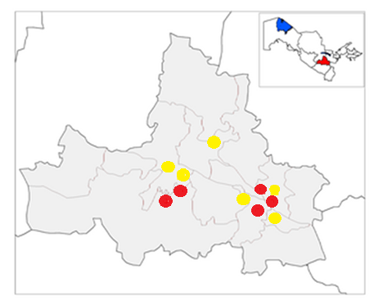
Figure 1. Geographic map of the study area — Samarkand region, Uzbekistan (🔴 Red: High damage intensity; 🟡 Yellow: Moderate damage intensity).

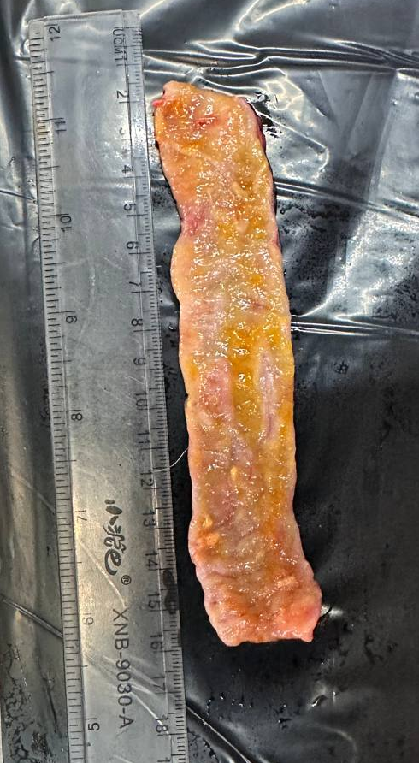
Figure 2. Small intestine infected with Toxocara canis under laboratory conditions (Samarkand region, 2025, foto by authors).
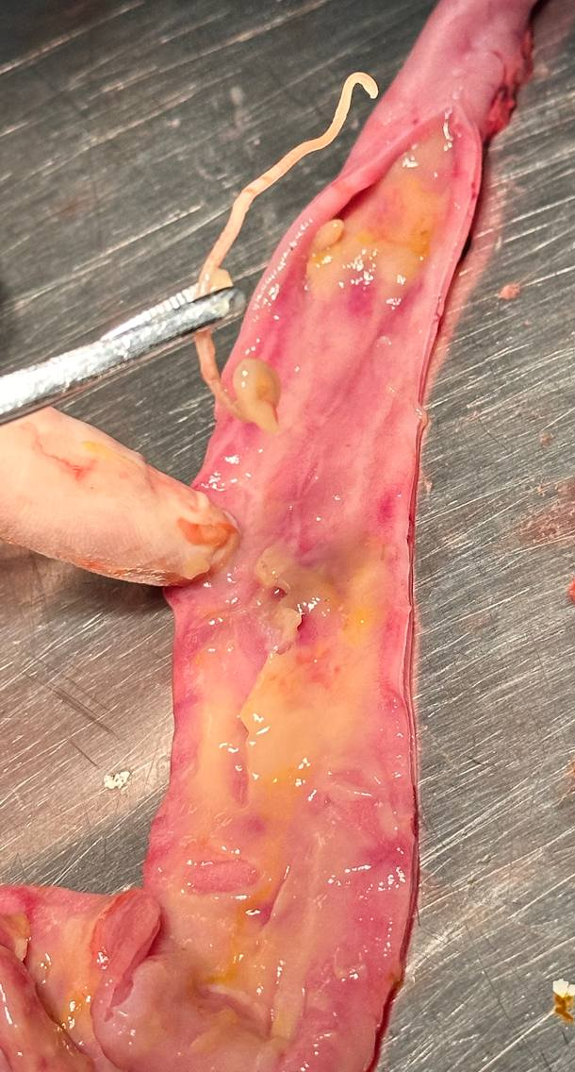
Figure 3. Sample obtained during helminthological necropsy: pathological changes in the small intestine infected with Toxocara canis (Samarkand region, 2025, foto by authors).
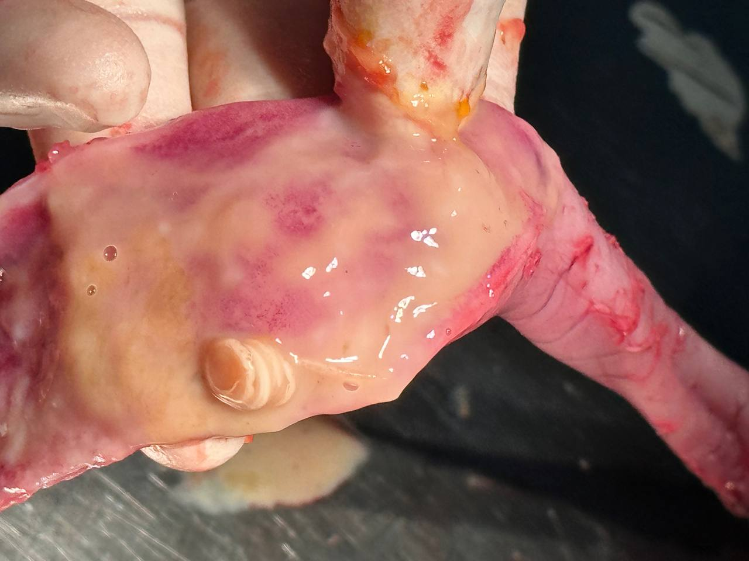
Figure 4. Stray dog specimen examined in the study: Helminthological necropsy procedure, (Samarkand region, 2025, foto by authors).
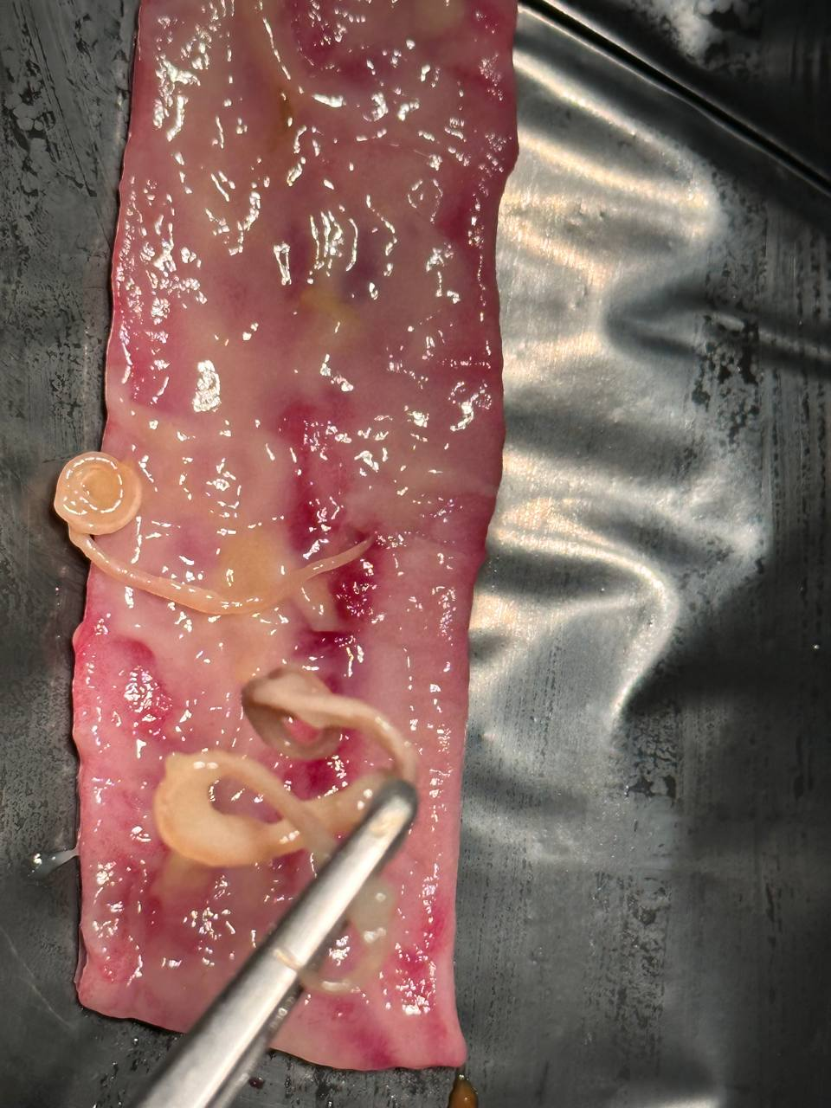
Figure 5. Ancylostoma caninum: adult A. caninum specimens recovered from dog intestine (Samarkand region, 2025, foto by authors).

