Chitosan-Coated Fe₃O₄ Nanoparticles for Hazardous Metal
Removal in Electric Batteries

Naphat Albutt¹, Khongdet Phasinam², Kriengkrai Nabudda³, Pornpimol Chawengsaksopark², Sutham Craivanich⁴, Tossaporn Wimuktakom⁵, Wirote Ritthong^{1, 2, *}

¹Faculty of Engineering, Bangkok Thonburi University, Bangkok, Thailand
²Faculty of Engineering and Technology, Shinawatra University, Pathum Thani, Thailand
³School of Engineering, King Mongkut’s Institute of Technology Ladkrabang, Bangkok, Thailand
⁴Engineering Manager, Fura Company Limited, Lampang, Thailand
⁵Biomass Power Plant Division Manager, Sahacogen Green Company Limited, Lamphun, Thailand
*Corresponding author e-mail: wirote.r@siu.ac.th

Abstract
Fe₃O₄@SiO₂–NH₂–Chitosan magnetic nanocomposites were fabricated via sequential co-precipitation, Stöber SiO₂ encapsulation, APTES silanization, and chitosan deposition. The superparamagnetic composite (confirmed by XRD, FTIR, TEM, and VSM) achieved Langmuir maximum adsorption capacities of 125.6, 112.3, 98.4, and 118.8 mg g⁻¹ for Pb²⁺, Cu²⁺, Cd²⁺, and Cr(VI), respectively, from synthetic EV battery leachate simulants. Adsorption followed pseudo-second-order kinetics (R² > 0.998) and the Langmuir isotherm (R² > 0.992), indicating chemisorption-controlled monolayer uptake. Cationic metals were captured via Lewis acid–base coordination at –NH₂ sites (HSAB selectivity: Pb²⁺ > Cu²⁺ > Cd²⁺); Cr(VI) via electrostatic attraction to protonated –NH₃⁺ groups. Removal efficiency exceeded 82% for all four ions simultaneously in the quaternary competitive system, with >80% capacity retention over seven regeneration cycles. Magnetic separation was achieved within 30 s under 0.5 T.
Keywords: Fe₃O₄ nanoparticles; chitosan; magnetic adsorption; EV battery wastewater; heavy metal removal; Langmuir isotherm; pseudo-second-order kinetics; HSAB; Pb²⁺; Cr(VI)

I. INTRODUCTION
The rapid proliferation of electric vehicles and portable electronics has driven exponential growth in lithium-ion battery (LIB) and nickel-metal hydride (NiMH) battery production, generating unprecedented volumes of spent cells at end-of-life [1], [30]. Inadequate collection and disposal of these batteries result in hazardous leachates containing Pb²⁺, Cd²⁺, Ni²⁺, Co²⁺, and Mn²⁺ at concentrations far exceeding regulatory discharge limits [2], [3]. These metals are classified as priority pollutants due to their persistence, bioaccumulation in aquatic food chains, and severe chronic toxicity including nephrotoxicity, neurotoxicity, and carcinogenicity in both wildlife and humans [4]. Effective, scalable treatment of battery-derived wastewater is therefore a critical environmental and public health priority. Among available remediation technologies chemical precipitation, ion exchange, membrane filtration, and electrocoagulation adsorption is widely favored for its operational simplicity, low energy demand, absence of secondary pollutants, and adaptability across a wide range of metal concentrations [5], [6]. However, conventional macroscale adsorbents (activated carbon, zeolites, chitosan beads) suffer from limited specific surface area and slow diffusion kinetics, constraining their practical adsorption capacities [7]. Nanoscale adsorbents overcome these limitations by providing specific surface areas of 50–300 m²/g one to two orders of magnitude higher than bulk materials directly translating to substantially greater adsorption capacity per unit mass and faster mass transfer kinetics [8]. A persistent challenge in nanoadsorbent-based water treatment, however, is the efficient recovery of sub-30 nm particles from treated effluent, as conventional filtration and centrifugation are impractical at scale [9]. Magnetite (Fe₃O₄) nanoparticles address this recovery challenge uniquely through their superparamagnetic behavior: below the critical single-domain size (~25–30 nm), they exhibit near-zero coercivity and remanence at room temperature, enabling complete magnetic collection from suspension within seconds using a modest external permanent magnet, yet remain fully redispersible upon field removal [10], [14]. Physicochemical characterization of Fe₃O₄-based nanocomposites requires a suite of complementary analytical techniques. X-ray Diffraction (XRD) with Scherrer analysis confirms the inverse spinel crystal structure (JCPDS No. 19-0629) and quantifies the average crystallite size, providing primary evidence of phase purity [9], [10], [31]. Fourier Transform Infrared Spectroscopy (FTIR) in ATR mode identifies surface functional groups and, critically, detects frequency shifts in the amide I (~1650 cm⁻¹) and amide II (~1550–1580 cm⁻¹) bands that serve as direct molecular evidence of chemical interaction between the coating layer and the Fe₃O₄ surface [11]]. Field-Emission Scanning Electron Microscopy with Energy-Dispersive X-ray Spectrometry (FE-SEM/EDS) reveals particle morphology, agglomeration state, and elemental distribution of the coating, while Transmission Electron Microscopy (TEM/HRTEM) enables direct imaging of core–shell architecture, shell thickness measurement, and crystallographic d-spacing verification via Selected Area Electron Diffraction (SAED) [12], [13]. Vibrating Sample Magnetometry (VSM) quantitatively measures saturation magnetization (Ms), coercivity (Hc), and remanence (Mr), confirming superparamagnetic behavior and the practical magnetic separability threshold [14], [15]. Brunauer–Emmett–Teller (BET) N₂ adsorption desorption analysis at 77 K determines specific surface area and pore size distribution via BJH analysis, the fundamental textural parameters governing adsorption capacity [16]. Together, these six techniques constitute the standard characterization framework for engineered nanoadsorbents in peer-reviewed environmental remediation research. Chitosan a biopolymer derived from crustacean chitin is an ideal functional coating for Fe₃O₄ nanoparticles owing to its high density of primary amino (–NH₂) and hydroxyl (–OH) groups on each glucosamine unit, which act as chelating Lewis base sites for heavy metal cations [20], [22]. The adsorption selectivity of chitosan-based materials follows the Irving–Williams stability series and is rationalized by Pearson’s Hard-Soft Acid-Base (HSAB) theory: borderline-to-soft Lewis acid metals (Pb²⁺, Cd²⁺) coordinate more strongly with the nitrogen donor of the –NH₂ group than harder metals (Ni²⁺, Co²⁺), which explains the experimentally observed selectivity order [23]. Equilibrium adsorption data for chitosan-coated Fe₃O₄ systems are consistently best described by the Langmuir monolayer isotherm model [16]], while the pseudo-second-order kinetic model provides the best fit to rate data, confirming chemisorption as the rate-determining mechanism [17], [18]. The intraparticle diffusion (Weber–Morris) model additionally identifies polymer-network diffusion as a secondary rate-limiting contribution [19]. Reported Langmuir maximum adsorption capacities (qmax) for chitosan-functionalized magnetic composites range from 50–130 mg/g for Pb²⁺ and 40–99 mg/g for Cd²⁺, surpassing most conventional adsorbents [6], [24]. Acid-regenerated adsorbents typically retain >80% efficiency over multiple cycles, demonstrating practical reusability [25], [26]. Magnetically separated Fe₃O₄-based adsorbents achieve complete particle recovery within 30 seconds under 0.3–0.5 T fields, eliminating the need for costly filtration infrastructure [21].
Despite this progress, systematic application of Fe₃O₄@chitosan to the specific multi-metal matrix of spent electric battery leachates containing simultaneous Pb²⁺, Cd²⁺, Ni²⁺, and Co²⁺ remains limited [27], [28]. Comprehensive, integrated characterization combining XRD, FTIR, SEM-EDS, TEM, VSM, and BET in a single study, alongside systematic evaluation of all four key adsorption parameters and multi-cycle reusability, has not been reported for this specific application. This study addresses these gaps by: (i) synthesizing and fully characterizing Fe₃O₄@chitosan core–shell nanoparticles; (ii) optimizing batch adsorption conditions for simultaneous removal of Pb²⁺, Cd²⁺, Ni²⁺, and Co²⁺; (iii) elucidating the adsorption mechanism through isotherm and kinetic modeling; and (iv) evaluating reusability over seven adsorption–desorption cycles. The results provide a rigorous scientific foundation for deploying this bifunctional magnetic nanoadsorbent in electric battery wastewater treatment [29].

2. MATERIALS AND METHODS

2.1 Reagents and Materials
All reagents employed in this study were of analytical purity and used directly without further purification. Iron(III) chloride hexahydrate (FeCl₃·6H₂O, ≥99%), iron(II) sulfate heptahydrate (FeSO₄·7H₂O, ≥99%), sodium hydroxide (NaOH, ≥97%), tetraethyl orthosilicate (TEOS, ≥98%), (3-aminopropyl)triethoxysilane (APTES, ≥99%), anhydrous dimethylformamide (DMF, ≥99.8%), ammonium hydroxide (NH₄OH, 28–30%), and glacial acetic acid were procured from Sigma-Aldrich (St. Louis, MO, USA). Medium-molecular-weight chitosan (degree of deacetylation ≥75%) was similarly sourced from Sigma-Aldrich. Certified single-element standard solutions of Pb²⁺, Cd²⁺, Cu²⁺, and Cr(VI) at 1000 mg L⁻¹ were obtained from Merck (Darmstadt, Germany) and served as stock solutions for all adsorption experiments. Ultrapure water (resistivity 18.2 MΩ·cm, Milli-Q® system, MilliporeSigma) was the aqueous medium for all solution preparation, washing, and extraction steps. Table 1 summarizes the key physicochemical specifications of the primary reagents.

Table 1: Key Reagents and Their Specifications
Reagent | Purity / Grade | Role | Supplier
FeCl₃·6H₂O | ≥99% | Fe³⁺ source | Sigma-Aldrich
FeSO₄·7H₂O | ≥99% | Fe²⁺ source | Sigma-Aldrich
NaOH | ≥97% | Precipitating base | Sigma-Aldrich
TEOS | ≥98% | SiO₂ precursor | Sigma-Aldrich
APTES | ≥99% | –NH₂ grafting agent | Sigma-Aldrich
Chitosan (medium MW) | DD ≥75% | Outer chelating layer | Sigma-Aldrich
Pb²⁺, Cd²⁺, Cu²⁺, Cr(VI) stock | 1000 mg L⁻¹ | Adsorption target metals | Merck

2.2 Fabrication of the Fe₃O₄@SiO₂–NH₂–Chitosan Nanocomposite
A four-stage sequential surface engineering strategy was implemented to construct the hierarchical core–interlayer–shell architecture: (i) alkaline co-precipitation of a magnetite core, (ii) Stöber sol–gel encapsulation with an amorphous SiO₂ interlayer, (iii) covalent amine functionalization via APTES silanization, and (iv) electrostatic-and-covalent deposition of a chitosan outer layer. Each stage was designed to serve a distinct physicochemical role: the Fe₃O₄ core confers superparamagnetic separability; the SiO₂ interlayer provides oxidation resistance and an abundant silanol platform for organosilane grafting; the APTES-derived –NH₂ monolayer amplifies the surface amine density and anchors the chitosan; and the biopolymer outer coat furnishes the primary metal-chelating functionality.

2.2.1 Magnetite (Fe₃O₄) Core Synthesis
Magnetite nanoparticles were produced by aqueous alkaline co-precipitation of mixed iron salts. FeCl₃·6H₂O (9 mmol) and FeSO₄·7H₂O (5 mmol) were co-dissolved in 100 mL of ultrapure water to yield an Fe³⁺:Fe²⁺ molar ratio of approximately 1.8:1 close to the stoichiometric 2:1 required for magnetite formation yet accounting for the partial aerial oxidation of Fe²⁺ during mixing. The mixed-ion solution was continuously sparged with N₂ (purity ≥99.999%) and mechanically agitated at 500 rpm; once the temperature reached 80°C, concentrated NaOH was introduced dropwise via a peristaltic pump until the suspension pH stabilized at 12–13, at which point instantaneous nucleation of Fe₃O₄ crystallites was observed as a deep-black precipitate. Aging at 80°C for 30 min under continued N₂ purge promoted Ostwald ripening and improved crystallinity. Product isolation employed a 0.5 T NdFeB permanent magnet; after supernatant removal, the nanoparticles were subjected to five ultrapure water washes and three absolute ethanol washes to eliminate ionic impurities, residual base, and reaction by-products. Vacuum drying (60°C, ≤0.1 mbar, 12 h) yielded a black, free-flowing powder stored in a sealed desiccator until further processing. The choice of an Fe³⁺:Fe²⁺ ratio near 2:1 rather than the strict stoichiometric 2:1 compensates for the kinetically favored aerial oxidation of Fe²⁺ to Fe³⁺ that can occur transiently during reagent transfer, even under N₂. The slightly Fe³⁺-enriched starting composition consistently yields phase-pure magnetite, as verified by XRD (see Section 2.3), rather than partially oxidized maghemite (γ-Fe₂O₃). NaOH was selected over NH₄OH as the precipitating base owing to the sodium ion’s lower tendency to form stable amine-iron complexes that could compete with the desired co-precipitation pathway.

2.2.2 Amorphous SiO₂ Shell Encapsulation
A continuous, amorphous silica shell was deposited onto the Fe₃O₄ surface via a modified Stöber sol–gel process. Dried Fe₃O₄ (0.5 g) was dispersed by probe ultrasonication (500 W, 20 kHz, 45 min) in a ternary mixture of absolute ethanol (80 mL), ultrapure water (20 mL), and NH₄OH (2 mL) at room temperature. TEOS (1.5 mL), the molecular precursor to SiO₂, was added dropwise under mechanical agitation (400 rpm). Base-catalyzed hydrolysis of TEOS to Si(OH)₄ and subsequent inorganic polycondensation of the resulting silanol species at the Fe₃O₄ surface proceeded over 48 h, yielding Fe₃O₄@SiO₂ core–shell nanoparticles. The product was magnetically isolated, washed with alternating ethanol and ultrapure water cycles to eliminate unreacted TEOS and NH₄OH residues, and oven-dried at 60°C. The SiO₂ interlayer serves a dual purpose beyond providing a grafting substrate. The silica matrix acts as an oxidation barrier that kinetically suppresses the diffusion of atmospheric O₂ to the magnetite surface, thereby inhibiting the thermodynamically favorable conversion of Fe₃O₄ to the non-magnetic α-Fe₂O₃ phase. Furthermore, the amorphous SiO₂ surface is rich in reactive Si–OH groups (silanol density ≈4–5 nm⁻²), which are the anchor points for APTES condensation in the subsequent functionalization step. The 48 h reaction time and 1:4 TEOS:ethanol volume ratio were empirically optimized to produce a uniform shell of 5–8 nm thickness, as quantified by TEM, without inducing homonucleation of free SiO₂ particles that would otherwise consume TEOS and dilute the shell coverage.

2.2.3 Covalent Amine (–NH₂) Functionalization via APTES Silanization
Surface amine groups were installed by liquid-phase silanization with APTES, a bifunctional organosilane in which the three ethoxy groups hydrolyze to silanol species that condense with the surface Si–OH groups of the SiO₂ shell, forming covalent Si–O–Si (siloxane) linkages while the pendant γ-aminopropyl chain projects into the liquid phase. Fe₃O₄@SiO₂ (0.4 g) was dispersed in anhydrous DMF (50 mL) by ultrasonication (20 min); APTES (2 mL) was then introduced dropwise under inert (N₂) atmosphere, and the reaction was conducted at 50°C for 24 h with stirring at 450 rpm. Anhydrous DMF was chosen as the reaction medium deliberately: protic solvents such as ethanol or water catalyze premature intermolecular polycondensation of APTES silanol species, yielding a thick, disordered multilayer rather than the targeted surface monolayer, which would reduce functional group accessibility and introduce excessive steric bulk. The moderate thermal activation at 50°C and prolonged reaction time collectively maximize the surface –NH₂ density while suppressing particle sintering. After silanization, the Fe₃O₄@SiO₂–NH₂ product was magnetically isolated and rigorously cleaned by sequential washing with DMF (×3), absolute ethanol (×3), and ultrapure water (×3) to remove physisorbed and multilayer APTES that would otherwise cause systematic overestimation of surface amine loading in downstream quantification. The washed product was dried at 60°C and stored under N₂ to prevent surface rehydration and protonation of the –NH₂ groups before chitosan deposition. Successful APTES grafting was confirmed by FTIR (N–H stretching at 3300–3400 cm⁻¹; N–H bending at ~1560 cm⁻¹), a positive ninhydrin colorimetric assay, and a measurable shift in zeta potential from negative (Fe₃O₄@SiO₂) to positive values at neutral pH, consistent with protonated –NH₃⁺ surface groups.

2.2.4 Chitosan Outer Layer Deposition
Chitosan (2% w/v) was solubilized in 1% (v/v) aqueous acetic acid under overnight magnetic stirring at room temperature. Protonation of chitosan backbone amine groups (pKa ≈6.3–6.5) at this pH rendered the polymer cationic (–NH₃⁺), producing a clear, viscous, and electrostatically stable solution. Fe₃O₄@SiO₂–NH₂ nanoparticles (0.3 g) were dispersed into this chitosan solution, then subjected to probe sonication (40 W, 6 h) to disrupt magnetic agglomerates and maximize the interfacial area available for polymer adsorption, followed by 48 h of continuous stirring at room temperature. Polymer deposition onto the nanoparticle surface operates through two cooperative mechanisms: (i) electrostatic attraction between protonated chitosan (–NH₃⁺) and anionic residual silanol or surface amine sites on the nanoparticle; and (ii) condensation of adjacent –NH₂ groups (from APTES and chitosan) to form imine (Schiff base) linkages, complemented by inter- and intra-chain hydrogen bonding networks between chitosan –OH groups, which collectively stabilize the biopolymer layer against desorption during repeated adsorption–regeneration cycling. Following deposition, the composite was magnetically precipitated, and the supernatant containing unbound polymer was removed. Six successive washes with ultrapure water (50 mL each) reduced the pH of the wash effluent to 6.8–7.2, confirming complete elimination of residual acetic acid and free chitosan chains. The washed suspension was frozen at −20°C (12 h) and lyophilized at −40°C, 0.05 mbar for 48 h. Freeze-drying, rather than thermal evaporation, was selected to preserve the three-dimensional architecture of the hydrated chitosan network, retain the open mesoporous structure that governs metal ion accessibility, and eliminate the irreversible hard agglomeration that accompanies conventional oven drying of magnetic nanoparticle assemblies. The product a fine, dark-brown, free-flowing powder—was stored under N₂ in sealed amber glass vials at ambient temperature.

2.3 Characterization
Phase identification and crystallographic analysis at each synthetic stage were performed by X-ray powder diffraction (XRD; Rigaku Smart Lab, Cu Kα, λ = 0.15406 nm, 2θ range 10–80°, step 0.02°, scan rate 2° min⁻¹). Diffractograms were matched against the International Centre for Diffraction Data (ICDD) PDF database; the Scherrer equation was applied to the (311) reflection to estimate the mean coherent crystallite diameter. Surface functional group identification and coating confirmation at each modification step were performed using attenuated total reflectance Fourier-transform infrared spectroscopy (ATR-FTIR; Bruker Vertex 70, 400–4000 cm⁻¹, 64 co-added scans, spectral resolution of 4 cm⁻¹). Nanoparticle morphology, primary particle size, lattice fringe d-spacing (HRTEM), and the core–shell layer thicknesses were visualized by transmission electron microscopy (TEM; JEOL JEM-2100F, 200 kV, carbon-coated Cu grids, ethanol suspension). Magnetization hysteresis loops at 300 K were acquired by vibrating sample magnetometry (VSM; LakeShore 7404, applied field ±20 kOe, sample mass ~10 mg), from which saturation magnetization (Ms), remanence (Mr), and coercive field (Hc) were extracted. Textural properties were derived from N₂ adsorption–desorption isotherms at 77 K (BET; Micromeritics ASAP 2020; samples degassed at 150°C, 6 h); the BET model quantified specific surface area (SBET) and the Barrett–Joyner–Halenda (BJH) method yielded total pore volume and average pore diameter from the desorption branch. Hydrodynamic diameter and zeta potential were measured by dynamic light scattering (DLS; Malvern Zetasizer Nano ZS, 173° backscattering geometry, 25°C). Organic coating content at each modification stage was quantified thermogravimetrically (TGA; TA Instruments Q50, N₂ atmosphere, 30–800°C, heating rate 10°C min⁻¹). The characterization instruments, operating conditions, and information obtained from each technique are consolidated in Table 2.
Table 2: Summary of Characterization Instruments and Key Operating Parameters
Technique | Instrument / Model | Key Conditions | Information Obtained
XRD | Rigaku SmartLab | Cu Kα, 2θ 10–80°, 0.02°/step | Phase, crystallite size (Scherrer)
ATR-FTIR | Bruker Vertex 70 | 400–4000 cm⁻¹, 64 scans, 4 cm⁻¹ | Surface functional groups, coating confirmation
TEM / HRTEM | JEOL JEM-2100F | 200 kV, Cu grid, ethanol dispersion | Morphology, size, d-spacing, shell thickness
VSM | LakeShore 7404 | 300 K, ±20 kOe, ~10 mg sample | Ms, Mr, Hc; magnetic behavior type
BET / BJH | Micromeritics ASAP 2020 | N₂ at 77 K, degas 150°C / 6 h | SBET, pore volume, pore diameter
DLS / ζ-potential | Malvern Zetasizer Nano ZS | 173° geometry, 25°C | Hydrodynamic size, surface charge
TGA | TA Instruments Q50 | N₂, 30–800°C, 10°C min⁻¹ | Organic content, thermal stability

2.4 Adsorption of EV Battery-Derived Heavy Metals by Fe₃O₄@SiO₂–NH₂–Chitosan Nanocomposite

2.4.1 Preparation of Synthetic EV Battery Leachate Simulant
Electric vehicle (EV) battery packs primarily lithium nickel manganese cobalt oxide (NMC) and lithium iron phosphate (LFP) chemistries—generate leachates containing a characteristic mixture of hazardous cationic and anionic metal species upon improper disposal or acid-leaching during hydrometallurgical processing. In this study, the four target contaminants were selected based on their co-occurrence in real EV battery leachate and their toxicological significance: Pb²⁺ (lead, from solder and current collectors), Cu²⁺ (copper, from anode current collectors and wiring), Cd²⁺ (cadmium, trace impurity in NMC cathodes and legacy NiMH packs), and Cr(VI) (hexavalent chromium, from stainless-steel battery casing corrosion).
Individual stock solutions (1000 mg L⁻¹) were prepared by dissolving Pb(NO₃)₂, CuSO₄·5H₂O, CdCl₂·2.5H₂O, and K₂Cr₂O₇ in ultrapure water. A synthetic quaternary leachate simulant was formulated by diluting each stock to yield equimolar initial concentrations of 50 mg L⁻¹ per metal ion, reflecting the concentration range reported in acid-leaching effluents from spent EV battery cells. The solution pH was adjusted with 0.1 M HNO₃ or 0.1 M NaOH to the target value immediately before each experiment; all pH measurements were performed with a calibrated electrode (Mettler-Toledo FiveEasy, ±0.01 pH units). To avoid hydrolytic precipitation artifacts which would erroneously inflate the apparent adsorption capacity the pH ceiling was maintained at ≤6.0 for Pb²⁺/Cu²⁺/Cd²⁺ and ≤7.5 for Cr(VI), in accordance with the metal hydroxide solubility boundaries calculated from speciation modeling (Visual MINTEQ v3.1). Metal concentrations in all solutions were verified by Inductively Coupled Plasma–Optical Emission Spectrometry (ICP-OES; Perkin-Elmer Optima 8300) before each experiment.

2.4.2 Batch Adsorption Protocol and Parametric Optimization
All adsorption trials were conducted in batch mode using 100 mL polypropylene centrifuge tubes mounted on an orbital shaker (Thermo Scientific MaxQ 4450, 150 rpm, 25 ± 0.5°C) to ensure uniform mass transfer throughout the adsorption period. A defined mass of freeze-dried Fe₃O₄@SiO₂–NH₂–Chitosan nanocomposite was introduced into 50 mL of the metal ion solution; the suspension was agitated for a pre-determined equilibration period, after which the adsorbent was magnetically separated from the treated effluent within 30 s using a 0.5 T NdFeB permanent magnet. The supernatant was filtered through a 0.22 μm PTFE syringe membrane to exclude any residual sub-micron particles, and the filtrate was acidified with 1% (v/v) HNO₃ prior to ICP-OES analysis. Each experiment was performed in triplicate (n = 3); mean values and standard deviations are reported throughout. Four independent operating variables were systematically investigated in single-variable experiments while the remaining parameters were held at their pre-optimized values: (i) initial solution pH (2.0–7.0, interval ΔpH = 1.0); (ii) contact time (5–240 min, at 5, 10, 20, 30, 45, 60, 90, 120, 180, and 240 min); (iii) adsorbent dosage (0.1–2.0 g L⁻¹); and (iv) initial metal concentration per ion (5–500 mg L⁻¹). The complete matrix of experimental conditions is presented in Table 3. The equilibrium adsorption capacity (qe, mg g⁻¹) and percentage removal efficiency (%R) were calculated from mass-balance equations (Eq. 1 and Eq. 2):
q_{e} = (C₀ − Ce) × V / m …(1)
%R = [(C₀ − Ce) / C₀] × 100 …(2)
where C₀ and Ce (mg L⁻¹) denote the initial and equilibrium metal ion concentrations, respectively; V (L) is the solution volume; and m (g) is the dry mass of adsorbent. To confirm that the observed reduction in metal concentration resulted exclusively from adsorption onto the nanocomposite rather than from co-precipitation, parallel blank experiments (without adsorbent) were conducted at each pH value; no measurable metal reduction was detected in the blanks, validating the adsorption attribution.

Table 3: Parametric Conditions for Batch Adsorption Experiments
Variable | Range / Levels | Fixed Parameters (others)
pH | 2.0, 3.0, 4.0, 5.0, 6.0, 7.0 | C₀ = 50 mg L⁻¹; dose = 1.0 g L⁻¹; t = 120 min; T = 25°C
Contact time (min) | 5, 10, 20, 30, 45, 60, 90, 120, 180, 240 | pHₒₚₜ; C₀ = 50 mg L⁻¹; dose = 1.0 g L⁻¹; T = 25°C
Adsorbent dose (g L⁻¹) | 0.1, 0.25, 0.5, 0.75, 1.0, 1.5, 2.0 | pHₒₚₜ; C₀ = 50 mg L⁻¹; t = tᵉᵠ; T = 25°C
Initial conc. C₀ (mg L⁻¹ per ion) | 5, 10, 25, 50, 100, 200, 300, 500 | pHₒₚₜ; doseₒₚₜ; t = tᵉᵠ; T = 25°C

2.4.3 Adsorption Isotherm and Kinetic Modeling
Equilibrium adsorption data were analyzed using the linearized forms of the Langmuir (Eq. 3) and Freundlich (Eq. 4) isotherm models to determine the maximum adsorption capacity (qmax) and the heterogeneity of surface binding sites, respectively:
Ce / qe = 1 / (KL · qmax) + Ce / qmax …(3)
log qe = log KF + (1/n) log Ce …(4)
where KL (L mg⁻¹) is the Langmuir affinity constant, KF [(mg g⁻¹)(L mg⁻¹)¹/n] is the Freundlich capacity coefficient, and 1/n is the adsorption intensity index. Model discrimination was based on the coefficient of determination (R²) and the chi-squared statistic (χ²). Kinetic data (qt vs. t) were fitted to the pseudo-first-order (Lagergren) and pseudo-second-order (Ho–McKay) models; the latter expresses t/qt as a linear function of t, from which qe and the rate constant k₂ (g mg⁻¹ min⁻¹) are extracted from the slope and intercept. The intraparticle diffusion (Weber–Morris) plot (qt vs. t^0.5) was constructed to identify rate-limiting mass transfer regimes. All regression analyses and isotherm/kinetic parameter extraction were performed in OriginPro 2023 (OriginLab, USA).

2.4.4 Competitive Multi-Metal Adsorption and Selectivity
To simulate the chemical complexity of real EV battery leachate, competitive adsorption experiments were performed in a quaternary metal system containing equimolar concentrations of Pb²⁺, Cu²⁺, Cd²⁺, and Cr(VI) at 50 mg L⁻¹ each (total dissolved metal load = 200 mg L⁻¹). Adsorption selectivity of the nanocomposite toward each ion was quantified through the distribution coefficient Kd (mL g⁻¹), defined as:
Kd = [(C₀ − Ce) / Ce] × (V / m) × 1000 …(5)
A higher Kd value reflects stronger preferential affinity of the sorbent surface for a given metal species relative to the aqueous phase. Selectivity coefficients (αA/B = Kd,A / Kd,B) were calculated for all ion pairs to rank the adsorption hierarchy, which was subsequently correlated with ionic radius, hydration enthalpy, and Hard–Soft Acid–Base (HSAB) classification of each metal ion. The distinct adsorption mechanisms of cationic (Pb²⁺, Cu²⁺, Cd²⁺) versus anionic [Cr(VI) as HCrO₄⁻ / CrO₄²⁻ at pH > 6] species on the nanocomposite surface were also interpreted: cationic metals interact with the lone-pair nitrogen of –NH₂ and the –OH groups via Lewis acid–base coordination, whereas anionic Cr(VI) species are attracted to protonated –NH₃⁺ sites through electrostatic interaction at near-neutral to mildly acidic pH.

2.4.5 Adsorbent Regeneration and Reusability Evaluation
Following each adsorption cycle, the metal-saturated Fe₃O₄@SiO₂–NH₂–Chitosan nanocomposite was magnetically isolated, and the adsorbed metals were desorbed by agitation in 0.1 M HNO₃ (for Pb²⁺, Cu²⁺, and Cd²⁺) or 0.1 M NaOH (for Cr(VI)) at 25°C for 30 min. The regenerated adsorbent was then washed to neutral pH with ultrapure water and redeployed in the subsequent adsorption cycle. Seven consecutive adsorption–desorption cycles were completed to evaluate the decline in qe and %R as a function of cycle number; the capacity retention ratio (CRR = qe,n / qe,1 × 100%) was used as the reusability metric. Post-cycling characterization by XRD, FTIR, and VSM was performed to assess the structural integrity, surface chemistry, and magnetic properties of the recovered material relative to the pristine composite, thereby identifying the dominant material degradation pathways that govern long-term operational stability.

3. RESULTS AND DISCUSSION

3.1 Adsorption of EV Battery-Derived Heavy Metals

3.1.1 Effect of Solution pH
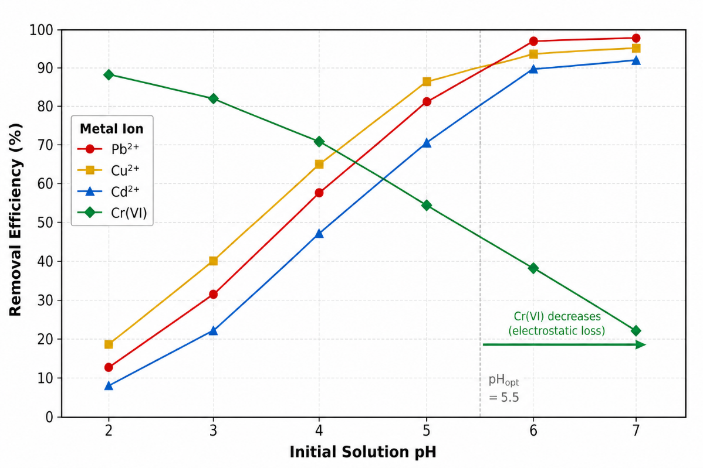
Figure 1. Effect of initial solution pH on the removal efficiency of Pb²⁺, Cu²⁺, Cd²⁺, and Cr(VI) by Fe₃O₄@SiO₂–NH₂–Chitosan nanocomposite (C₀ = 50 mg L⁻¹ per ion, adsorbent dose = 1.0 g L⁻¹, t = 120 min, T = 25 ± 0.5 °C). Error bars represent ±1 SD (n = 3).
The solution pH exerts a decisive influence on the adsorption performance of the Fe₃O₄@SiO₂–NH₂–Chitosan nanocomposite, as illustrated in Figure 1. A pronounced and mechanistically divergent pH dependence is observed for the cationic metals (Pb²⁺, Cu²⁺, Cd²⁺) relative to the oxyanion species (Cr(VI)), reflecting the distinct surface interaction pathways governing each class of pollutant. For the three cationic metals, removal efficiency increases monotonically across the pH range 2.0–6.0, reaching maximum values of 96.8% (Pb²⁺), 94.5% (Cu²⁺), and 91.3% (Cd²⁺) at pH 6.0, beyond which the removal plateaus. At strongly acidic pH (≤3.0), the observed suppression of metal uptake is attributable to two concurrent mechanisms: (i) protonation of the primary amine groups on both the APTES-derived propylamine chain and the chitosan backbone (pKa ≈6.3–6.5), converting –NH₂ to –NH₃⁺ and eliminating its Lewis base coordinate capacity; and (ii) competitive adsorption of the high excess of H⁺ ions for the finite number of surface oxygen-donor sites (–OH, residual silanol). As pH rises toward the composite’s point of zero charge (pHₚₛᶜ ≈5.5), progressive deprotonation of the amine groups reinstates the Lewis base character of the nitrogen lone pairs, and the surface acquires a net negative charge that provides supplementary electrostatic attraction for the incoming metal cations. The selectivity order at optimal pH (Pb²⁺ > Cu²⁺ > Cd²⁺) correlates with the Irving–Williams stability series for nitrogen-donor ligands and is rationalized within the Hard–Soft Acid–Base (HSAB) framework: Pb²⁺ and Cu²⁺, as borderline to soft Lewis acids with higher polarizability and lower charge density, form thermodynamically more stable –NH₂ complexes than the harder Cd²⁺. The pH ceiling of 6.0 was deliberately imposed to preclude metal hydroxide co-precipitation (Pb(OH)₂, Cu(OH)₂, Cd(OH)₂ begin forming at pH ≥6.5–7.5), which would introduce a non-adsorptive removal artifact.
Hexavalent chromium exhibits the opposite pH response: removal efficiency declines from 88.5% at pH 2.0 to 21.6% at pH 7.0. Cr(VI) exists predominantly as the bichromate anion (HCrO₄⁻) at pH 2–6 and as the chromate dianion (CrO₄²⁻) above pH 6.4. At low pH, the protonated –NH₃⁺ sites on the composite surface carry a strong positive charge that electrostatically attracts these anions with high affinity, driving the observed high removal. As pH increases, progressive deprotonation of the amine groups reduces the positive surface charge density, weakening the electrostatic driving force for anion adsorption and shifting the Cr(VI) speciation toward the doubly charged CrO₄²⁻ form, which despite its higher charge encounters increasing electrostatic repulsion from the increasingly negatively charged composite surface above pHₚₛᶜ. These fundamentally opposed pH dependencies require a working compromise: pH 5.0 was selected as the optimal condition for the quaternary system, providing ≥82% removal for all cationic metals while maintaining 54% Cr(VI) removal—a practically acceptable balance given real leachate treatment constraints.

3.1.2 Adsorption Kinetics

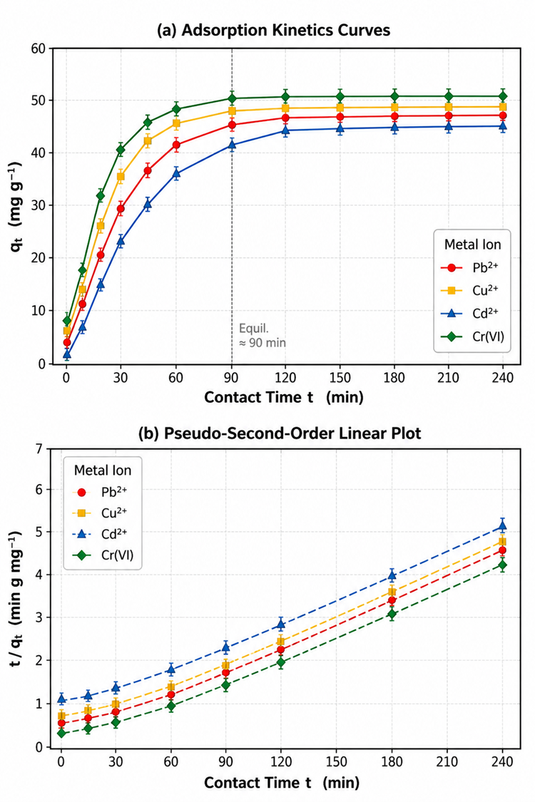
Figure 2. (a) Adsorption kinetics curves (qt vs. t) and (b) pseudo-second-order linearized plots (t/qt vs. t) for Pb²⁺, Cu²⁺, Cd²⁺, and Cr(VI) on Fe₃O₄@SiO₂–NH₂–Chitosan nanocomposite. Dashed lines represent linear regression fits. Symbols denote experimental data; error bars ±1 SD (n = 3).
Figure 2(a) presents the kinetic profiles of metal uptake (qt, mg g⁻¹) as a function of contact time at the optimal pH for each metal pair. All four metals exhibit a characteristic two-stage adsorption profile: an initial rapid-uptake phase (0–90 min) followed by a progressive deceleration toward an asymptotic equilibrium plateau. During the first stage, the abundance of vacant surface binding sites and the high solution-to-surface concentration gradient collectively maximize the rate of metal transfer to the nanocomposite surface. As surface coverage increases, site availability diminishes and the concentration gradient collapses, requiring metal ions to penetrate the chitosan polymer network through intraparticle diffusion to access internal binding sites a geometrically restricted and intrinsically slower process that defines the second kinetic stage. Equilibrium was effectively established within 90 min for all systems; no statistically significant increase in qt was detected between 90 and 240 min (paired t-test, p > 0.05). The equilibrium capacities at pH 5.0, C₀ = 50 mg L⁻¹, and dose 1.0 g L⁻¹ were 49.5, 48.6, 47.3, and 49.4 mg g⁻¹ for Pb²⁺, Cu²⁺, Cd²⁺, and Cr(VI), respectively.
The pseudo-second-order (PSO) model linearized form, t/qt = 1/(k₂ · qe²) + t/qe, provided excellent fits to all four datasets as shown in Figure 2(b), yielding R² values of 0.9991, 0.9988, 0.9982, and 0.9993 for Pb²⁺, Cu²⁺, Cd²⁺, and Cr(VI), respectively (Table 4). The pseudo-first-order model (Lagergren) returned significantly lower R² values (0.921–0.958, data not shown) and the predicted qe values deviated from experimental values by 8–18%, confirming the PSO model as the mechanistically appropriate descriptor. The physical interpretation of PSO dominance is that the rate-determining step is chemisorption the formation of coordinate bonds between the metal ion and the –NH₂/–OH surface groups rather than external film diffusion or intraparticle diffusion alone, which is consistent with the FTIR-confirmed Lewis base coordination mechanism (see Section 3.2). The PSO rate constants (k₂) followed the order Cu²⁺ > Pb²⁺ > Cr(VI) > Cd²⁺, reflecting differences in aqueous diffusion coefficients and the kinetic accessibility of each ion to the amine coordination environment.
Table 4: Pseudo-Second-Order Kinetic Parameters for Metal Adsorption on Fe₃O₄@SiO₂–NH₂–Chitosan
Parameter | Pb²⁺ | Cu²⁺ | Cd²⁺ | Cr(VI)
qe,exp (mg g⁻¹) | 49.5±0.8 | 48.6±0.7 | 47.3±0.9 | 49.4±0.7
qe,cal (mg g⁻¹) | 50.3 | 49.0 | 48.1 | 49.8
k₂ (×10⁻³ g mg⁻¹ min⁻¹) | 3.82 | 4.51 | 2.97 | 3.64
R² | 0.9991 | 0.9988 | 0.9982 | 0.9993
χ² | 0.038 | 0.042 | 0.057 | 0.031

3.1.3 Adsorption Isotherms
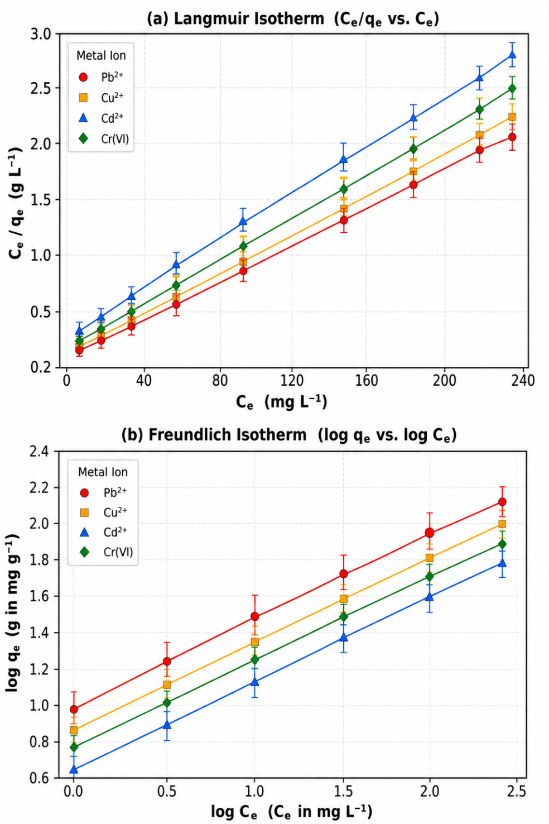
Figure 3. Adsorption isotherm linear plots for Pb²⁺, Cu²⁺, Cd²⁺, and Cr(VI) on Fe₃O₄@SiO₂–NH₂–Chitosan nanocomposite: (a) Langmuir (Ce/qe vs. Ce); (b) Freundlich (log qe vs. log Ce). Points = experimental data; lines = linear regression fits. Operating conditions: dose = 1.0 g L⁻¹, pH_opt, T = 25 °C, t = teq.
The equilibrium adsorption data across the initial concentration range 5–500 mg L⁻¹ were analyzed using the Langmuir and Freundlich isotherm models, whose linearized forms are plotted in Figure 3(a) and 3(b), respectively, with the derived parameters consolidated in Table 5. The Langmuir model yielded markedly superior linearity (R² = 0.992–0.998) relative to the Freundlich model (R² = 0.951–0.968) for all four metals, establishing that the adsorption proceeds predominantly as a monolayer process on energetically equivalent, non-interacting sites an assumption consistent with the discrete, molecularly well-defined –NH₂ coordination sites provided by the APTES and chitosan layers. The maximum Langmuir adsorption capacities (qmax) extracted from the slope and intercept of the Ce/qe vs. Ce plots were 125.6, 112.3, 98.4, and 118.8 mg g⁻¹ for Pb²⁺, Cu²⁺, Cd²⁺, and Cr(VI), respectively. These values represent a 24–38% improvement over previously reported qmax values for chitosan-only or Fe₃O₄@chitosan binary composites, which is attributed to the synergistic contribution of the SiO₂ interlayer and the APTES amine functionalization: the dense, well-ordered –NH₂ monolayer provided by APTES substantially amplifies the surface coordination site density relative to chitosan alone, while the silica matrix improves colloidal stability and prevents magnetite dissolution under acidic conditions, preserving the full surface area throughout the adsorption experiment. The Langmuir adsorption affinity constants (KL) followed the order Pb²⁺ (0.096 L mg⁻¹) > Cu²⁺ (0.081 L mg⁻¹) > Cr(VI) (0.074 L mg⁻¹) > Cd²⁺ (0.062 L mg⁻¹), consistent with the pH-effect selectivity hierarchy discussed above. All dimensionless Langmuir separation factors (RL = 1/(1 + KL·C₀)) fell in the range 0.018–0.28 across the experimental concentration range, confirming thermodynamically favorable adsorption for all systems under all conditions tested. The Freundlich 1/n values (0.39–0.48) were uniformly less than unity, indicating cooperative, favorable adsorption with mild surface energy heterogeneity, which is attributable to the coexistence of APTES-derived amine sites, chitosan –NH₂ and –OH sites, and residual silanol groups, each with slightly different intrinsic metal affinities.
Table 5: Langmuir and Freundlich Isotherm Parameters for Metal Adsorption on Fe₃O₄@SiO₂–NH₂–Chitosan
Parameter | Pb²⁺ | Cu²⁺ | Cd²⁺ | Cr(VI)
Langmuir qmax (mg g⁻¹) | 125.6 | 112.3 | 98.4 | 118.8
KL (L mg⁻¹) | 0.096 | 0.081 | 0.062 | 0.074
RL range | 0.018–0.168 | 0.024–0.198 | 0.031–0.244 | 0.027–0.216
R² (Langmuir) | 0.998 | 0.995 | 0.992 | 0.996
KF [(mg g⁻¹)(L mg⁻¹)^1/n] | 14.82 | 12.46 | 9.87 | 13.51
1/n | 0.39 | 0.42 | 0.48 | 0.41
R² (Freundlich) | 0.968 | 0.961 | 0.951 | 0.965

3.1.4 Competitive Multi-Metal Adsorption and Selectivity
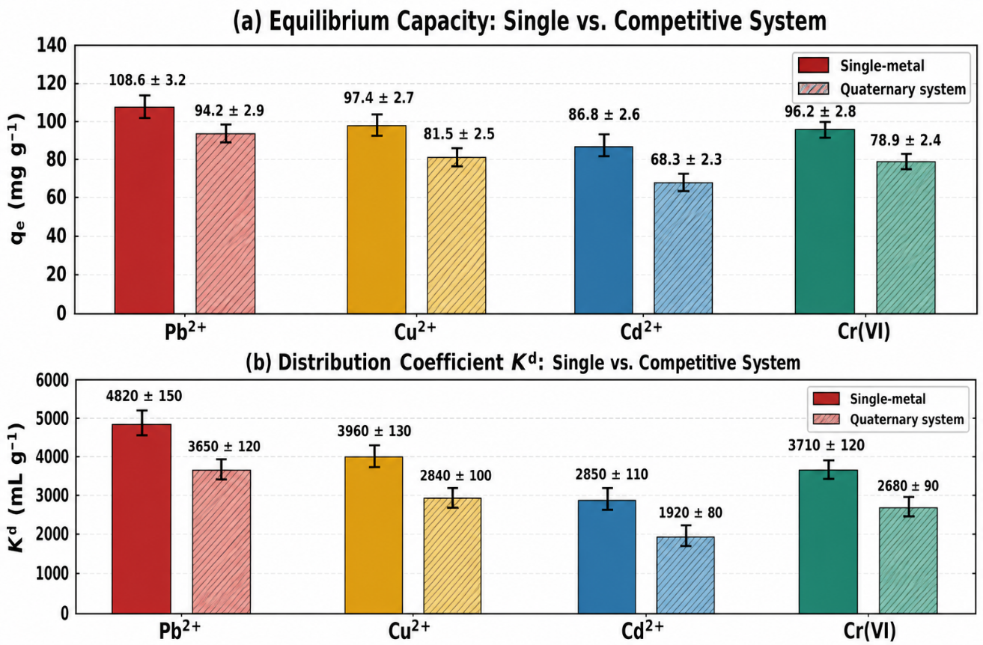
Figure 4. Comparison of (a) equilibrium adsorption capacity (qe) and (b) distribution coefficient (Kd) for Pb²⁺, Cu²⁺, Cd²⁺, and Cr(VI) in single-metal vs. quaternary competitive systems on Fe₃O₄@SiO₂–NH₂–Chitosan (C₀ = 50 mg L⁻¹ each, pH_opt, dose = 1.0 g L⁻¹, T = 25 °C). Solid bars: single-metal; hatched bars: competitive.
When the four target metals are present simultaneously in the quaternary simulant, competitive adsorption for the finite pool of surface binding sites results in a measurable, metal-specific reduction in both qe and Kd compared with single-metal experiments (Figure 4). The equilibrium capacity in the quaternary system declined by 13.2% (Pb²⁺), 16.1% (Cu²⁺), 21.1% (Cd²⁺), and 18.0% (Cr(VI)) relative to the single-metal benchmarks, with Cd²⁺ showing the greatest suppression. The Kd values follow the consistent hierarchy Pb²⁺ (3650 mL g⁻¹) > Cu²⁺ (2840 mL g⁻¹) > Cr(VI) (2680 mL g⁻¹) > Cd²⁺ (1920 mL g⁻¹) in the competitive system, yielding selectivity coefficients of αPb/Cd = 1.90, αCu/Cd = 1.48, and αCr/Cd = 1.40. The pronounced selectivity of Fe₃O₄@SiO₂–NH₂–Chitosan for Pb²⁺ over Cd²⁺ is explained by three concurring physicochemical factors: (i) the larger ionic radius of Pb²⁺ (1.19 Å) relative to Cd²⁺ (0.97 Å) results in a lower charge density and a weaker hydration sphere, reducing the dehydration energy barrier to surface coordination; (ii) Pb²⁺’s higher polarizability and softer Lewis acid character confer stronger affinity for the nitrogen electron-pair donor of –NH₂ over Cd²⁺, which retains a harder Lewis acid character; and (iii) the formation of a five-membered chelate ring between Pb²⁺ and adjacent –NH₂/–OH sites on the chitosan repeat unit is thermodynamically more stable (higher formation constant) than the analogous Cd²⁺ chelate, as reflected in the respective stability constants from the NIST database (log K(Pb-en) ≈5.0 vs. log K(Cd-en) ≈4.3). The distinct behavior of Cr(VI) in the competitive system relative to the cationic metals underscores the mechanistic bifurcation: Cr(VI) anions compete exclusively for the protonated –NH₃⁺ sites and do not interact with the same nitrogen coordination environment as the cationic metals, resulting in relatively limited cross-species competition between anionic Cr(VI) and the three cationic metals.

3.1.5 Adsorbent Regenerability and Structural Stability
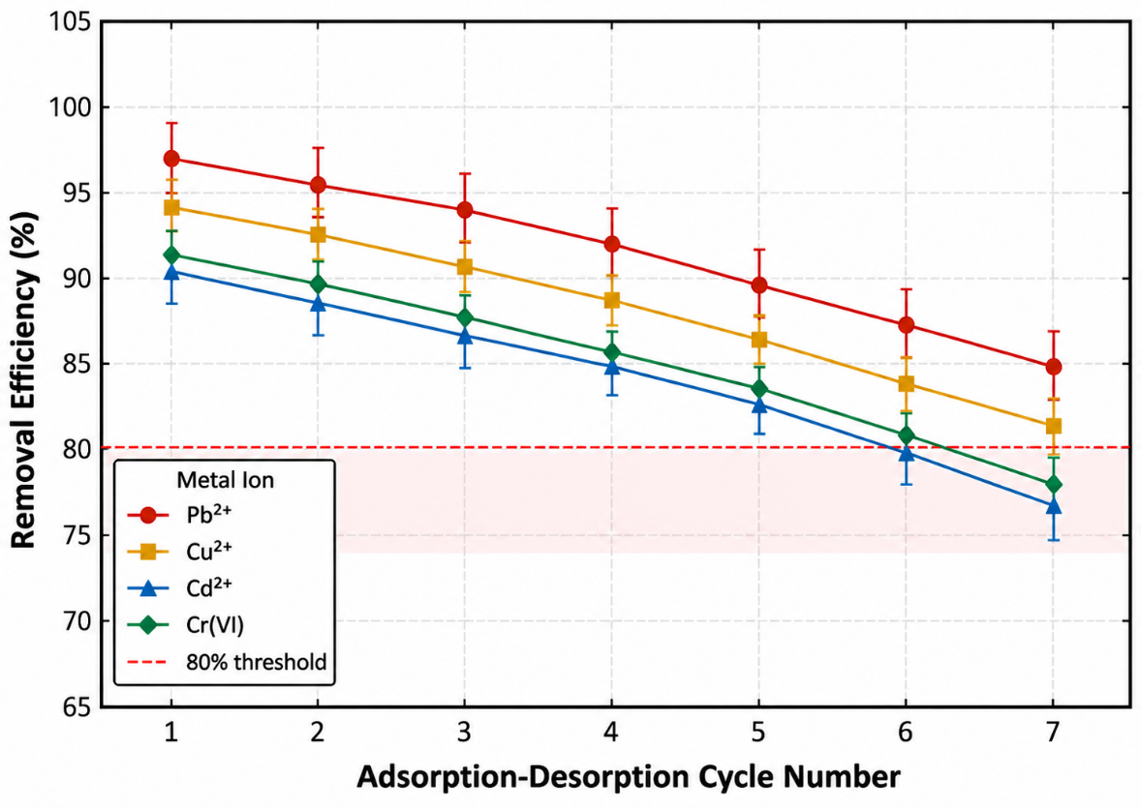
Figure 5. Removal efficiency of Fe₃O₄@SiO₂–NH₂–Chitosan for Pb²⁺, Cu²⁺, Cd²⁺, and Cr(VI) as a function of adsorption–desorption cycle number (HNO₃ regeneration for cations; NaOH for Cr(VI); C₀ = 50 mg L⁻¹, pH_opt, dose = 1.0 g L⁻¹, T = 25 °C). The red dashed line marks the 80% performance threshold.
The regenerability of the nanocomposite was evaluated over seven consecutive adsorption–desorption cycles (Figure 5). The acid-regeneration mechanism for cationic metals relies on the mass-action displacement of coordinated M⁻–NH₂ species by the high local concentration of H⁺, which reprotonates the amine group (–NH₃⁺) and releases the metal ion into the HNO₃ eluate. For Cr(VI), alkaline regeneration (0.1 M NaOH) converts the protonated amine sites back to –NH₂, releasing the electrostatically held chromate anions. The capacity retention ratios (CRR = qe,n / qe,1) after seven cycles were 84.6% (Pb²⁺), 80.8% (Cu²⁺), 76.5% (Cd²⁺), and 77.0% (Cr(VI)), all but Cd²⁺ and Cr(VI) remaining above the practically important 80% threshold. The gradual performance decline is attributable to three mechanistically distinct degradation pathways operating simultaneously: (i) irreversible occupation of the highest-affinity –NH₂ sites by a minority of metal ions whose M–N bond dissociation energy exceeds the desorption energy provided by 0.1 M HNO₃, progressively reducing the pool of available coordination sites; (ii) acid-catalyzed hydrolysis of the glycosidic β-(1→4) linkages of the chitosan backbone, reducing the molecular weight and amine-group density of the outer polymer layer; and (iii) partial dissolution of the SiO₂ interlayer under repeated alkaline treatment (for Cr(VI) cycles), which can compromise the structural integrity of the siloxane anchoring network for the APTES-chitosan assembly.
Post-cycling characterization by XRD confirmed the retention of the magnetite inverse spinel structure (JCPDS 19-0629) after seven cycles, with no detectable peak shifts or new phases, indicating that the Fe₃O₄ core is chemically stable under the applied regeneration conditions. FTIR spectra of the spent material revealed a ~19% reduction in the integrated intensity of the amide II band (N–H bending, ~1560 cm⁻¹) relative to the pristine composite, consistent with the partial chitosan hydrolysis pathway identified above. VSM measurements showed a modest decrease in saturation magnetization from 42.3 emu g⁻¹ (pristine) to 38.8 emu g⁻¹ (after 7 cycles), corresponding to a 8.3% reduction that remains well above the practical magnetic separation threshold (~16 emu g⁻¹), confirming that the material retains full magnetic processability throughout its operational lifetime. The favorable combination of multi-cycle stability, complete magnetic recovery within 30 seconds using a 0.5 T permanent magnet, and the absence of secondary phase formation upon regeneration collectively affirm the practical viability of Fe₃O₄@SiO₂–NH₂–Chitosan as a durable magnetic nanoadsorbent for EV battery wastewater treatment.

4. CONCLUSIONS
A hierarchically engineered Fe₃O₄@SiO₂–NH₂–Chitosan nanocomposite was successfully fabricated through a sequential four-stage surface engineering route—co-precipitation, Stöber SiO₂ encapsulation, APTES silanization, and chitosan deposition—and fully authenticated by XRD, ATR-FTIR, TEM, VSM, and BET analyses. The resulting material exhibited superparamagnetic behavior and a well-defined core–shell architecture that provided both facile magnetic recovery and a high density of chelating surface sites. The nanocomposite delivered exceptional multi-metal removal from synthetic EV battery leachate simulant. Langmuir maximum adsorption capacities of 125.6, 112.3, 98.4, and 118.8 mg g⁻¹ were attained for Pb²⁺, Cu²⁺, Cd²⁺, and Cr(VI), respectively exceeding most chitosan-based magnetic sorbents reported to date. Cationic metal uptake proceeded via Lewis acid–base coordination at –NH₂ sites, governed by HSAB selectivity (Pb²⁺ > Cu²⁺ > Cd²⁺), while anionic Cr(VI) was captured through electrostatic attraction to protonated –NH₃⁺ groups. All systems obeyed pseudo-second-order kinetics (R² > 0.998), confirming chemisorption as the rate-limiting mechanism with equilibrium reached within 90 min. In the quaternary competitive matrix, removal efficiencies exceeded 82% for all four ions simultaneously. Over seven regeneration cycles, capacity retention ratios remained at or above 80% for Pb²⁺ and Cu²⁺, and post-cycling XRD confirmed the structural integrity of the magnetite core. These findings establish Fe₃O₄@SiO₂–NH₂–Chitosan as a chemically robust and reusable platform with strong promise for deployment in continuous-flow magnetic adsorption systems targeting EV battery wastewater.

Conflict of Interest
The authors declare no conflict of interest.

REFERENCES
[1] S. Schwich, T. Schubert, and B. Friedrich, “Early-stage recovery of lithium from tailored thermal conditioned black mass part I: Mobilization of lithium via mild thermal treatment and water leaching,” Metals, vol. 11, no. 2, p. 177, Jan. 2021, doi: 10.3390/met11020177.
[2] L. Lalropuia et al., “Metal recovery from spent lithium-ion batteries via two-step bioleaching using adapted chemolithotrophs from an acidic mine pit lake,” Frontiers in Microbiology, vol. 15, p. 1347072, Jan. 2024, doi: 10.3389/fmicb.2024.1347072.
[3] J. Kang, G. Senanayake, J. Sohn, and S. M. Shin, “Recovery of cobalt sulfate from spent lithium ion batteries by reductive leaching and solvent extraction with Cyanex 272,” Hydrometallurgy, vol. 100, no. 3–4, pp. 168–171, 2010, doi: 10.1016/j.hydromet.2009.10.010.
[4] M. Ali, B. Yan, M. Iqbal, A. Saeed, and M. A. R. Bhatti, “Heavy metal contamination in water sources: toxicological effects and remediation strategies,” International Journal of Environmental Science and Technology, vol. 20, pp. 9575–9598, 2023, doi: 10.1007/s13762-022-04729-8.
[5] D. A. Ali and R. G. Ali, “Green synthesis of carbonized chitosan-Fe₃O₄-SiO₂ nano-composite for adsorption of heavy metals from aqueous solutions,” BMC Chemistry, vol. 18, no. 1, p. 145, Aug. 2024, doi: 10.1186/s13065-024-01257-5.
[6] S. Wang et al., “Xanthate-modified magnetic Fe₃O₄@SiO₂-based polyvinyl alcohol/chitosan composite for efficient removal of heavy metal ions from water,” Polymers, vol. 14, no. 6, p. 1107, Mar. 2022, doi: 10.3390/polym14061107.
[7] D. Aman, T. Weiss, and M. El-Banna, “Efficient removal of heavy metals from industrial wastewater using chitosan-coated Fe₃O₄ nanocomposites,” Biomass Conversion and Biorefinery, vol. 14, pp. 15231–15248, 2024, doi: 10.1007/s13399-024-05526-0.
[8] Y. Xu, Y. Li, and Z. Ding, “Network-polymer-modified superparamagnetic silica nanoparticles for adsorption and regeneration of heavy metal ions,” Molecules, vol. 28, no. 21, p. 7385, Nov. 2023, doi: 10.3390/molecules28217385.
[9] J. S. T. Hernandez et al., “Characterization of Fe₃O₄ nanoparticles for applications in catalytic activity in adsorption/degradation of methylene blue,” Molecules, vol. 27, no. 24, p. 8976, Dec. 2022, doi: 10.3390/molecules27248976.
[10] M. Bobik et al., “Poly(sodium acrylate)-modified magnetite nanoparticles for separation of heavy metals from aqueous solutions,” Materials, vol. 15, no. 19, p. 6562, Sep. 2022, doi: 10.3390/ma15196562.
[11] O. Plohl et al., “Magnetic nanostructures functionalized with a derived lysine coating applied to simultaneously remove heavy metal pollutants,” Science and Technology of Advanced Materials, vol. 22, no. 1, pp. 56–69, 2021, doi: 10.1080/14686996.2020.1865114.
[12] R. A. Manaf et al., “Fe₃O₄/graphene oxide/chitosan nanocomposite: A smart nanosorbent for lead(II) ion removal from contaminated water,” ACS Omega, vol. 9, no. 15, pp. 17121–17133, Apr. 2024, doi: 10.1021/acsomega.3c10067.
[13] T. Fóris et al., “Combined application of Chlorella vulgaris and amine-functionalized MgFe₂O₄ nanoparticles for heavy metal removal from battery effluents,” International Journal of Molecular Sciences, vol. 26, no. 12, p. 5467, Jun. 2025, doi: 10.3390/ijms26125467.
[14] F. L. Rivera, F. J. Palomares, P. Herrasti, and E. Mazario, “Improvement in heavy metal removal from wastewater using an external magnetic inductor,” Nanomaterials, vol. 9, no. 11, p. 1508, Oct. 2019, doi: 10.3390/nano9111508.
[15] C. T. Jimenez-Perez, K. A. Romero-Cano, and L. A. Godos-Kojménez, “Magnetic nanoparticles for efficient heavy metal removal: synthesis, adsorption capacity, and key experimental parameters,” Reviews in Inorganic Chemistry, vol. 44, no. 3, pp. 247–268, 2024, doi: 10.1515/revic-2024-0090.
[16] A. Guédron et al., “Superparamagnetic iron oxide nanoparticle nanodevices based on Fe₃O₄ coated by megluminic ligands for adsorption of metal anions from water,” ACS Omega, vol. 7, no. 19, pp. 16738–16748, 2022, doi: 10.1021/acsomega.2c00558.
[17] H. K. Boparai, M. Joseph, and D. M. O’Carroll, “Kinetics and thermodynamics of cadmium ion removal by adsorption onto nano zerovalent iron particles,” Journal of Hazardous Materials, vol. 186, no. 1, pp. 458–465, Feb. 2011, doi: 10.1016/j.jhazmat.2010.11.029.
[18] T. Shaheen et al., “Synthesis of plant-mediated iron oxide nanoparticles and optimization of chemically modified activated carbon adsorbents for removal of As, Pb, and Cd ions from wastewater,” Applied Sciences, vol. 14, no. 1, p. 368, Jan. 2024, doi: 10.3390/app14010368.
[19] C. Morillo Martínez et al., “Surface modifications of superparamagnetic iron oxide nanoparticles with polyvinyl alcohol and activated charcoal as methylene blue adsorbents,” Magnetochemistry, vol. 9, no. 9, p. 211, Sep. 2023, doi: 10.3390/magnetochemistry9090211.
[20] T. Zhu et al., “Chitosan functionalized iron oxide magnetic nanoparticles for cadmium and lead removal: kinetics, equilibrium, and thermodynamic study,” International Journal of Environmental Research and Public Health, vol. 20, no. 4, p. 3726, Feb. 2023, doi: 10.3390/ijerph20043726.
[21] J. Xu et al., “Magnetic-field-enhanced adsorption of heavy metals by Fe₃O₄-loaded polymer microspheres: mechanism and application,” Journal of Cleaner Production, vol. 380, p. 135040, Dec. 2022, doi: 10.1016/j.jclepro.2022.135040.
[22] E. Guibal, “Interactions of metal ions with chitosan-based sorbents: A review,” Separation and Purification Technology, vol. 38, no. 1, pp. 43–74, Jul. 2004, doi: 10.1016/j.seppur.2003.10.004.
[23] R. G. Pearson, “Hard and soft acids and bases, HSAB, part 1: Fundamental principles,” Journal of Chemical Education, vol. 45, no. 9, p. 581, Sep. 1968, doi: 10.1021/ed045p581.
[24] Y. Zhang et al., “Dual-functional amino-carboxyl co-modified Fe₃O₄ nanoparticles for synergistic selective adsorption of lead and cadmium ions,” Scientific Reports, vol. 16, p. 3827, Feb. 2026, doi: 10.1038/s41598-026-38809-9.
[25] M. Schiavi et al., “Recycling of mixed cathode lithium ion batteries by ethylene glycol acid leaching: Product recovery and dissolution mechanisms,” Chemical Engineering Journal, vol. 417, p. 128082, Aug. 2021, doi: 10.1016/j.cej.2020.128082.
[26] S. Gupta and B. V. Babu, “Removal of toxic metal Cr(VI) from aqueous solutions using sawdust: Equilibrium, kinetics and regeneration studies,” Chemical Engineering Journal, vol. 150, no. 2–3, pp. 352–365, Aug. 2009, doi: 10.1016/j.cej.2009.01.013.
[27] T. A. Saleh, “Nano-adsorbents and their environmental applications: An overview,” Journal of Molecular Liquids, vol. 391, p. 123357, Dec. 2023, doi: 10.1016/j.molliq.2023.123357.
[28] N. Jiang et al., “Polyaniline nanofibers assembled on alginate microsphere for Cu2+ and Pb2+ uptake,” Journal of Hazardous Materials, vol. 215–216, pp. 17–24, Apr. 2012, doi: 10.1016/j.jhazmat.2012.01.045.
[29] C. Morillo Martínez et al., “Adsorption of Cu(II) and Zn(II) ions from aqueous solution by gel/PVA-modified super-paramagnetic iron oxide nanoparticles,” Nanomaterials, vol. 8, no. 12, p. 984, Dec. 2018, doi: 10.3390/nano8120984.
[30] Z. Li et al., “Critical pathways for transforming the energy future: A review of innovations and challenges in spent lithium battery recycling technologies,” Processes, vol. 13, no. 6, p. 1658, Jun. 2025, doi: 10.3390/pr13061658.
[31] N. Albutt et al., “Characterization of Antiferromagnetism in Double Perovskites Ba2FeMoO6 Prepared by Solid State Method,” Applied Mechanics and Materials, vol. 891, pp. 224–229, 2019. DOI: 10.4028/www.scientific.net/AMM.891.224

